Logistic information for travel and accommodation

Venue

The 11th EUSAIR FORUM, will take place on 18 -20 May at the hotel Holiday Inn, Skopje,
Filip Vtori Makedonski, 5 Skopje, 1000, North Macedonia, see on map.

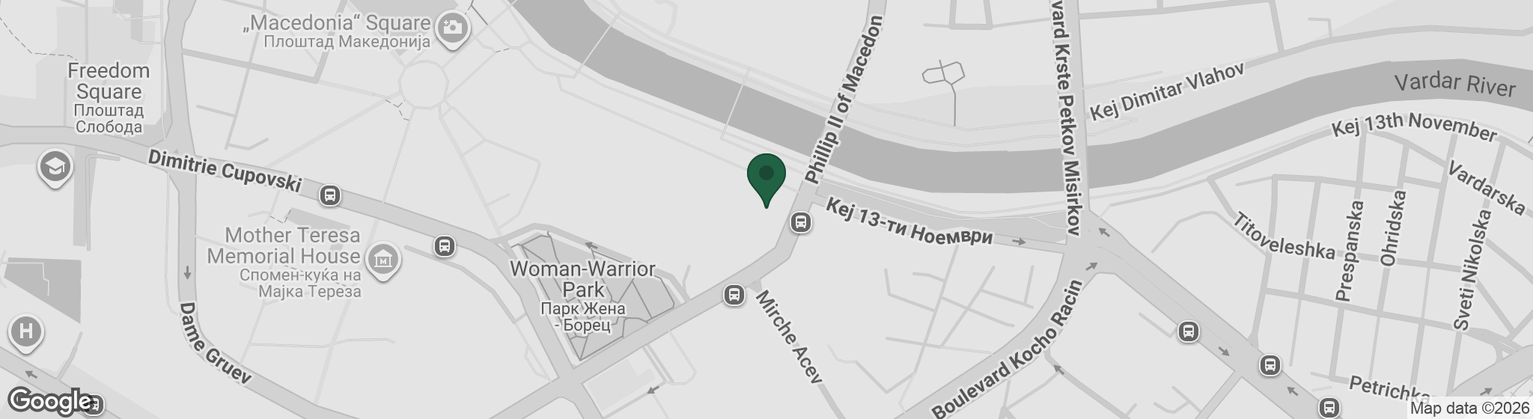

Evening Receptions

18 May, Monday
20.00 – 22.00 - Welcoming cocktail for all participants, details on location will follow.

19 May, Tuesday
20.00 – 22.00 - Reception for all participants, details on location will follow.

Sightseeing tour – optional, registration required

21 May, Thursday
10.00-15.00 Optional sightseeing tour hosted by the Presidency, itinerary and details will follow.

Accommodation – hotel:
Please note that no advance reservations have been made at these hotels. Participants are kindly asked to book directly, and standard market rates apply.
Holiday Inn Skopje 5*  A: Filip Vtori Makedonski No. 5, 1000 Skopje, North Macedonia  W: Holiday Inn Skopje by IHG  T: +389 (866) 238 - 4218 | Price:  • Single room: 111 EUR  • Double room: 136 EUR  Transfer from Airport to Hotel and otherwise:  The hotel is approx. 25 km from the airport.  - By taxi: 25–35 minutes, around 20–25 EUR. Official airport taxis with a taximeter are recommended.  - Private transfer: Car (up to 3 people) approx. 20 EUR; Van (up to 8 people) approx. 35 EUR. Can be pre-booked with the hotel.  - Public transport: Vardar Express shuttle to the city center (approx. 40 min, 3 EUR). From there, Holiday Inn Skopje is a 15–20 min walk or short taxi ride.  - Alternative: Ride-hailing apps such as Bolt are available.
Hotel Limak Skopje 5*  A: Blvd. Aleksandar Makedonski 3, 1000 Skopje, North Macedonia  W: https://www.limakhotels.com/skopje  T: +389 (0)2 555 0000 |  | Price:  • Single room: 135 EUR  • Double room: 136 EUR  Transfer from Airport to Hotel and otherwise:  The hotel is approx. 25 km from the airport.  - By taxi: 25–35 minutes, around 20–25 EUR. Official airport taxis with a taximeter are recommended.  - Private transfer: Car (up to 3 people) approx. 20 EUR; Van (up to 8 people) approx. 35 EUR. Can be pre-booked with the hotel.  - Public transport: Vardar Express shuttle to the city center (approx. 40 min, 3 EUR). From there, Hotel Limak is a 15–20 min walk or short taxi ride.  - Alternative: Ride-hailing apps such as Bolt are available.
Skopje Marriott Hotel 4*  A: Macedonia Square No.7, Skopje 1000, North Macedonia  W: https://www.mariott.com  T: +389 (0)2 510 2510 |  | Price:  • Single room: 189 EUR  • Double room: 199 EUR  Transport from Airport to hotel and otherwise:  The hotel is approx. 25 km from the airport.  - By taxi: 25–35 minutes, around 20–25 EUR. Official airport taxis with a taximeter are recommended.  - Private transfer: Car (up to 3 people) approx. 20 EUR; Van (up to 8 people) approx. 35 EUR. Can be pre-booked with the hotel.  - Public transport: Vardar Express shuttle to the city center (approx. 40 min, 3 EUR). From there, Hotel Angels is a 15–20 min walk or short taxi ride.  - Alternative: Ride-hailing apps such as Bolt are available.
Alexander Square Boutique Hotel 4*  A: Blvd. Macedonia 4, 1000 Skopje, North Macedonia  W: https://www.alexandersquarehotel.com.mk  T: +389 (0)2 311 2345 |  | Price:  • Single room: 109 EUR  • Double room: 120 EUR  Transport from Airport to hotel and otherwise:  The hotel is approx. 25 km from the airport.  - By taxi: 25–35 minutes, around 20–25 EUR. Official airport taxis with a taximeter are recommended.  - Private transfer: Car (up to 3 people) approx. 20 EUR; Van (up to 8 people) approx. 35 EUR. Can be pre-booked with the hotel.  - Public transport: Vardar Express shuttle to the city center (approx. 40 min, 3 EUR). From there, the hotel is a 15–20 min walk or short taxi ride.  - Alternative: Ride-hailing apps such as Bolt are available.
Bliss Palace Hotel & Spa 5*  A: Blvd. Partizanski Odredi 52, 1000 Skopje, North Macedonia  W: https://www.blisspalace.com.mk  T: +389 (0)2 312 3456 |  | Price:  • Single room: 100 EUR  • Double room: 140 EUR  Transport from Airport to hotel and otherwise:  The hotel is approx. 25 km from the airport.  - By taxi: 25–35 minutes, around 20–25 EUR. Official airport taxis with a taximeter are recommended.  - Private transfer: Car (up to 3 people) approx. 20 EUR; Van (up to 8 people) approx. 35 EUR. Can be pre-booked with the hotel.  - Public transport: Vardar Express shuttle to the city center (approx. 40 min, 3 EUR). From there, Bliss Palace Hotel & Spa is a 15–20 min walk or short taxi ride.  - Alternative: Ride-hailing apps such as Bolt are available.
In addition to the hotels described above, there are also hotels located within a 10-minute walk from the venue:
- Hotel Macedonia Square
- Hotel Solun

Travel and transfers
Skopje International Airport (SKP) ✈️

T: +389 2 3148 333
W: http://skp.airports.com.mk/

Distance from the Skopje International Airport to the venue: approx. 25 km
Approximate travel time: around 30 minutes by car/taxi during low traffic volume

Transfer from the airport to the venue (Public Room Skopje):

By taxi: Taxis are available directly outside the arrivals terminal. The ride to Public Room Skopje takes about 25–35 minutes, depending on traffic, and costs around 20–25 EUR. It is recommended to use official airport taxis with a taximeter.

By public transport: You can take the shuttle bus operated by Vardar Express or by Erak Transporter from the airport to the Skopje city center. The timeline of Erak Transporter can be find here: Airport Shuttle Bus. The journey takes about 40 minutes and costs approx. 3 EUR. From the bus station, Public Room Skopje is about a 15–20 minute walk or a short taxi ride. Tickets for the shuttle bus can be purchased at the counter in the arrivals hall or directly from the driver.

Alternative: Private shuttle services and ride-hailing apps such as Bolt are also available and may offer convenient transfer options, especially for groups or late arrivals.

Practical information

- Local currency: Macedonian Denar (MKD). 1 EUR ≈ 61.5 MKD. Credit cards are widely accepted in hotels, restaurants, and larger shops, but it is recommended to carry some cash for smaller establishments.
- Time zone: Central European Summer Time (CEST), UTC +2
- Banks and ATMs: Banks are generally open from 8:00 AM to 4:00 PM, Monday to Friday. ATMs are widely available across the city.
- Weather: In May, Skopje typically enjoys warm and pleasant weather, with average daytime temperatures ranging between 22°C and 25°C and cooler evenings around 10–12°C. Light layers are recommended for the mornings and evenings, while daytime clothing can be summery.
- Medical services: Skopje has several public and private hospitals and clinics. Emergency services are available 24/7. Participants are advised to arrange their own health insurance.
- Tourist information: https://www.exploringmacedonia.com
- City website: City of Skopje - Official portal
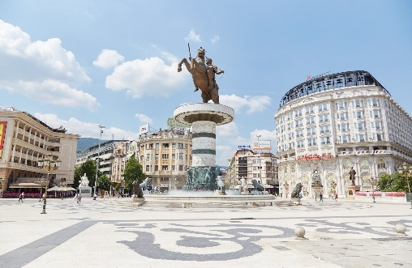
For any additional support regarding logistic you may contact: eusair.point.mkrr@gov.si

