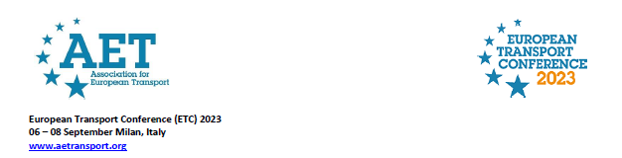

European Transport Conference
6th-8th September 2023
Politecnico di Milano, Bovisa Campus
Via R. Lambruschini 4 – 20156 Milano (Italy)

SPECIAL SESSION
THE GREEN & SMART PORTS CONCEPT IN THE FRAMEWORK OF THE EUROPEAN STRATEGY FOR THE ADRIATIC-IONIAN REGION (EUSAIR)
8th September 2023 14:00 – 16:00
Aula Magna Carassa e Dadda, Building BL28

Chair: Prof. Pierluigi Coppola, Ministry of Infrastructure and Transports, EUSAIR Pillar 2 (Transport Sub-group) Coordinator

DRAFT AGENDA

8 September 2023, 14:00-16:00
14:00 -14:30 | Opening Remarks  On Carlo Ciccioli (Regione Marche Council) - The role of Marche Region for sustainable transport in the Adriatic and Ionian region- tbc  On Umberto Trenta (Regione Marche Council) - New proposal for a regional legal framework for the EUSAIR strategy  Ms Anna Maria Bertini (Municipality of Ancona/AI FAIC) – Cooperation in the Adriatic-Ionian Region towards more sustainable and smarter city-ports
14:30-15:30 | Prof Oliviero Baccelli (Bocconi University) – Green and Smart ports in the framework of EU sustainable transport policies  Prof Pierluigi Coppola (EUSAIR Pillar 2 Coordinator) – Embedding the Green & Smart concept in the new European Territorial Cooperation programmes (2021-2027): the role of EUSAIR  Dr Giuseppe Siciliano (PTSClas ) - Implementing the Green and Smart Port concept in the Adriatic-Ionian Region  Ms Lucia Calliari (ADRION JS) Embedding the Green & Smart concept in the Interreg ADRION Programme  Ms Anna Flavia Zuccon (IT-HR MA) Embedding the Green & Smart concept in the Interreg CBC Programme Italy-Croatia - tbc  Mr Mauro Novello (IPA IT-AL-MN JS) Embedding the Green & Smart concept in the IPA CBC Programme Italy- Albania-Montenegro
15:30-15:45 | Q&A
16:00 | Closure of the session

