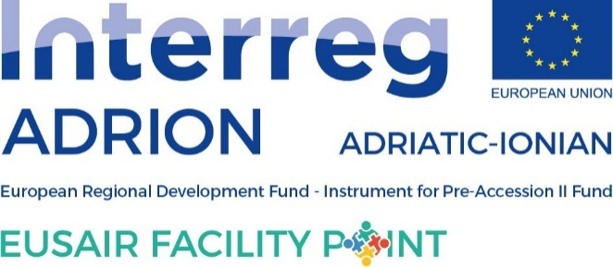
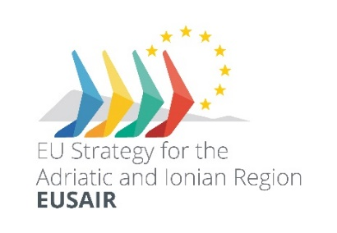
22 April 2020
Subject: Mediterranean Coast and Macro-regional Strategies Week – SI PRESIDENT-SEA– Slovenia, 14-25 September 2020 – SAVE-THE-DATE
Dear Sir or Madam,
we are pleased to invite you to the fifth Mediterranean Coast and Macro-regional Strategies Week – SI PRESIDENT-SEA which will take place between 14 and 25 September 2020 on Slovenian coast.
Traditionally, the event aims to raise awareness about the sea, its coast and the natural and economic potential it boasts, and outlines the risks facing the sea and the coast as a result of natural phenomena and human activities. In addition, the event highlights the importance of collaboration to effectively address today’s and tomorrow’s challenges.
The fifth Mediterranean Coast and Macro-Regional Strategies Week is one of the key events during Slovenia's Presidency of the EU Strategy for the Adriatic and Ionian Region (EUSAIR), hence the idea of this year’s slogan. Numerous interesting events and activities will take place in cooperation with international, macro-regional and domestic institutions and stakeholders. The event will bring together politicians, decision-makers, experts, civil society and interested public from all levels - local, regional, national and international. Special attention will be given to the stakeholders’ views on the state of play and the future of the sea and coastal management.
The Mediterranean countries have been celebrating the Mediterranean Coast Day since its launch on 25 September 2007. 25 September was chosen as the Mediterranean Coast Day to honor Slovenia as the first country in the Mediterranean region which ratified the Protocol on Integrated Coastal Zone Management (ICZM) in 2009. The ICZM Protocol is a unique legal instrument which allows the countries in the Mediterranean to better manage and protect their coastal zones in pursuit of sustainable development. Each year, one of the Mediterranean countries is a host of the Mediterranean Coast Day main celebration, while other countries organize their own events.
In Slovenia, the celebration is widely known as the “Mediterranean Coast Week” and is inextricably linked to regional cooperation under the three European macro-regional strategies which are implemented in Slovenian territory, namely the Danube, Adriatic-Ionian and Alpine Strategy. Without cooperation, there are no appropriate solutions and no common future.

Draft programme:
14.09.2020 | Meeting of EU Strategy for Alpine Region - EUSALP embedding (TBC), day 1  (by invitation only, event in English language)
15.09.2020 | Meeting of EU Strategy for Alpine Region - EUSALP embedding (TBC), day 2  (by invitation only, event in English language)
15.09.2020 | 'Roadshow' EUSALP and AlpGov2 project – Presentation of EUSALP and Action Groups (TBC)  (open to wider public, event in English language)
16.09.2020 | Meeting of Trio Presidency of all four EU macro-regional strategies  (by invitation only, event in English language)
16.09.2020 | OFFICIAL OPENING of the 2020 Mediterranean Coast and Macro-regional Strategies Week  (open to wider public, registration needed, event in Slovenian language, interpretation in English language provided)
16.09.2020 | EU Strategy for Adriatic-Ionian Region (EUSAIR) Pillar coordinators technical meeting  (by invitation only, event in English language)
16.09.2020 | EU Strategy for Adriatic-Ionian Region (EUSAIR) National coordinators meeting  (by invitation only, event in English language)
16.09.2020 | Meeting of Adriatic-Ionian Initiative Senior Officials  (by invitation only, event in English language)
17.09.2020 | EU Strategy for Adriatic-Ionian Region (EUSAIR) Governing Board  (by invitation only, event in English language)
18.09.2020 | Youth, Water and EUSAIR (TBC)  (open to wider public, registration needed, event in Slovenian language)
18.09.2020 | Presentation of Maritime spatial plan Slovenia  (public discussion open to wider public, registration needed, event in Slovenian language)
21.09.2020 | Workshop organized by EUSAIR Pillar 3 (Environmental Quality) and INTERACT: “The opportunities of Green Deal for macro-regions”, Day 1  (by invitation only, event in English language)
22.09.2020 | Workshop organized by EUSAIR Pillar 3 (Environmental Quality) and INTERACT: “The opportunities of Green Deal for macro-regions”, Day 2  (by invitation only, event in English)
23.09.2020 | Meeting of EU Strategy for Adriatic-Ionian Region smart specialization representatives  (by invitation only, event in English language)
24.09.2020 | Study Visit and Workshop on Blue Growth (TBC)  (by invitation only, event in English language)
25.09.2020 | EUROPEAN RESEARCHER'S NIGHT (TBC)  (event open to wider public, in Slovenian language)  Closing of the 2020 Mediterranean Coast and Macro-regional Strategies Week
! Organizers reserve the right to modify the programme and /or hold online events due to the COVID 19 pandemic.
Further information about the event will be available on the dedicated website of the EU Strategy for the Adriatic and Ionian Region (EUSAIR) in the coming weeks: http://www.adriatic-ionian.eu/.
We would like to invite you to watch a short video presenting the events of the Mediterranean Coast and Macro-regional Strategies Week 2019 by following this link.
Organization committee

