EUSAIR FACILITY POINT
National pages Manual

INDEX

1. Reaching the national page editor 2
2. Preview 4
3. Saving changes to the page 5
4. Elements of the page 6
5. Editing the text 7
6. Editing pictures 9
7. Highlights and events 11
8. Editing the events 12

Reaching the national page editor
The first step to editing the national pages is logging to intranet.
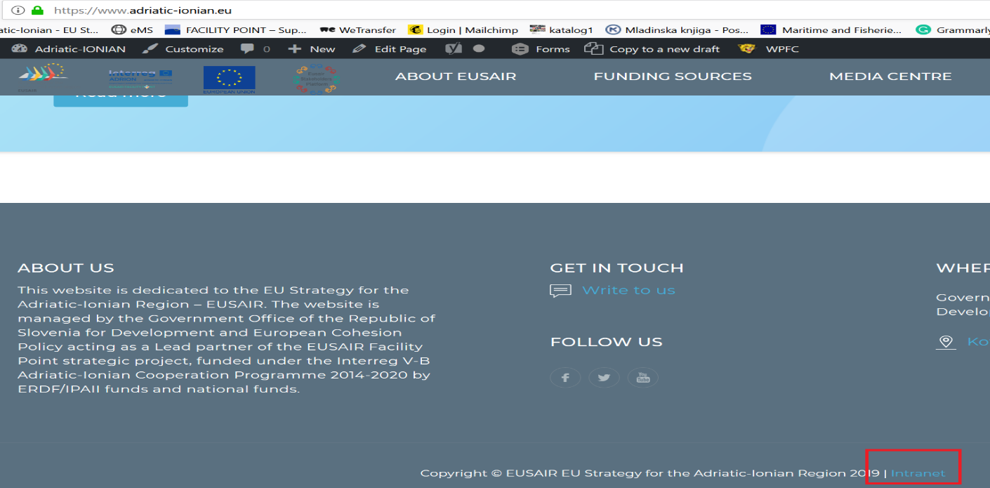
The access to edit the national pages had already been given to specific users. The usernames with the access are: albana.merja@mfa.gov.al, Tina Trapara, irina.muselin@mint.hr, itzika@mou.gr, natalino.barbizzi@regione.marche.it, milos.mugosa@gsv.gov.me, Uros Stojkovic, emilija.kastelic@izola.si. In case of forgotten password please contact ajda.starc@gov.si.
In the next step you need to open the Dashboard in the upper left corner.
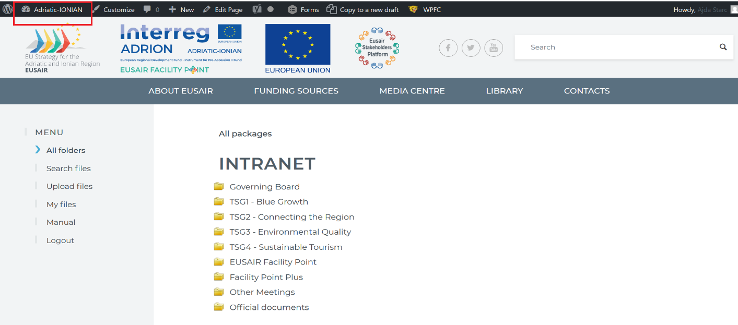
On the left side from the Dashboard options choose Pages.
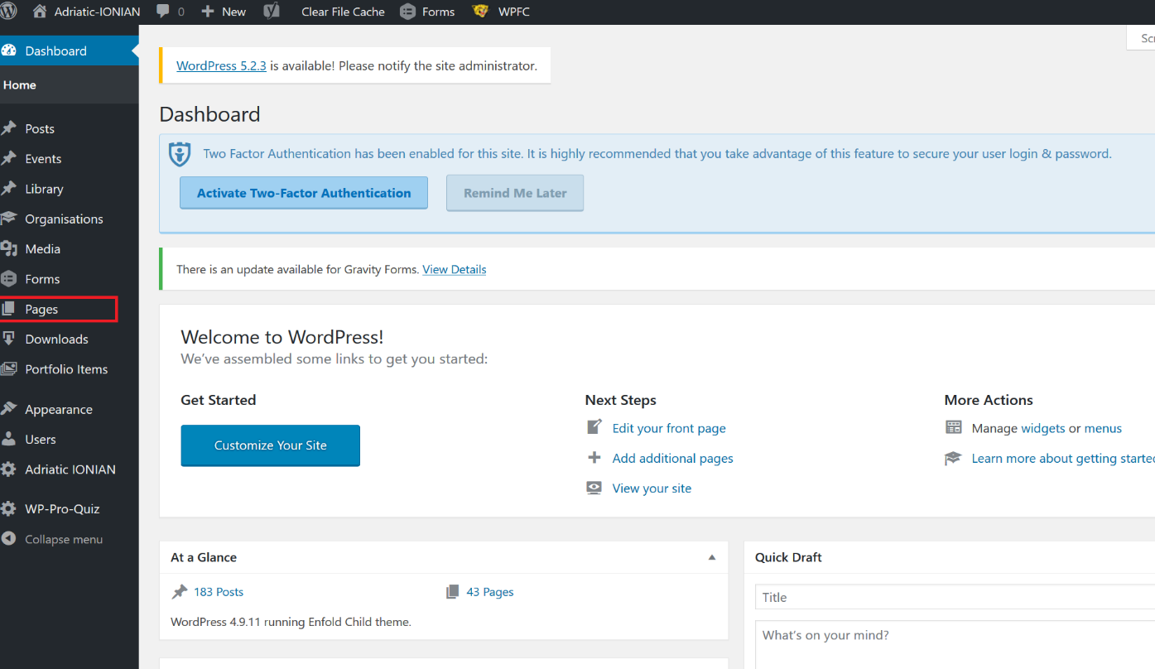
You will be able to choose your national page by clicking it.
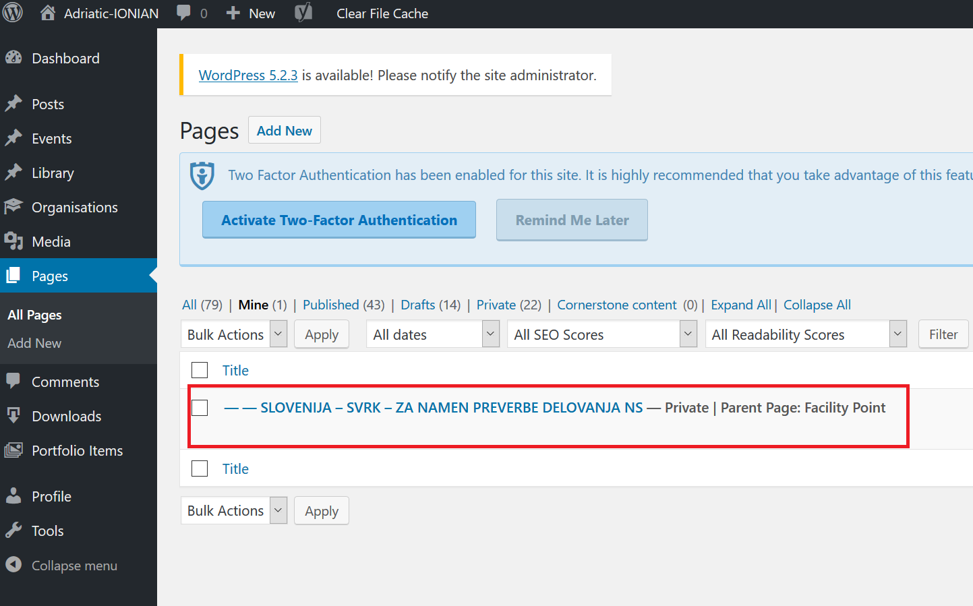

Preview
On the upper right side, you will be able choose Preview to view how the national pages will look like on the web.
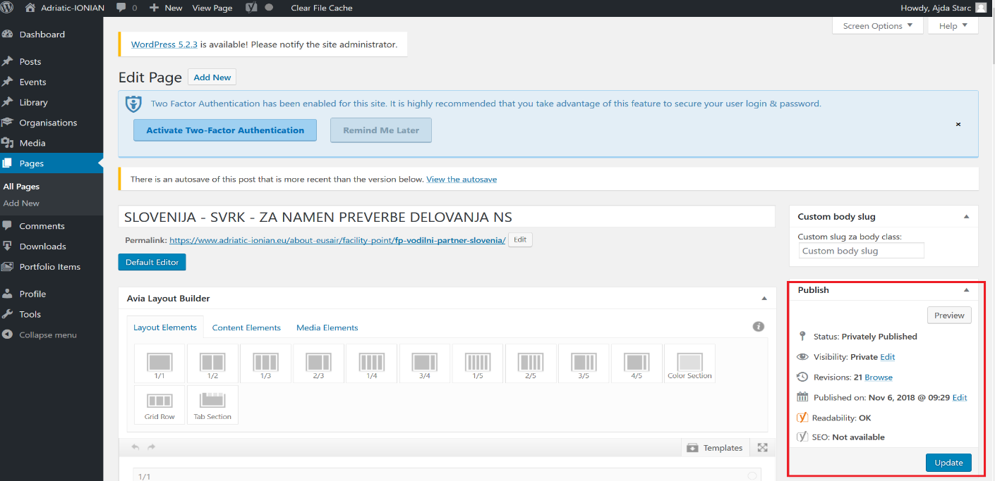
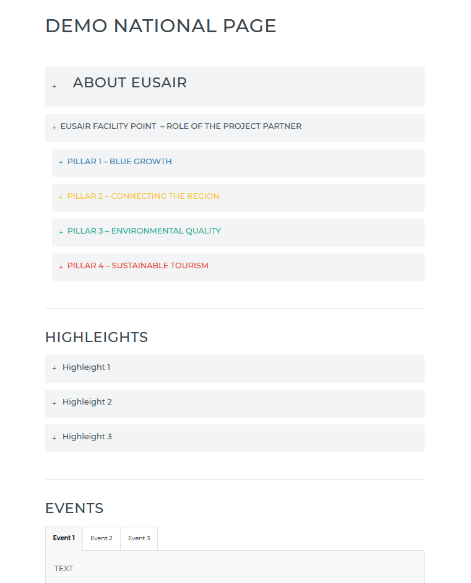

Saving changes made to the page
In the same rectangle you can click Update to save the changes you have made to your national page. It is advisable to make regular updates when you are editing the page.
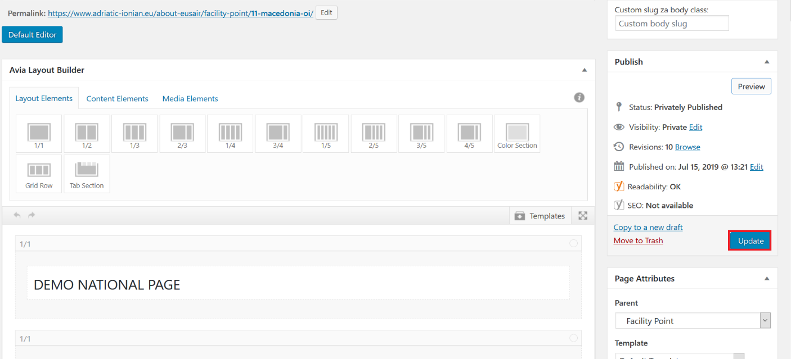

Elements of the page
In the upper part of the national page you will be able to add Layout elements, they determine how the text and media will be positioned, Content elements (text, heading, separator…) and Media (image) elements to your page by clicking them.
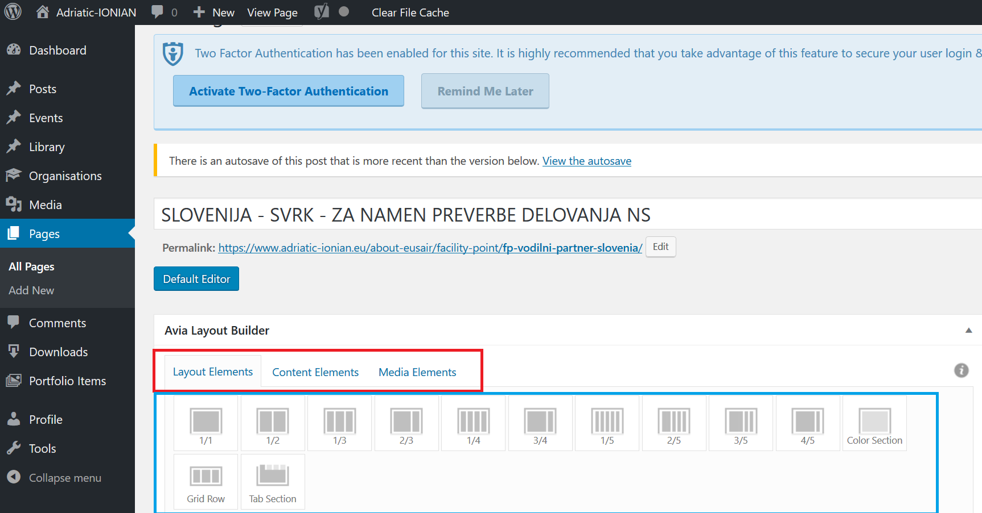
By clicking on the created content elements or media elements the editor will open, that will enable you to edit the content.

Editing the text
In the text block editor, the options for editing the text are gathered in the rectangle highlighted below.
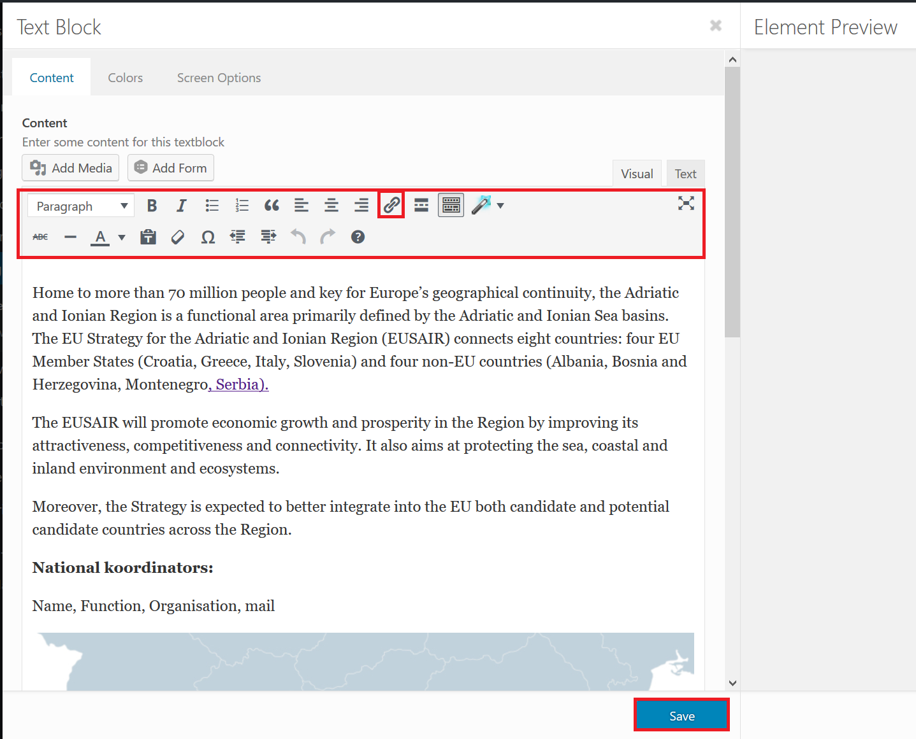
Among the editing options you will find bold, italics, create bullet list, numbered list, special alignment of the text, clear editing and special character. The most import option is Insert or edit link, highlighted in a square. In the top left corner of the rectangle highlighted above the font can be determined. HEADING 1 is reserved for the main heading (your institution), HEADING 2 is used for heading ABOUT EUSAIR, HIGHLEIGHTS and EVENTS. HEADING 3 is used for other headings. Paragraph is used for non-heading text.
The uniform text in English is to be translated to national languages and supplemented (text in the attachment). Contact information specific to your country needs to be added as well as the text regarding your role as a partner. You can write or insert the translation. You can insert the copied text by using the function paste by simultaneously pressing ctrl and v.

The pillar headings have specific colors: blue color #3589b6, yellow #f9c317, green #29b29b and red #e64a38. You can determine the text color by choosing custom color.
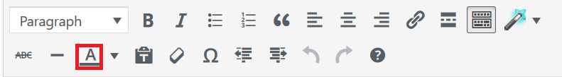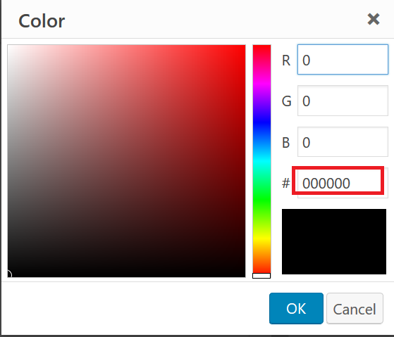
When you are done editing the text you need to save the changes to the text block, by clicking save in the bottom and then update the page in the upper right corner (picture page 5).
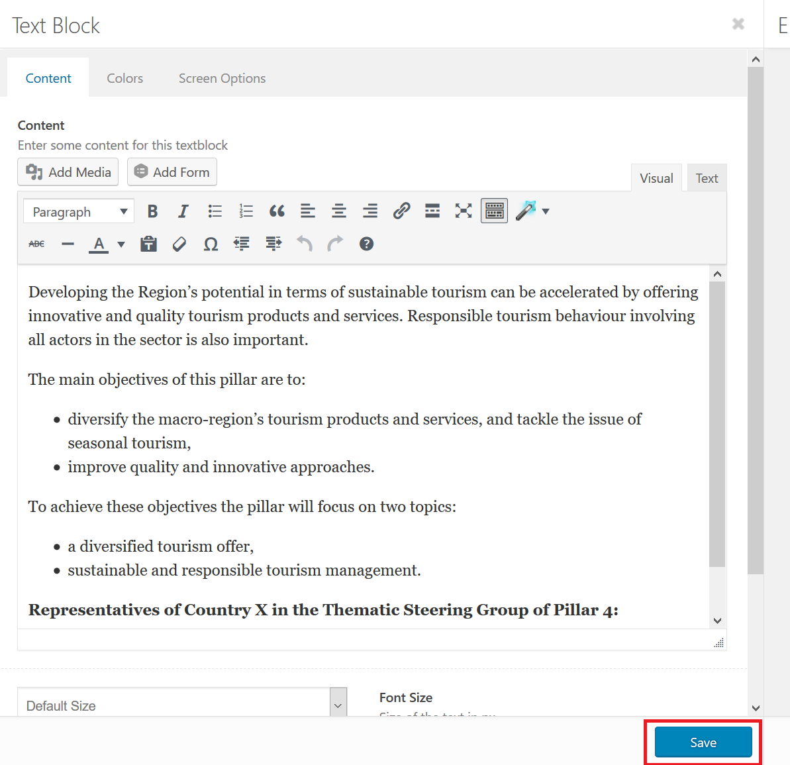

Editing pictures
You can insert the picture in to the image block or text block. 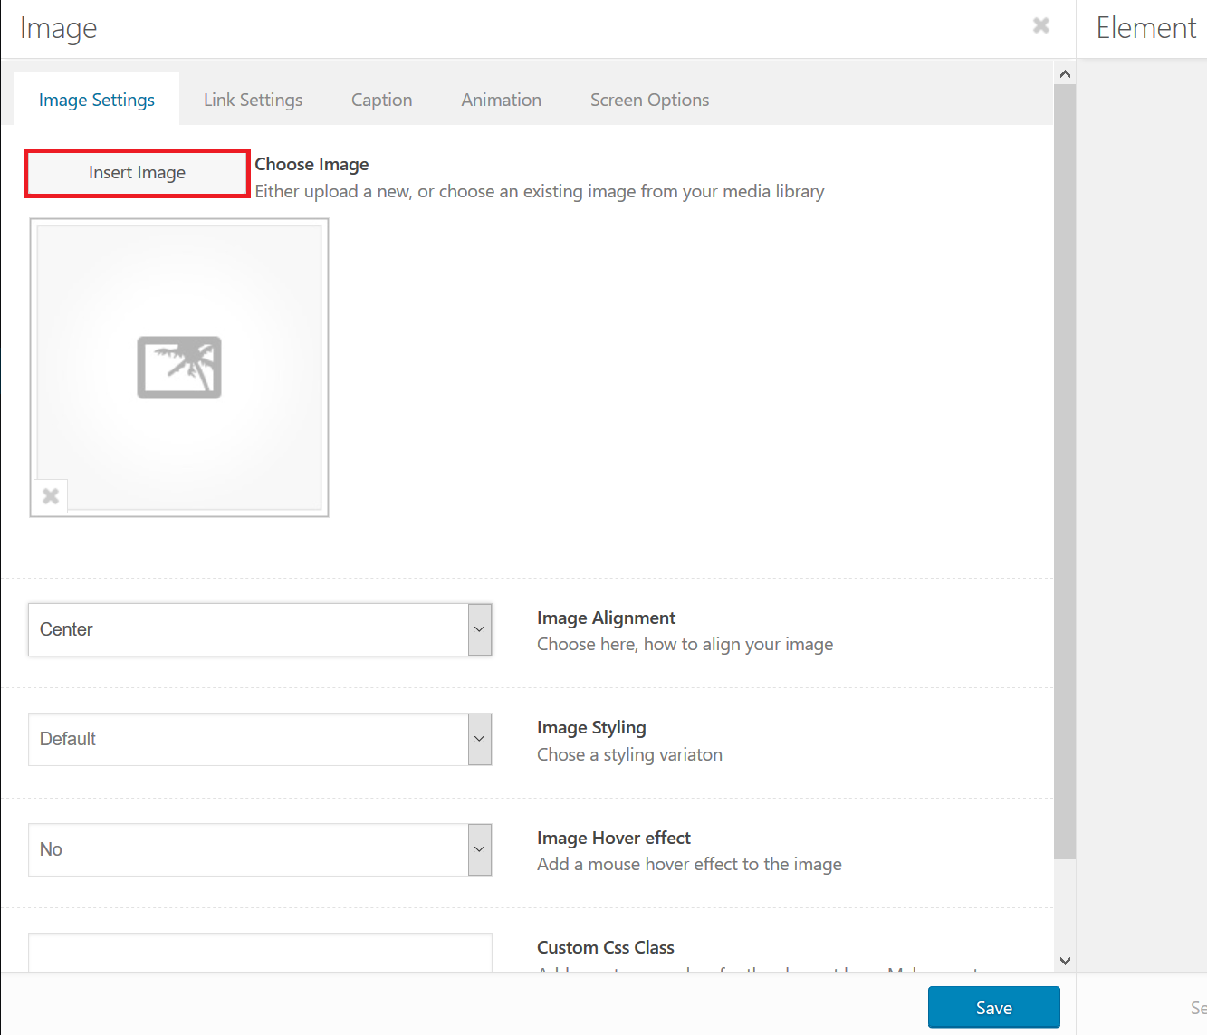
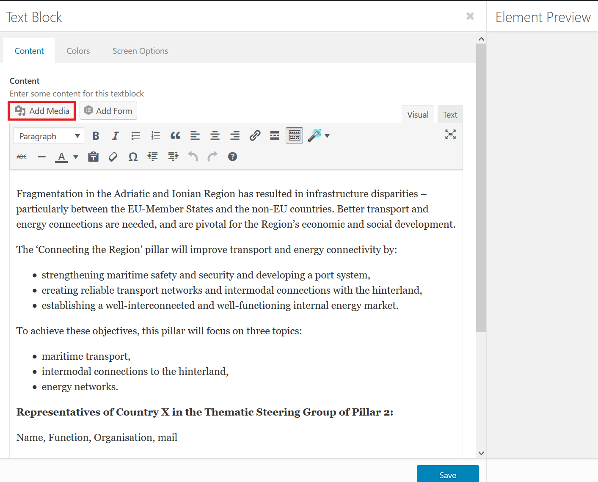
The example inserting the image will be presented in the text block.

You can upload files from your computer.
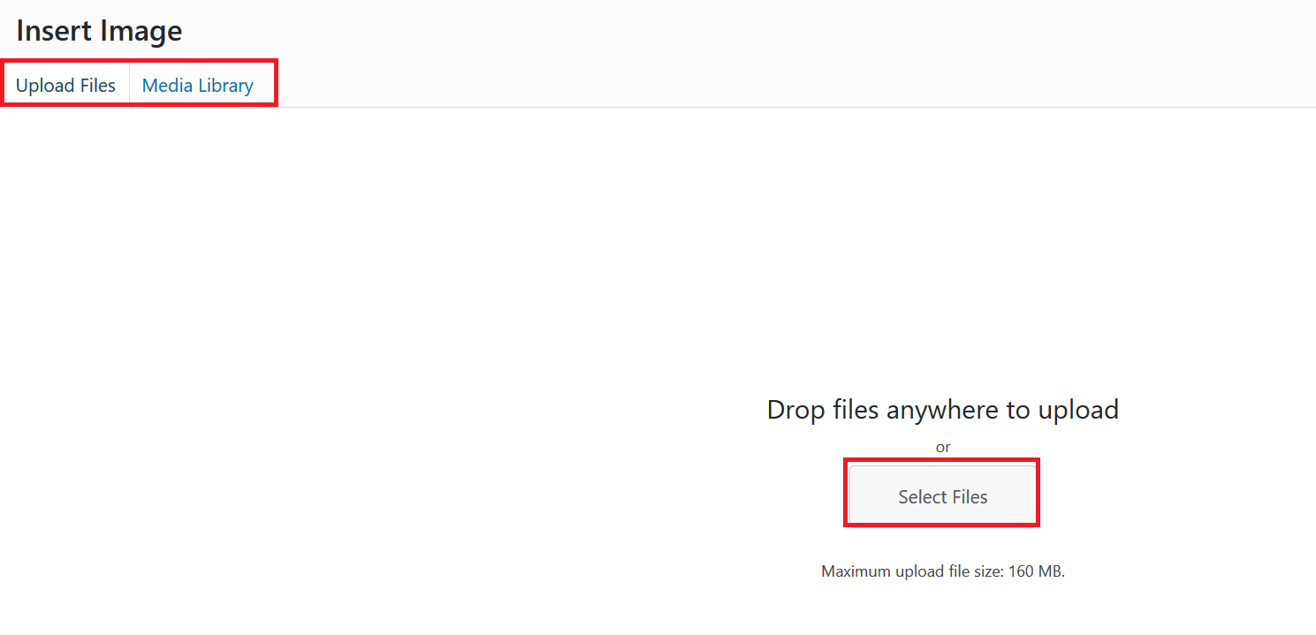
The images that will be added should not be bigger than 1 MB, because bigger files will slow down the page. For the same reason we strongly advise the project partners not to upload videos, but add the video links (for example to YouTube). Media file should only be uploaded once. After a media has been uploaded it can be chosen in Media Library in the upper left corner.
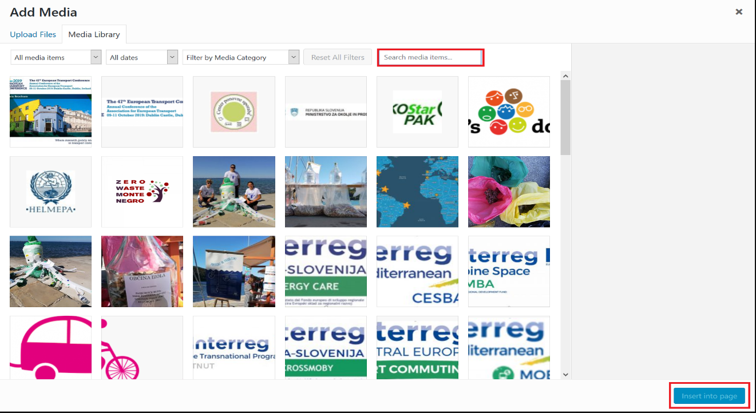
There is a vast collection of pictures there. Specifically, logos should be found in media library and not uploaded again. To find specific image you can use the search engine, filter by dates or you can scroll down and search manually.
You can edit the picture by clicking on it and clicking the pencil.
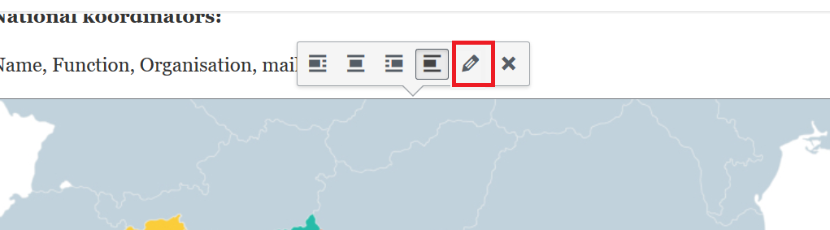
This will open Image editor, where you can set caption, set the alignment, resize the image and add custom link.
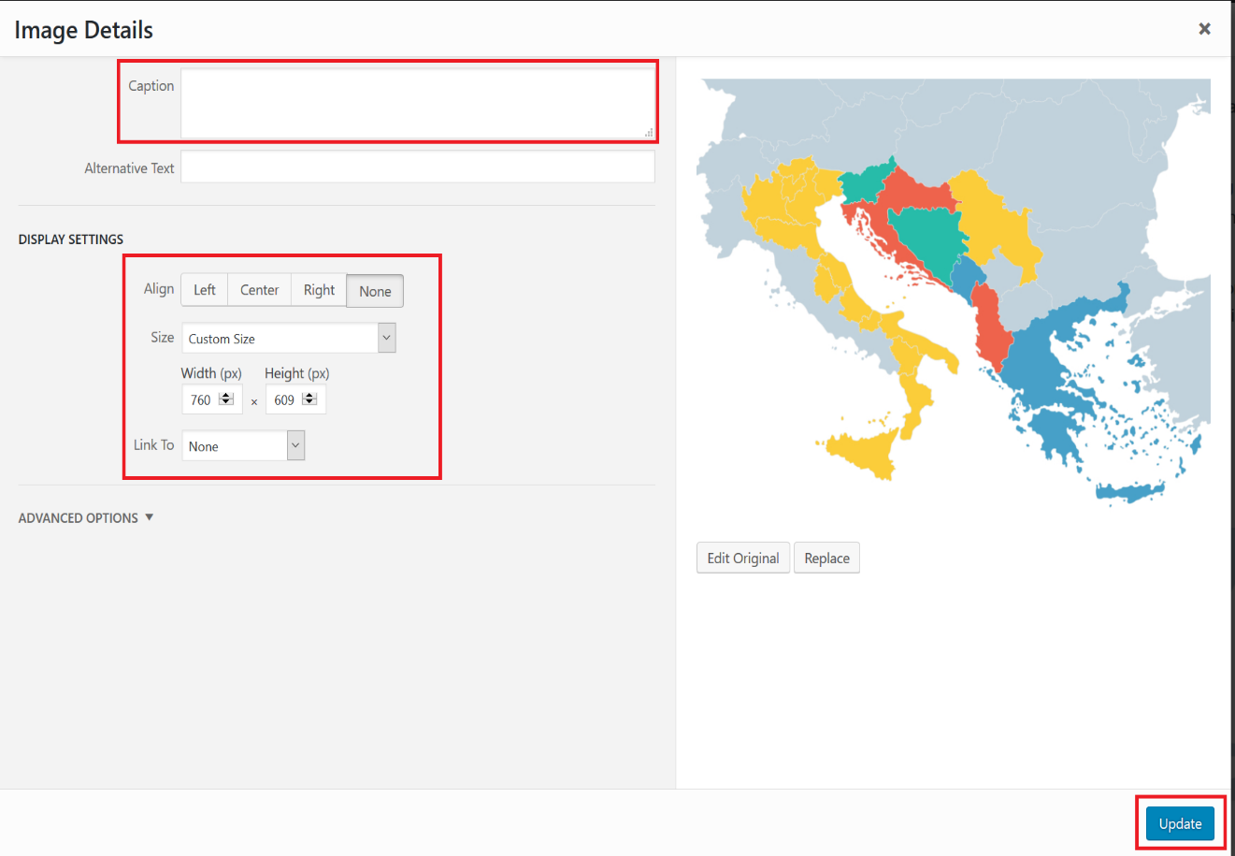
When you are done editing the picture you need to save the changes by clicking Update in the bottom right corner. Then you need to save changes to the text block, by clicking save in the bottom and then update the page in the upper right corner (picture page 5).

Highlights and events
This part of the page is personalized and is where you can show your creativity. It will contain the events you wish to present to your stakeholders, and the highlights you will want to publicize. This part of the national page is meant to be the eye-catcher with graphical presentations and interesting relevant news.

Editing the events
To edit the events, click on the block called TABS.
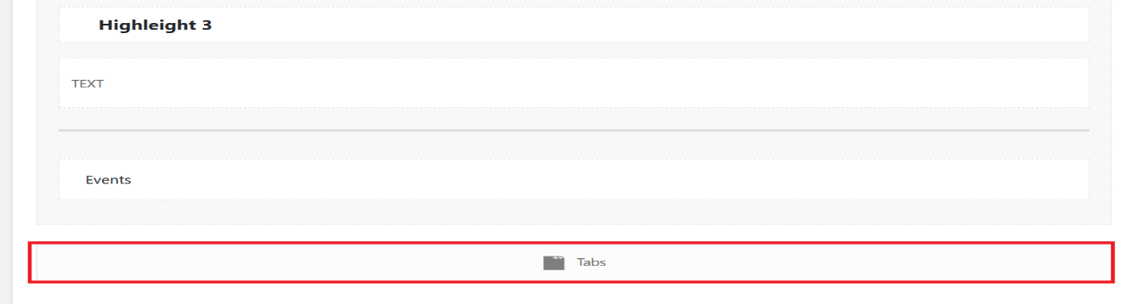
We have prepared three tabs for event information.
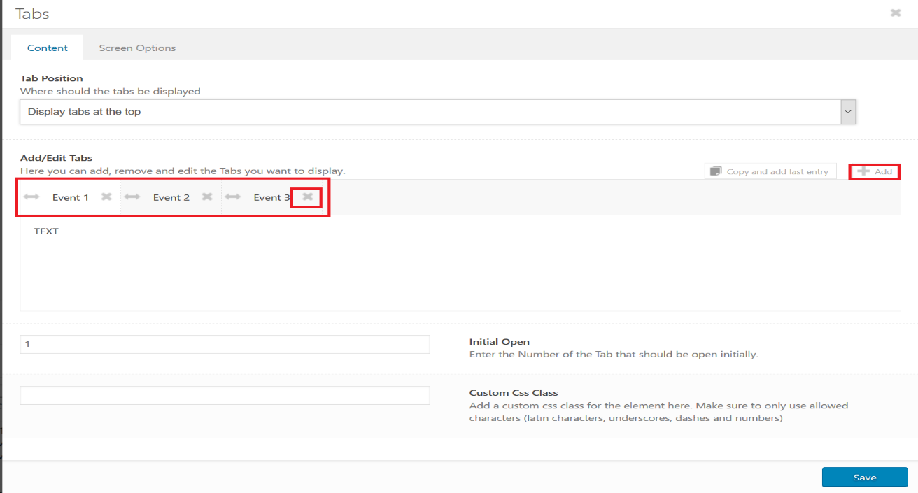
You can add the event by clicking the +ADD sign at the right upper corner. You can delete the event by clicking X.

You can edit the Event by clicking on it.
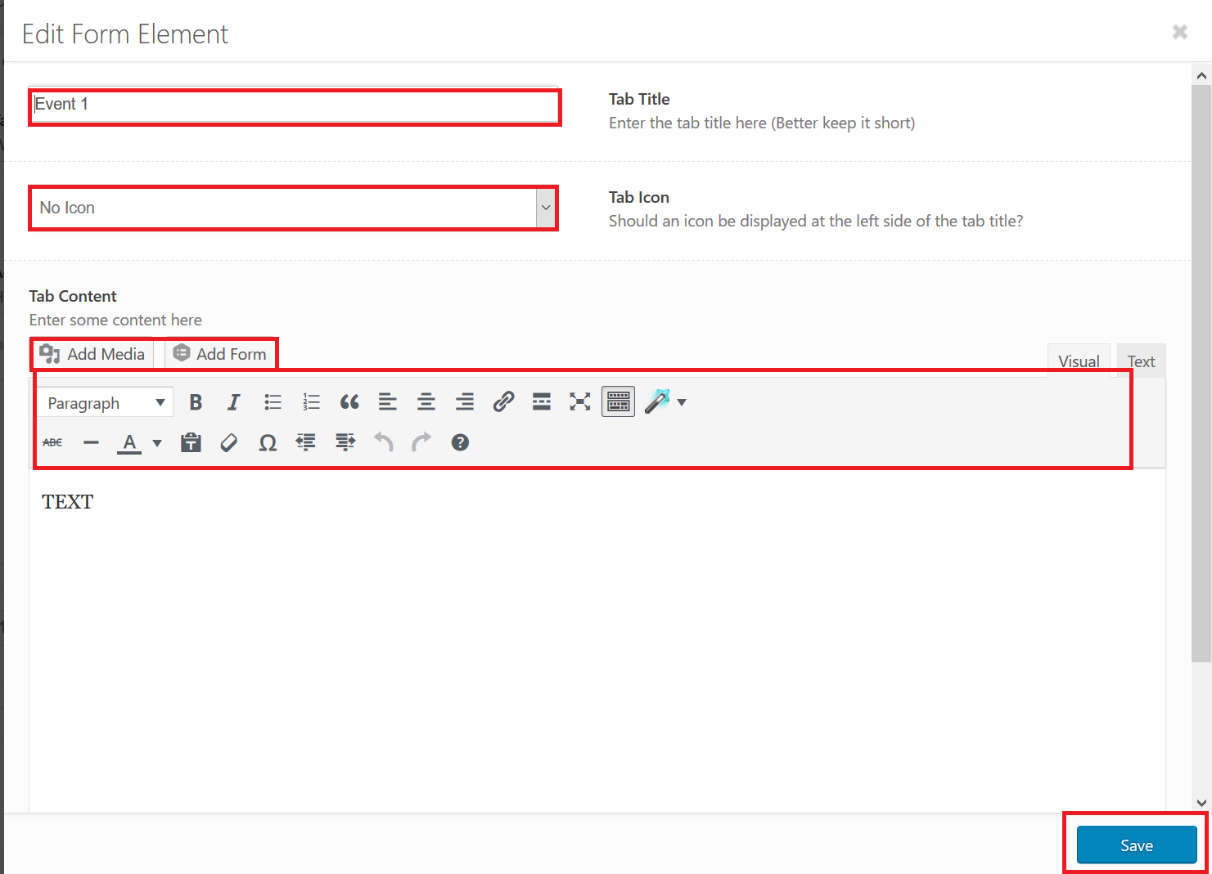
You can set title, icon, add text or media.
When you are done editing the event you need to save your changes by clicking Save at the bottom right corner. Then you need to save changes to the tabs, by clicking save in the bottom and then update the page in the upper right corner (picture page 5).
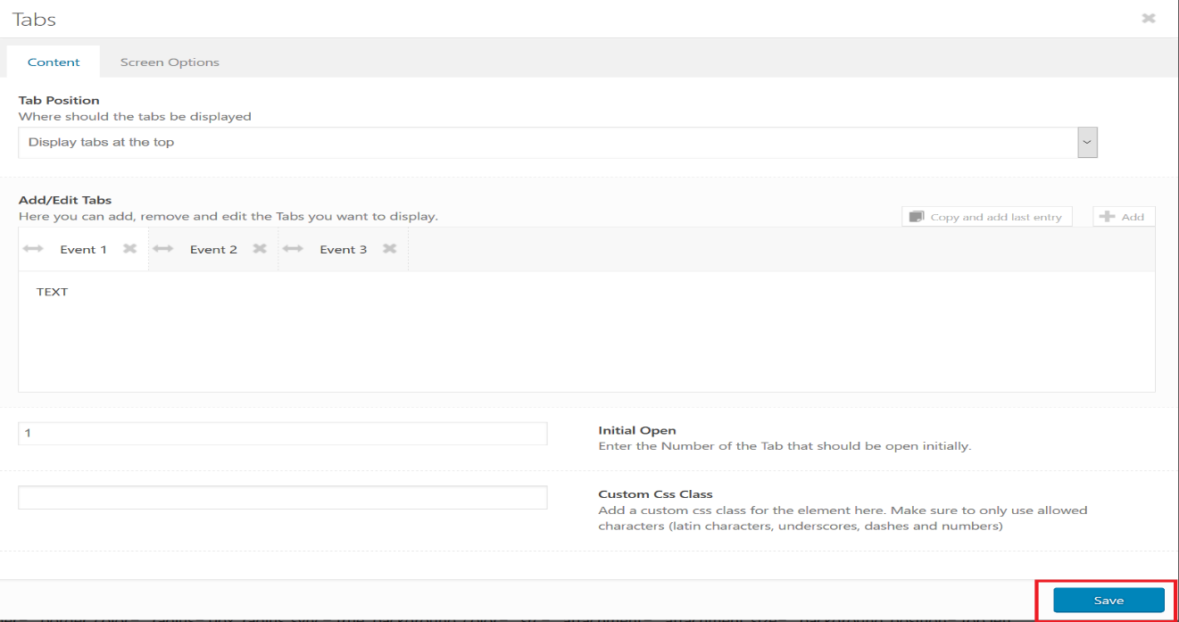
Hope you will enjoy working with national pages. If you have any additional questions my contact information is ajda.starc@gov.si.

