Information Note

Workshop
The Present and the Future of
Sustainable and Responsible Tourism

24 - 25 April 2017
Hotel Palace, Zagreb, Croatia

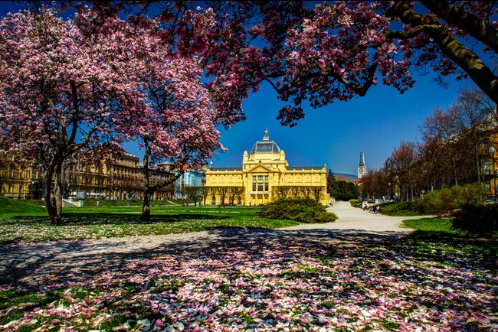

1. Introduction

On the occasion of the International Year of Sustainable Tourism for Development 2017., the workshop on “The Present and Future of Sustainable and Responsible Tourism” aims at sharing expertise and good practise across stakeholders of the Adriatic and Ionian Region. With a strong focus on SMEs, the workshop is rooted on the Sustainable Tourism Pillar (4) of the European Strategy for the region (EUSAIR). Moreover, the workshop shall raise awareness of the potential of tourism to advance the implementation of the Sustainable Development Goals (SDGs), in particular through the Sustainable Tourism Programme of the 10-Year Framework of Programmes on Sustainable Consumption and Production (10YFP STP).

The workshop will take place on Monday, 24 April, starting at 12:00, and on Tuesday, 25 April from 9:00 in the Hotel Palace, Josip Juraj Strossmayer Square 10, 10 000 Zagreb (central located).

2. Registration

Participants are kindly requested to complete the registration form sent with the Information note by Tuesday, 18 April and return it by-email to persons listed below in contact details. In order to help us make the necessary arrangements for transfers, please provide information on your travel schedule.

3. Contact details for any additional information

Ms Blanka Belošević  Head, Department for International Cooperation  The Ministry of Tourism of the Republic of Croatia | Tel.: +385(1) 6169 300  E-mail: blanka.belosevic@mint.hr
Ms Senka Daniel  Head, Unit for Multilateral Cooperation  The Ministry of Tourism of the Republic of Croatia | Tel.: +385(1) 6169 252  E-mail: senka.daniel@mint.hr

4. Workshop programme

The detailed workshop programme and agenda are sent with the Information note. Working languages of the workshop: Croatian and English.

5. Social programme

Atypical Zagreb sightseeing tour normally includes numerous local attractions: central Ban Jelačić Square, the Zagreb Cathedral, Dolac market, the historical core of the city – the Upper Town with St. Mark Church, Croatian Parliament building, The Stone Gate Shrine, Old City Hall, Lotršćak Tower, St. Catherine Church, Furnicular; the Lower Town including Flower Square, Croata Kravata Boutique, Croatian National Theatre, the Zagreb University, Mimara Museum, Croatian State Archives Building, Botanical Gardens, etc.

You are able to join the sightseeing tour on 24 April, starting at 10:30 am., and on 25 April, starting at 4:30 pm.

For those who would want to learn and/or visit more please check the following website: http://www.infozagreb.hr/

6. Accommodation

The rooms will be offered at discounted rates. The participants are requested to make their own reservations by directly contacting the hotels, indicating their status as participants in the workshop. Recommended hotels and reservation instructions are listed below.

Recommended hotels :
- Palace Hotel **** (venue)  Josip Juraj Strossmayer Square 10, 10000 Zagreb  Tel.: +385(1) 4899-600/611  http://www.palace.hr/  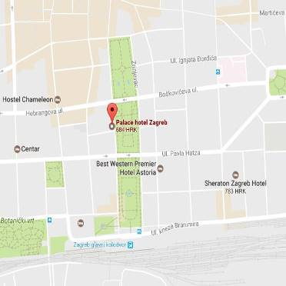  *follow the link to see the enlarged map | Price:  Comfort Single room: 80,00 EUR  Comfort Double room: 95,00 EUR  Superior Single room: 100,00 EUR  Superior Double room: 115,00 EUR
Reservation instruction:

Person is requested to fulfill a registration form (sent with the info note) by 3 April and return it by e-mail: margarita.sikic@palace.hr or fax: +385(1) 4920-530
- Sheraton Hotel *****  Kneza Borne 2, 10 000 Zagreb, Croatia  Tel.: +385(1) 455 3535  http://www.sheratonzagreb.com/hr  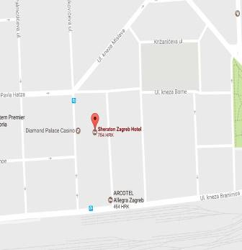  *follow the link to see the enlarged map  Distance from the Sheraton Hotel to the venue (Palace): 1,8 km | Price:  Deluxe Single room: 895 KN  (120,85 EUR)  Deluxe Double room: 1.040 KN (141,00 EUR)
Reservation instruction:

Online: http://www.sheratonzagreb.com/hr
or by phone: +385(1) 455 3535
- reservation code: IY2017

- Dubrovnik Hotel ****  Gajeva 1, 10000 Zagreb, Croatia  Tel.: +385(1) 4863 516/517  https://hotel-dubrovnik.hr/  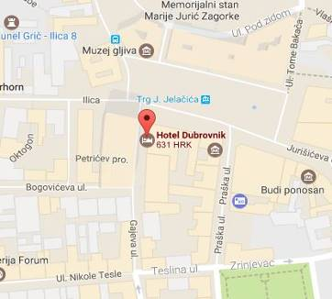  *follow the link to see the enlarged map  Distance from the Dubrovnik Hotel to the venue (Palace): 2,2 km | Price:  Single room: 85,00 EUR  Deluxe single room: 95,00 EUR
Reservation instruction:

Person is requested to fulfill a registration form (sent with the info note) by 20 March and return it by e-mail:
pbaloban@hotel-dubrovnik.hr

Contact for additional questions
Ms Petra Baloban: +385(1) 4863517
- Jadran Hotel ***  Vlaška 50, 10000 Zagreb, Croatia  Tel.: +385(1) 4553 777  www.hoteljadran.com.hr  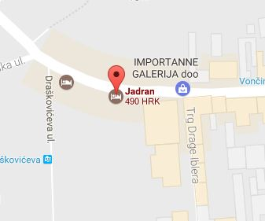  *follow the link to see the enlarged map  Distance from the Jadran Hotel to the venue (Palace): 1,3 km | Price:  Single room: 430 KN (58,00 EUR)  Double room: 520 KN (70,15 EUR)
Reservation instruction:

by phone : +385(1) 4553 777 or by e-mail: jadran@hup-zagreb.hr

- with reference: Ministry of Tourism of the Republic of Croatia

*The rates include breakfast

**The rates do not include tourist tax (1 EUR per person per day)

*Sheraton: free entry to the hotel pool, sauna and fitness centre, free wi-fi
*Dubrovnik Hotel: parking place on request (daily ticket for outdoor parking place: 14,00 EUR)

7. Travel options

By plane | By train | By bus
Zagreb Airport  Tel.: +385 60 32 03 20  info@mzlz-zagreb-airport.hr  http://www.croatiaairlines.com/hr | Railway Station  Trg kralja Tomislava 12  Tel.: +385 60 333 444  informacije@hzpp.hr  www.hzpp.hr | Bus Terminal  Avenija Marina Držića 4  Tel.: +385 60 31 33 33  promet@akz.hr  www.akz.hr
- distance from the Zagreb Airport to the venue (Palace Hotel): cca 18 km  - transfers from the Airport to the Bus Terminal (address: Avenija Marina Držića 4):  Every day at:  7.00 – 8.00 – 8.30 – 9.00 – 9.30 – 10.30 – 11.30 –12.00 – 12.30 – 13.00 – 13.30 – 14.00 – 14.30 – 15.00 – 15.30 – 16.00 – 16.30 – 17.00 – 17.30 – 18.00 – 18.30 – 19.00 – 19.30 – 20.00  *bus ticket is not included in the price of air ticket (price: cca 4 EUR) | - distance from the Railway Station to the venue (Palace Hotel): 1,5 km | - distance from the Bus Terminal to the venue (Palace Hotel): cca 4 km
Taxi
- Ekotaxi
Tel.: +385 1 1414
- Radio Taxi Zagreb
Tel.: +385 1 1717
- Taxi Cammeo
Tel.: +385 1 1212

8. Transfers
The host country will provide the participants with transport service from the airport to the workshop venue.
9. Practical information
- official language: Croatian
- local currency and exchange rates: the official currency of Croatia is the kuna (HRK). The applicable exchange rate as at 15/03/2017: http://www.hnb.hr/temeljne-funkcije/monetarna-politika/tecajna-lista/tecajna-lista
Banks are open from 8:00 to 18:00, Monday to Friday. Exchange offices can be found all around Zagreb, and are clearly marked. ATMs are also widely available around the city. All shops accept major credit cards.
- weather: the temperature ranges between 10 and 22 degrees during the day. A raincoat or an umbrella is also advisable in case of rain.
- medical services: Zagreb has an extensive network of health centres (primary care services) and hospitals. There are no vaccination requirements for international visitors.
- tourist information on Zagreb: http://www.zagreb-touristinfo.hr/

