October 2019
EUSAIR Multimodal Transport Model
Zoning System Technical Note

Prepared for:
EUSAIR Thematic Steering Group2
Table of Content
1. Introduction 1
1.1. Adriatic-Ionian Region Masterplan for Transport Interconnectivity – AIM-TI 1
1.2. EUSAIR Multimodal Transport Model – EMTM 1
2. Zones of the EMTM 3
2.1. EMTM Zoning System 3
2.1.1. Nomenclature of Territorial Units for Statistics (NUTS) 3
2.1.2. Zones of the EMTM 4
2.2. EMTM TAZs by country and their socioeconomic parameters 5
2.2.1. Albania 5
2.2.2. Bosnia and Herzegovina 6
2.2.3. Croatia 8
2.2.4. Greece 9
2.2.5. Italy 11
2.2.6. Kosovo (under United Nations Security Council Resolution 1244/99) 14
2.2.7. Montenegro 15
2.2.8. North Macedonia 16
2.2.9. Serbia 17
2.2.10. Slovenia 18

List of Figures
Figure 1: TAZs of the EMTM in the Adriatic Ionian Region 4
Figure 2: TAZs of the EMTM in Albania 5
Figure 3: TAZs of the EMTM in Bosnia and Herzegovina 6
Figure 4: TAZs of the EMTM in Croatia 8
Figure 5: TAZs of the EMTM in Greece 10
Figure 6: TAZs of the EMTM in Italy 12
Figure 7: TAZs of the EMTM in Kosovo 14
Figure 8: TAZs of the EMTM in Montenegro 15
Figure 9: TAZs of the EMTM in North Macedonia 16
Figure 10: TAZs of the EMTM in Serbia 17
Figure 11: TAZs of the EMTM in Slovenia 19

List of Tables
Table 1: TAZs of the EMTM by country in the Adriatic Ionian Region 4
Table 2: TAZs of the EMTM in Albania and main socioeconomic parameters 5
Table 3: TAZs of the EMTM in Bosnia and Herzegovina and main socioeconomic parameters 7
Table 4: TAZs of the EMTM in Croatia and main socioeconomic parameters 9
Table 5: TAZs of the EMTM in Greece and main socioeconomic parameters 10
Table 6: TAZs of the EMTM in Italy and main socioeconomic parameters 12
Table 7: TAZs of the EMTM in Kosovo and main socioeconomic parameters 14
Table 8: TAZs of the EMTM in Montenegro and main socioeconomic parameters 15
Table 9: TAZs of the EMTM in North Macedonia and main socioeconomic parameters 17
Table 10: TAZs of the EMTM in Serbia and main socioeconomic parameters 18
Table 11: TAZs of the EMTM in Slovenia and main socioeconomic parameters 19

Glossary of abbreviations

ASK | Kosovo Agency of Statistics
BiH | Bosnia and Herzegovina
AIM-TI | Adriatic Ionian Region Masterplan for Transport Interconnectivity
EMTM | EUSAIR Multimodal Transport Model
EU | European Union
FIS | Institute for Statistics of Federation of Bosnia and Herzegovina
GDP | Gross Domestic Product
n.a. | Not available
MONSTAT | Statistical Office of Montenegro
NUTS | Nomenclature of territorial units for statistics (Nomenclature des Unités Territoriales Statistiques)
RSIS | Republika Srpska Institute of Statistics
TAZ | Traffic Analysis Zone
TEN-T | Trans-European Network-Transport
TENtec | European Commission's Information System to coordinate and support the Trans-European Transport Network Policy
TSG2 | Thematic Steering Group of the EUSAIR Transport and Energy Networks Pillar

Country codes after ISO 3166 alpha-2 code
Albania AL
Bosnia and Herzegovina BA
Croatia HR
Greece GR
Italy IT
Kosovo XK
Montenegro ME
North Macedonia MK
Serbia RS
Slovenia SI

Introduction

Adriatic-Ionian Region Masterplan for Transport Interconnectivity – AIM-TI
In order to support the development of the European Union Strategy for the Adriatic and Ionian Regions (EUSAIR) the Transport Subgroup of the Thematic Steering Group of the EUSAIR Transport and Energy Networks Pillar (TSG2) has proposed to develop a Transport Master Plan, i.e. the Adriatic Ionian Region Masterplan for Transport Interconnectivity – AIM-TI.
The AIM-TI is conceived as a tool for the coordinated implementation of the macro-regional strategy in the framework of the EU policies for the Union’s Enlargement and Cooperation with Neighbouring Countries, Territorial Integration and Cohesion, Single European Transport Area. It aims at identifying projects of macro-regional relevance and support their implementation towards a more competitive and resource efficient transport system in the Adriatic-Ionian Region, with a focus on the maritime dimension of the macro-regional transport and economic systems, green and multimodal accessibility to urban, transport and touristic nodes.
As part of the activities for the elaboration of the AIM-TI a transport model will be developed, i.e. the EUSAIR Multimodal Transport Model – EMTM.

EUSAIR Multimodal Transport Model – EMTM
The EMTM is a macrosimulation model based on the CUBE specialised software by Bentley Industries (former Citilabs), that will be used for the description of the existing and future networks of the region and the simulation of the current and forecasted transport flows across them.
The EMTM will be developed as a multimodal tool. It will focus on long-distance flows of both freight and passengers transport; it will simulate rail, road and short sea shipping traffic. In order to develop such a model a number of information and data are required, including a set of socioeconomic information to estimate current and future traffic. Transport models simulate the distribution of traffic and transport flows along networks and routes across territories. The areas covered by transport models are usually disaggregated into subareas, referred to as Traffic Analysis Zones (TAZs). TAZs are used to describe the distribution of Origin and/or Destination of transport flows in the study area. As transport activities are embedded in society traffic flows are estimated based on socioeconomic information processed with reference to TAZs, i.e. population, GDP, employment, motorisation, household structure…The number and size of the TAZs depends on the geographic scale and purposes of the models. As a general praxis for large scale models, TAZs correspond to individual or aggregated statistical units as defined by national or international institutes of statistics.
This technical note describes the system of zones identified for the EMTM and the main socioeconomic parameters associated with them.
The note is assumed to be used for validation and integration purposes by the Transport Subgroup Members of the TSG2.

Zones of the EMTM

EMTM Zoning System
Dedicated to the simulation of transport flows at the international scale in a macro-regional territory, the TAZs of the EMTM generally correspond to the Nomenclature of Territorial Units for Statistics – NUTS 3 zones.

Nomenclature of Territorial Units for Statistics (NUTS)
The Nomenclature of Territorial Units for Statistics (NUTS) is a hierarchical system for dividing up the economic territory of the European Union (EU) for the purpose of collection, development and harmonisation of European regional statistics, socioeconomic analyses of the regions and framing of EU regional polices. Four different levels of units have been defined and used by Eurostat to collect and deliver territorial statistics:
- NUTS 0: covering the entire country;
- NUTS 1: covering major socio-economic regions;
- NUTS 2: covering basic regions for the application of regional polices;
- NUTS 3: covering small regions for specific diagnoses.
Basic principles adopted by the European Union to define the Nomenclature of Territorial Units for Statistics are as follow:
- Principle 1. Population thresholds (for NUTS 3: 150,000 – 800,000). For administrative levels of NUTS, it is sufficient if the average size of the corresponding regions lies within the thresholds; in case of non-administrative levels, each individual region should do so. Exceptions exist however in case of geographical, socio-economic, historical, cultural or environmental circumstances.
Despite the aim of ensuring that regions of comparable size all appear at the same NUTS level, each level still contains regions which differ greatly in terms of population.
- Principle 2. NUTS favours administrative division. For practical reasons the NUTS classification generally mirrors the territorial administrative division of the Member States. This supports the availability of data and the implementation capacity of policy.
- Principle 3. Regular and extraordinary amendments. The NUTS classification can be amended, but generally not more frequently than every three years. The amendments are usually based on changes of the territorial structure in one or more Member States. In case of a substantial reorganisation of the administrative structure of a Member State, amendments to the NUTS may be adopted at intervals of less than three years. This has only happened once so far, in 2014 for Portugal.

Zones of the EMTM
NUTS 3 are available in all EU Member States and candidate countries of the Adriatic Ionian Region, i.e. Albania, Croatia, Greece, Italy, North Macedonia, Serbia, Slovenia. For Montenegro, where only one NUTS 3 is defined, it was decided to divide this unit into smaller units (aggregating data on the basis of information available at the municipal level) that are generally comparable in terms of area with NUTS 3 regions. For Bosnia and Herzegovina and Kosovo TAZs were identified by combining local administrative units, mainly on the basis of geographical, socioeconomic or cultural considerations. The table below lists the TAZs of the EMTM by country in the Adriatic Ionian Region.
Table 1: TAZs of the EMTM by country in the Adriatic Ionian Region
COUNTRY | CODE | NUMBER OF ZONES
Albania | AL | 12
Bosnia and Herzegovina | BA | 18
Croatia | HR | 21
Greece | EL | 52
Italy | IT | 69
Kosovo | XK | 7
Montenegro | ME | 8
North Macedonia | MK | 8
Serbia | RS | 25
Slovenia | SI | 12
TOTAL |  | 232
Source: Authors, based on Eurostat and National Statistics
Figure 1: TAZs of the EMTM in the Adriatic Ionian Region
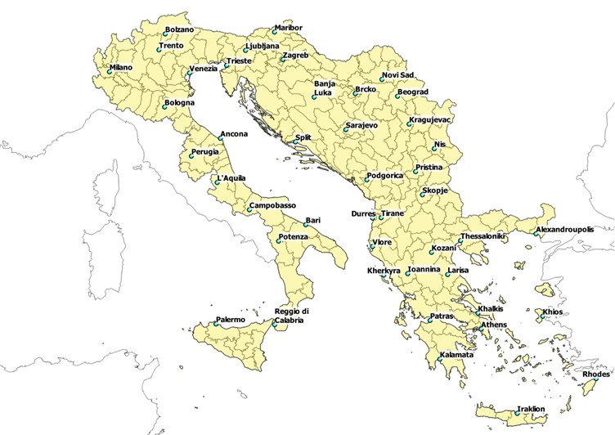
Source: Authors, based on Eurostat and National Statistics
Overall 232 TAZs have been identified for the EMTM in the Adriatic Ionian Region, which are graphically represented in the map above.

EMTM TAZs by country and their socioeconomic parameters

Albania
The zoning system of the EMTM in Slovenia has been developed on the basis of the following basic principles:
- Zoning level of detail: NUTS 3;
- Corresponding administrative unit: counties of Albania;
- Data source: Eurostat.
The map in the following figure represents the TAZs of the EMTM in Albania.
Figure 2: TAZs of the EMTM in Albania
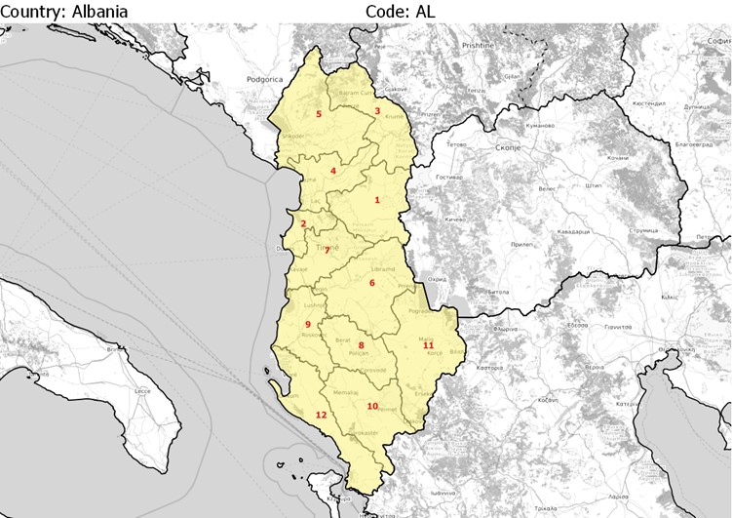
Source: Authors, based on Eurostat
The correspondence table between EMTM TAZs and statistical units in Albania is provided below, together with the main socioeconomic parameters.
Table 2: TAZs of the EMTM in Albania and main socioeconomic parameters
 | TAZ | NUTS3 | NAME | POPULATION | GDP | EMPLOYEES
AL | 1 | AL011 | Diber | 125,579 | 372 | n.a.
AL | 2 | AL012 | Durres | 284,823 | 1,148 | n.a.
AL | 3 | AL013 | Kukes | 79,559 | 191 | n.a.
AL | 4 | AL014 | Lezhe | 129,019 | 383 | n.a.
AL | 5 | AL015 | Shkoder | 207,924 | 600 | n.a.
AL | 6 | AL021 | Elbasan | 283,822 | 791 | n.a.
AL | 7 | AL022 | Tirana | 862,361 | 4,866 | n.a.
AL | 8 | AL031 | Berat | 131,942 | 437 | n.a.
AL | 9 | AL032 | Fier | 302,507 | 1,246 | n.a.
AL | 10 | AL033 | Gjirokaster | 65,939 | 263 | n.a.
AL | 11 | AL034 | Korce | 214,321 | 638 | n.a.
AL | 12 | AL035 | Vlore | 188,795 | 641 | n.a.
Source: Authors, based on Eurostat; Notes: population data refer to 2017, GDP data in million EUR (current market prices 2017) refer to 2017, employment data are not available

Bosnia and Herzegovina
The zoning system of the EMTM in Bosnia and Herzegovina has been developed on the basis of the following basic principles:
- Zoning level of detail: comparable to NUTS 3;
- Corresponding administrative unit: cantons of Bosnia and Herzegovina Federation, autonomous Brcko District, statistical regions of Republika Srpska (aggregation of municipalities of Republika Srpska);
- Data source: Institute for Statistics of Federation of BiH/FIS, Institute for Statistics of Republika Srpska/RSIS.
The map in the following figure represents the TAZs of the EMTM in Bosnia and Herzegovina.
Figure 3: TAZs of the EMTM in Bosnia and Herzegovina
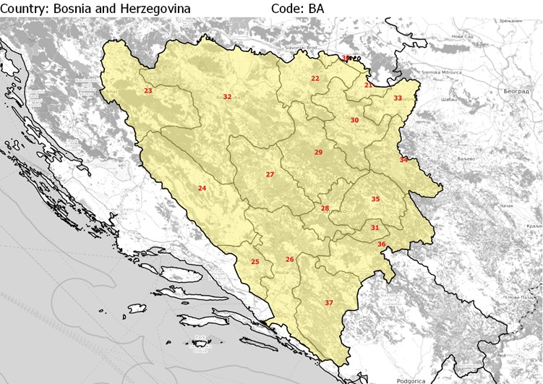
Source: Authors, based on Institute for Statistics of Federation of BiH/FIS, Institute for Statistics of Republika Srpska/RSIS
The correspondence table between EMTM TAZs and statistical units in Bosnia and Herzegovina is provided below, together with the main socioeconomic parameters.
Table 3: TAZs of the EMTM in Bosnia and Herzegovina and main socioeconomic parameters
COUNTRY | TAZ | NUTS3 | NAME | AGGREGATED MUNICIPALITIES | POPULATION | GDP | EMPLOYEES
BA | 21 | n.a. | Brcko District | - | 93,028 | n.a. | n.a.
BA | 22 | n.a. | Doboj | Brod, Vukosavlje, Derventa, Grad Doboj, Donji Zabar, Modrica, Pelagicevo, Petrovo, Stanari, Samac | 165,508 | n.a. | n.a.
BA | 23 | n.a. | Unsko-sanski kanton | - | 299,343 | n.a. | n.a.
BA | 24 | n.a. | Kanton 10 | - | 90,727 | n.a. | n.a.
BA | 25 | n.a. | Zapadno-hercegovacki kanton | - | 97,893 | n.a. | n.a.
BA | 26 | n.a. | Hercegovacko-neretvanski kanton | - | 236,278 | n.a. | n.a.
BA | 27 | n.a. | Srednjobosanski kanton | - | 273,149 | n.a. | n.a.
BA | 28 | n.a. | Kanton Sarajevo | - | 438,443 | n.a. | n.a.
BA | 29 | n.a. | Zenicko-dobojski kanton | - | 385,067 | n.a. | n.a.
BA | 30 | n.a. | Tuzlanski kanton | - | 477,278 | n.a. | n.a.
BA | 31 | n.a. | Bosansko-podrinjski kanton | - | 25,336 | n.a. | n.a.
BA | 32 | n.a. | Banja Luka | Grad Banja Luka, Gradiska, Istocni Drvar, Jezero, Knezevo, Kozarska Dubica, Kostajnica, Kotor Varos, Krupa na Uni, Kupres, Mrkonjic Grad, Novi Grad, Ostra Luka, Petrovac, Grad Prijedor, Prnjavor, Ribnik, Srbac, Teslic, Celinac, Sipovo | 524361 | n.a. | n.a.
BA | 33 | n.a. | Bijeljina | Grad Bijeljina, Lopare, Ugljevik | 132,343 | n.a. | n.a.
BA | 34 | n.a. | Zvornik | Bratunac, Vlasenica, Grad Zvornik, Laktasi, Milici, Osmaci, Srebrenica, Sekovici | 149,817 | n.a. | n.a.
BA | 35 | n.a. | Sokolac | Grad Istocno Sarajevo, Han Pisejak | 63,444 | n.a. | n.a.
BA | 36 | n.a. | Foca | Visegrad, Kalinovik, Novo Gorazde, Rogatica, Rudo, Foca, Cajinice | 52,959 | n.a. | n.a.
BA | 37 | n.a. | Trebinje | Berkovici, Bileca, Gacko, Istocni Mostar, Ljubinje, Nevesinje, Grad Trebinje | 64,585 | n.a. | n.a.
BA | 38 | n.a. | Posavski kanton | - | 48,089 | n.a. | n.a.
Source: Authors, based on Institute for Statistics of Federation of BiH/FIS, Institute for Statistics of Republika Srpska/RSIS; Notes: population data refer to 2013 for Federation of Bosnia and Herzegovina and for Brcko District and to 2017 for Republika Srpska, GDP and employment data are not available

Croatia
The zoning system of the EMTM in Croatia has been developed on the basis of the following basic principles:
- Zoning level of detail: NUTS 3;
- Corresponding administrative unit: counties of Croatia;
- Data source: Eurostat.
The map in the following figure represents the TAZs of the EMTM in Croatia.
Figure 4: TAZs of the EMTM in Croatia
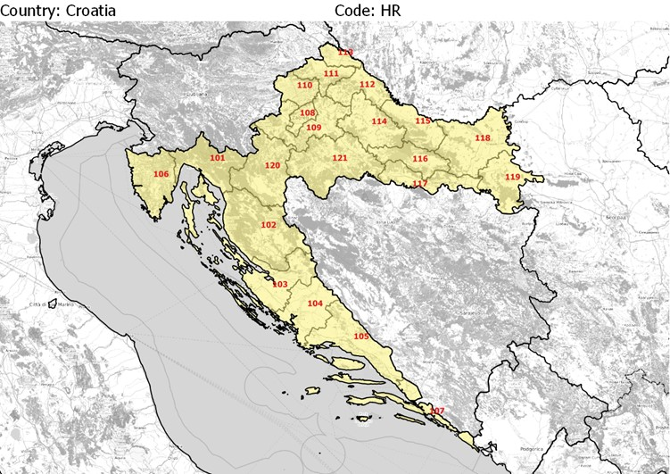
Source: Authors, based on Eurostat
The correspondence table between EMTM TAZs and statistical units in Croatia is provided below, together with the main socioeconomic parameters.
Table 4: TAZs of the EMTM in Croatia and main socioeconomic parameters
COUNTRY | TAZ | NUTS3 | NAME | POPULATION | GDP | EMPLOYEES
HR | 101 | HR031 | Primorsko-goranska zupanija | 288,328 | 3,874 | 104,500
HR | 102 | HR032 | Licko-senjska zupanija | 46,485 | 400 | 12,799
HR | 103 | HR033 | Zadarska zupanija | 169,306 | 1,544 | 42,280
HR | 104 | HR034 | Sibensko-knisnska zupanija | 102,238 | 902 | 27,480
HR | 105 | HR035 | Splitsko-dalmatinska zupanija | 451,226 | 3,910 | 131,640
HR | 106 | HR036 | Istarska zupanija | 208,109 | 2,936 | 75,340
HR | 107 | HR037 | Dubrovacko-neretvanska zupanija | 121,671 | 1,374 | 37,190
HR | 108 | HR041 | Grad Zagreb | 803,647 | 15,677 | 412,370
HR | 109 | HR042 | Zagrebacka zupanija | 313,072 | 2,700 | 74,130
HR | 110 | HR043 | Krapinsko-zagorska zupanija | 127,060 | 951 | 32,920
HR | 111 | HR044 | Varazdinska zupanija | 169,805 | 1,619 | 58,660
HR | 112 | HR045 | Koprivnicko zupanija | 110,129 | 1,018 | 29,110
HR | 113 | HR046 | Medimurska zupanija | 111,669 | 1,068 | 35,390
HR | 114 | HR047 | Bjelovarsko-bilogorska zupanija | 110,841 | 861 | 28,390
HR | 115 | HR048 | Viroviticko-podravska zupanija | 78,239 | 489 | 18,140
HR | 116 | HR049 | Pozesko-slavonska zupanija | 70,937 | 456 | 17,310
HR | 117 | HR04A | Brodsko-posavska zupanija | 146,288 | 931 | 32,790
HR | 118 | HR04B | Osjecko-barnjska zupanija | 287,124 | 2,559 | 83,640
HR | 119 | HR04C | Vukovarsko-srijemska zupanija | 163,324 | 1,086 | 39,080
HR | 120 | HR04D | Karlovacka zupanija | 119,464 | 1,023 | 35,110
HR | 121 | HR04E | Sisacko-moslavacka zupanija | 155,251 | 1,262 | 40,550
Source: Authors, based on Eurostat; Notes: population data refer to 2017, GDP data in million EUR (current market prices 2017) refer to 2016 and employees data refer to 2016

Greece
The zoning system of the EMTM in Greece has been developed on the basis of the following basic principles:
- Zoning level of detail: NUTS 3;
- Corresponding administrative unit: regional units or combinations thereof;
- Data source: Eurostat.
The map in the following figure represents the TAZs of the EMTM in Greece.
Figure 5: TAZs of the EMTM in Greece
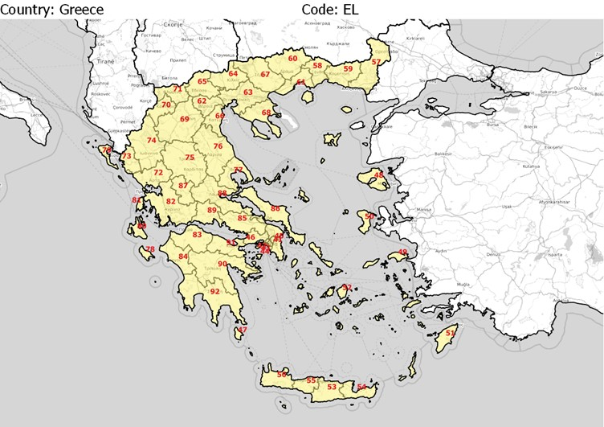
Source: Authors, based on Eurostat
The correspondence table between EMTM TAZs and statistical units in Greece is provided below, together with the main socioeconomic parameters.
Table 5: TAZs of the EMTM in Greece and main socioeconomic parameters
COUNTRY | TAZ | NUTS3 | NAME | POPULATION | GDP | EMPLOYEES
EL | 41 | EL301 | Voreios Tomeas Athinon | 586,621 | 14,894 | 212,260
EL | 42 | EL302 | Dytikos Tomeas Athinon | 484,628 | 5,472 | 90,180
EL | 43 | EL303 | Kentrikos Tomeas Athinon | 924,917 | 29,871 | 450,080
EL | 44 | EL304 | Notios Tomeas Athinon | 531,739 | 9,723 | 136,260
EL | 45 | EL305 | Anatoliki Attiki | 561,097 | 10,518 | 154,520
EL | 46 | EL306 | Dytiki Attiki | 178,703 | 4,066 | 65,650
EL | 47 | EL307 | Peiraias, Nisoi | 505,854 | 9,328 | 148,130
EL | 48 | EL411 | Lesvos, Limnos | 106,184 | 1,279 | 17,670
EL | 49 | EL412 | Ikaria, Samos | 43,523 | 532 | 8,670
EL | 50 | EL413 | Chios | 53,993 | 644 | 12,240
EL | 51 | EL421 | Kalymnos, Karpathos, Kos, Rodos | 211,425 | 3,230 | 61,250
EL | 52 | EL422 | Andros, Thira, Kea, Milos, Mykonos, Naxos, Paros, Syros, Tinos | 126,958 | 2,751 | 29,300
EL | 53 | EL431 | Irakleio | 311,640 | 4,215 | 78,840
EL | 54 | EL432 | Lasithi | 74,463 | 1,115 | 13,590
EL | 55 | EL433 | Rethymni | 87,482 | 1,174 | 18,090
EL | 56 | EL434 | Chania | 159,089 | 2,228 | 39,720
EL | 57 | EL511 | Evros | 147,709 | 1,833 | 32,490
EL | 58 | EL512 | Xanthi | 112,112 | 1,124 | 22,470
EL | 59 | EL513 | Rodopi | 111,731 | 1,122 | 19,240
EL | 60 | EL514 | Drama | 96,836 | 1,015 | 14,470
EL | 61 | EL515 | Thasos, Kavala | 134,411 | 1,808 | 27,599
EL | 62 | EL521 | Imathia | 141,517 | 1,532 | 24,160
EL | 63 | EL522 | Thessaloniki | 1,108,085 | 15,552 | 302,800
EL | 64 | EL523 | Kilkis | 80,762 | 918 | 13,020
EL | 65 | EL524 | Pella | 138,583 | 1,572 | 22,480
EL | 66 | EL525 | Pieria | 131,388 | 1,421 | 20,670
EL | 67 | EL526 | Serres | 169,242 | 1,678 | 20,800
EL | 68 | EL527 | Chalkidiki | 110,545 | 1,565 | 12,190
EL | 69 | EL531 | Grevena, Kozani | 173,569 | 2,552 | 33,370
EL | 70 | EL532 | Kastoria | 47,723 | 517 | 8,430
EL | 71 | EL533 | Florina | 50,196 | 847 | 9,459
EL | 72 | EL541 | Arta, Preveza | 122,687 | 1,414 | 23,230
EL | 73 | EL542 | Thesprotia | 45,131 | 532 | 7,080
EL | 74 | EL543 | Ioannina | 167,432 | 2,013 | 36,310
EL | 75 | EL611 | Karditsa, Trikala | 238,594 | 2,545 | 40,570
EL | 76 | EL612 | Larisa | 282,542 | 4,070 | 67,530
EL | 77 | EL613 | Magnisia, Sporades | 204,738 | 2,599 | 36,410
EL | 78 | EL621 | Zakynthos | 39,938 | 722 | 12,010
EL | 79 | EL622 | Kerkyra | 102,613 | 1,548 | 23,160
EL | 80 | EL623 | Ithaki, Kefallinia | 38,945 | 566 | 4,570
EL | 81 | EL624 | Lefkada | 23,935 | 288 | 4,090
EL | 82 | EL631 | Aitoloakarnania | 204,159 | 2,360 | 34,280
EL | 83 | EL632 | Achaia | 303,224 | 3,956 | 63,970
EL | 84 | EL633 | Ileia | 156,587 | 1,716 | 28,810
EL | 85 | EL641 | Voiotia | 121,004 | 2,509 | 32,299
EL | 86 | EL642 | Evvoia | 212,764 | 2,836 | 36,030
EL | 87 | EL643 | Evrytania | 19,285 | 198 | 4,090
EL | 88 | EL644 | Fthiotida | 160,278 | 2,196 | 37,360
EL | 89 | EL645 | Fokida | 42,430 | 446 | 7,010
EL | 90 | EL651 | Argolida, Arkadia | 180,508 | 2,790 | 36,640
EL | 91 | EL652 | Korinthia | 148,540 | 2,006 | 29,349
EL | 92 | EL653 | Lakonia, Messinia | 250,134 | 3,081 | 48,150
Source: Authors, based on Eurostat; Notes: population data refer to 2017, GDP data in million EUR (current market prices 2017) refer to 2016 and employees data refer to 2016

Italy
The zoning system of the EMTM in Italy has been developed on the basis of the following basic principles:
- Zoning level of detail: NUTS 3;
- Corresponding administrative unit: provinces of Italy;
- Data source: Eurostat.
The map in the following figure represents the TAZs of the EMTM in Italy.
Figure 6: TAZs of the EMTM in Italy
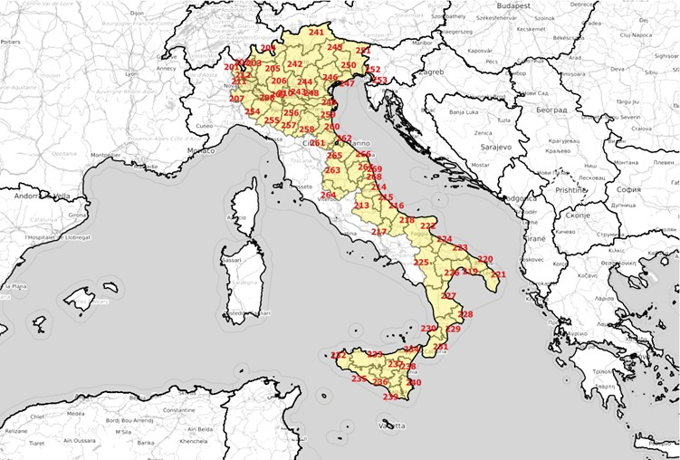
Source: Authors, based on Eurostat
The correspondence table between EMTM TAZs and statistical units in Italy is provided below, together with the main socioeconomic parameters.
Table 6: TAZs of the EMTM in Italy and main socioeconomic parameters
COUNTRY | TAZ | NUTS3 | NAME | POPULATION | GDP | EMPLOYEES
IT | 201 | ITC41 | Varese | 890,043 | 25,567 | 267,000
IT | 202 | ITC42 | Como | 600,190 | 16,505 | 174,100
IT | 203 | ITC43 | Lecco | 339,238 | 10,075 | 100,800
IT | 204 | ITC44 | Sondrio | 181,437 | 5,234 | 61,200
IT | 205 | ITC46 | Bergamo | 1,109,933 | 34,805 | 374,800
IT | 206 | ITC47 | Brescia | 1,262,678 | 40,666 | 418,000
IT | 207 | ITC48 | Pavia | 547,251 | 13,024 | 133,600
IT | 208 | ITC49 | Lodi | 229,338 | 5,999 | 61,400
IT | 209 | ITC4A | Cremona | 359,388 | 10,725 | 103,800
IT | 210 | ITC4B | Mantova | 412,610 | 12,602 | 137,200
IT | 211 | ITC4C | Milano | 3,218,201 | 168,419 | 1,561,700
IT | 212 | ITC4D | Monza e della Brianza | 868,859 | 25,699 | 252,500
IT | 213 | ITF11 | L'Aquila | 301,910 | 7,260 | 85,400
IT | 214 | ITF12 | Teramo | 309,859 | 7,183 | 90,500
IT | 215 | ITF13 | Pescara | 321,309 | 7,750 | 83,800
IT | 216 | ITF14 | Chieti | 389,169 | 9,608 | 118,100
IT | 217 | ITF21 | Isernia | 85,805 | 1,648 | 19,500
IT | 218 | ITF22 | Campobasso | 224,644 | 4,445 | 54,900
IT | 219 | ITF43 | Taranto | 583,479 | 10,297 | 141,799
IT | 220 | ITF44 | Brindisi | 397,083 | 7,027 | 92,400
IT | 221 | ITF45 | Lecce | 802,082 | 12,718 | 171,700
IT | 222 | ITF46 | Foggia | 628,556 | 10,874 | 140,400
IT | 223 | ITF47 | Bari | 1,260,142 | 26,534 | 348,300
IT | 224 | ITF48 | Barletta-Andria-Trani | 392,546 | 6,046 | 86,700
IT | 225 | ITF51 | Potenza | 370,680 | 8,484 | 96,900
IT | 226 | ITF52 | Matera | 199,685 | 3,406 | 46,699
IT | 227 | ITF61 | Cosenza | 711,739 | 11,071 | 152,600
IT | 228 | ITF62 | Crotone | 175,566 | 2,741 | 37,300
IT | 229 | ITF63 | Catanzaro | 362,343 | 6,862 | 97,300
IT | 230 | ITF64 | Vibo Valentia | 161,619 | 2,465 | 33,700
IT | 231 | ITF65 | Reggio di Calabria | 553,861 | 9,760 | 126,300
IT | 232 | ITG11 | Trapani | 434,476 | 6,768 | 89,500
IT | 233 | ITG12 | Palermo | 1,268,217 | 23,046 | 281,600
IT | 234 | ITG13 | Messina | 636,653 | 11,099 | 145,400
IT | 235 | ITG14 | Agrigento | 442,049 | 6,521 | 88,400
IT | 236 | ITG15 | Caltanissetta | 269,710 | 4,123 | 56,500
IT | 237 | ITG16 | Enna | 168,052 | 2,598 | 32,500
IT | 238 | ITG17 | Catania | 1,113,303 | 19,679 | 259,200
IT | 239 | ITG18 | Ragusa | 321,359 | 5,551 | 83,200
IT | 240 | ITG19 | Siracusa | 402,822 | 7,640 | 95,300
IT | 241 | ITH10 | Bolzano-Bozen | 524,256 | 22,101 | 215,700
IT | 242 | ITH20 | Trento | 538,604 | 18,885 | 193,700
IT | 243 | ITH31 | Verona | 921,557 | 30,486 | 323,900
IT | 244 | ITH32 | Vicenza | 865,082 | 28,367 | 300,800
IT | 245 | ITH33 | Belluno | 205,781 | 6,788 | 71,200
IT | 246 | ITH34 | Treviso | 885,972 | 28,140 | 298,000
IT | 247 | ITH35 | Venezia | 854,275 | 26,594 | 284,500
IT | 248 | ITH36 | Padova | 936,274 | 31,245 | 331,300
IT | 249 | ITH37 | Rovigo | 238,588 | 6,104 | 67,600
IT | 250 | ITH41 | Pordenone | 312,051 | 9,382 | 106,800
IT | 251 | ITH42 | Udine | 531,466 | 15,811 | 177,400
IT | 252 | ITH43 | Gorizia | 139,673 | 3,817 | 44,400
IT | 253 | ITH44 | Trieste | 234,682 | 7,966 | 87,300
IT | 254 | ITH51 | Piacenza | 286,758 | 8,982 | 98,100
IT | 255 | ITH52 | Parma | 448,899 | 16,125 | 171,700
IT | 256 | ITH53 | Reggio nell'Emilia | 532,483 | 18,495 | 181,800
IT | 257 | ITH54 | Modena | 700,862 | 26,474 | 259,200
IT | 258 | ITH55 | Bologna | 1,009,210 | 39,825 | 404,600
IT | 259 | ITH56 | Ferrara | 348,362 | 9,270 | 98,100
IT | 260 | ITH57 | Ravenna | 391,414 | 12,367 | 127,900
IT | 261 | ITH58 | Forli -Cesena | 394,067 | 12,385 | 130,300
IT | 262 | ITH59 | Rimini | 336,786 | 9,846 | 104,700
IT | 263 | ITI21 | Perugia | 660,690 | 16,478 | 202,400
IT | 264 | ITI22 | Terni | 228,218 | 5,086 | 61,600
IT | 265 | ITI31 | Pesaro e Urbino | 360,711 | 9,555 | 111,899
IT | 266 | ITI32 | Ancona | 474,124 | 13,932 | 162,200
IT | 267 | ITI33 | Macerata | 318,921 | 8,019 | 90,300
IT | 268 | ITI34 | Ascoli Piceno | 209,450 | 5,247 | 58,300
IT | 269 | ITI35 | Fermo | 174,849 | 4,332 | 49,100
Source: Authors, based on Eurostat; Notes: population data refer to 2017, GDP data in million EUR (current market prices) refer to 2016 and employees data refer to 2016

Kosovo
The zoning system of the EMTM in Kosovo has been developed on the basis of the following basic principles:
- Zoning level of detail: comparable to NUTS 3;
- Corresponding administrative unit: UNMIK’s districts of Kosovo;
- Data source: Kosovo Agency of Statistics (ASK).
The map in the following figure represents the TAZs of the EMTM in Kosovo.
Figure 7: TAZs of the EMTM in Kosovo
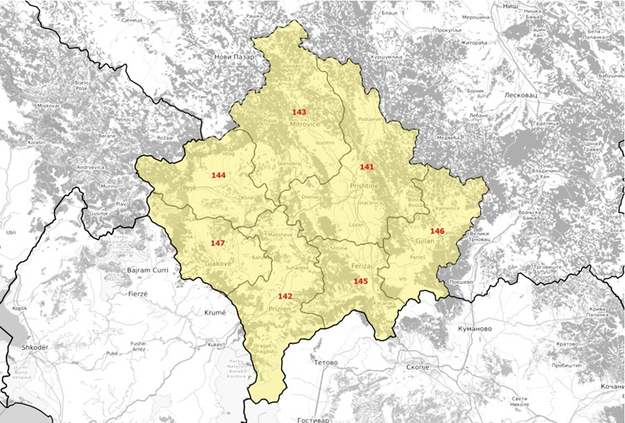
Source: Authors, based on Kosovo Agency of Statistics
The correspondence table between EMTM TAZs and statistical units in Kosovo is provided below, together with the main socioeconomic parameters.
Table 7: TAZs of the EMTM in Kosovo and main socioeconomic parameters
COUNTRY | TAZ | NUTS3 | NAME | POPULATION | GDP | EMPLOYEES
XK | 141 | n.a. | Pristina | 484,517 | n.a. | n.a.
XK | 142 | n.a. | Prizren | 347,506 | n.a. | n.a.
XK | 143 | n.a. | Kosovksa Mitrovica | 225,212 | n.a. | n.a.
XK | 144 | n.a. | Pec | 178,326 | n.a. | n.a.
XK | 145 | n.a. | Ferizaj | 179,245 | n.a. | n.a.
XK | 146 | n.a. | Gjilani | 166,212 | n.a. | n.a.
Source: Authors, based on Kosovo Agency of Statistics; Notes: population data refer to 2016, GDP and employment data are not available

Montenegro
The zoning system of the EMTM in Montenegro has been developed on the basis of the following basic principles:
- Zoning level of detail: comparable to NUTS 3;
- Corresponding administrative unit: aggregation of municipalities of Montenegro;
- Data source: Statistical Office of Montenegro (MONSTAT).
The map in the following figure represents the TAZs of the EMTM in Montenegro.
Figure 8: TAZs of the EMTM in Montenegro
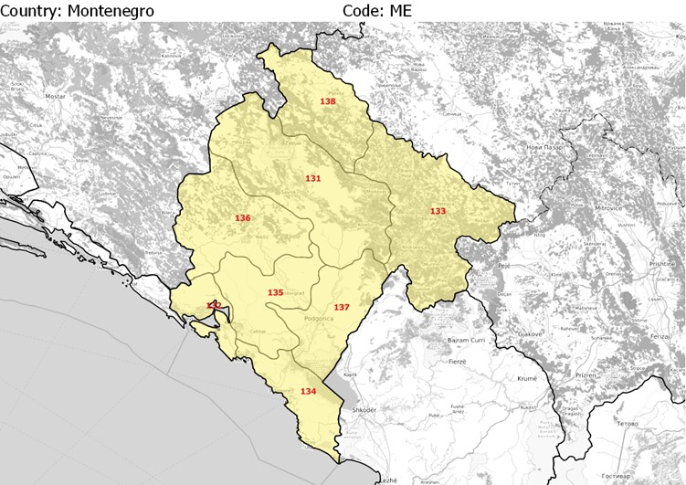
Source: Authors, based on Statistical Office of Montenegro
The correspondence table between EMTM TAZs and statistical units in Montenegro is provided below, together with the main socioeconomic parameters.
Table 8: TAZs of the EMTM in Montenegro and main socioeconomic parameters
COUNTRY | TAZ | NUTS3 | NAME | AGGREGATED MUNICIPALITIES | POPULATION | GDP | EMPLOYEES
ME | 131 | n.a. | Mojkovac | Savnik, Kolasin, Mojkovac, Pluzine, Zabljak | 23,274 | n.a. | n.a.
ME | 132 | n.a. | Kotor - Herceg Novi | Kotor, Herceg Novi, Tivat | 68,115 | n.a. | n.a.
ME | 133 | n.a. | Bijelo Polje | Gusinje, Rozaje, Andrijevica, Berane, Bijelo Polje | 116,520 | n.a. | n.a.
ME | 134 | n.a. | Bar | Ulcinj, Bar, Budva | 84,781 | n.a. | n.a.
ME | 135 | n.a. | Danilovgrad | Cetinje, Danilovgrad | 33,928 | n.a. | n.a.
ME | 136 | n.a. | Niksic | - | 70,042 | n.a. | n.a.
ME | 137 | n.a. | Podgorica | - | 197,589 | n.a. | n.a.
ME | 138 | n.a. | Pljevlja | - | 28,124 | n.a. | n.a.
Source: Authors, based on Statistical Office of Montenegro; Notes: population data refer to 2017, GDP and employment data are not available

North Macedonia
The zoning system of the EMTM in North Macedonia has been developed on the basis of the following basic principles:
- Zoning level of detail: NUTS 3;
- Corresponding administrative unit: statistical regions of North Macedonia;
- Data source: Eurostat.
The map in the following figure represents the TAZs of the EMTM in North Macedonia.
Figure 9: TAZs of the EMTM in North Macedonia
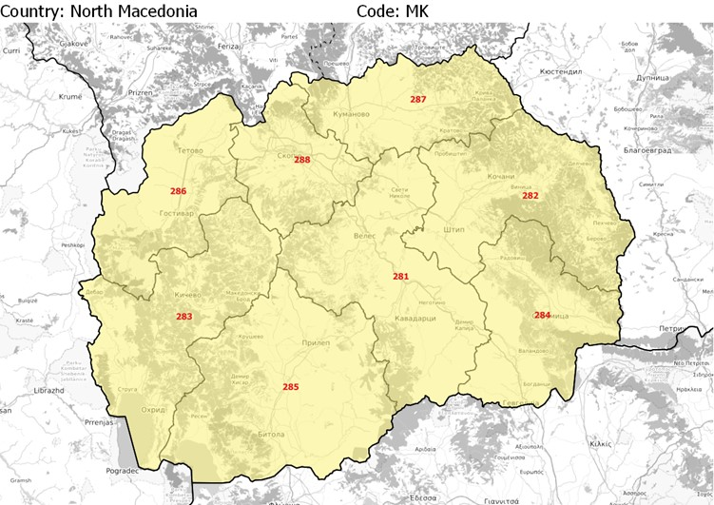
Source: Authors, based on Eurostat
The correspondence table between EMTM TAZs and statistical units in North Macedonia is provided below, together with the main socioeconomic parameters.

Table 9: TAZs of the EMTM in North Macedonia and main socioeconomic parameters
COUNTRY | TAZ | NUTS3 | NAME | POPULATION | GDP | EMPLOYEES
MK | 281 | MK001 | Vardarski | 152,569 | 750 | 43,520
MK | 282 | MK002 | Istocen | 176,261 | 763 | 58,040
MK | 283 | MK003 | Jugozapaden | 219,729 | 792 | 48,340
MK | 284 | MK004 | Jugoistocen | 173,517 | 963 | 46,880
MK | 285 | MK005 | Pelagoniski | 229,993 | 1,056 | 64,879
MK | 286 | MK006 | Poloski | 320,765 | 690 | 52,540
MK | 287 | MK007 | Severoistocen | 176,127 | 481 | 33,060
MK | 288 | MK008 | Skopski | 624,522 | 4,161 | 210,850
Source: Authors, based on Eurostat; Notes: population data refer to 2017, GDP data in million EUR (current market prices 2017) refer to 2016 and employees data refer to 2016

Serbia
The zoning system of the EMTM in Serbia has been developed on the basis of the following basic principles:
- Zoning level of detail: NUTS 3;
- Corresponding administrative unit: districts of Serbia;
- Data source: Eurostat.
The map in the following figure represents the TAZs of the EMTM in Serbia.
Figure 10: TAZs of the EMTM in Serbia
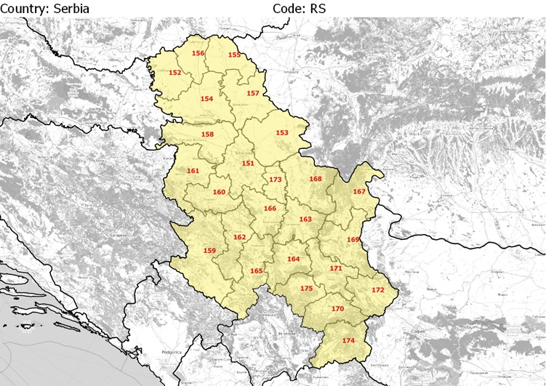
Source: Authors, based on Eurostat
The correspondence table between EMTM TAZs and statistical units in Serbia is provided below, together with the main socioeconomic parameters.
Table 10: TAZs of the EMTM in Serbia and main socioeconomic parameters
COUNTRY | TAZ | NUTS3 | NAME | POPULATION | GDP | EMPLOYEES
RS | 151 | RS110 | Beogradska oblast | 1,685,797 | 14,750 | n.a.
RS | 152 | RS121 | Zapadnobacka oblast | 176,379 | 718 | n.a.
RS | 153 | RS122 | Juznobanatska oblast | 282,199 | 1,315 | n.a.
RS | 154 | RS123 | Juznobacka oblast | 617,702 | 4,072 | n.a.
RS | 155 | RS124 | Severnobanatska oblast | 139,088 | 585 | n.a.
RS | 156 | RS125 | Servernobacka oblast | 180,790 | 878 | n.a.
RS | 157 | RS126 | Srednjobanatska oblast | 178,099 | 825 | n.a.
RS | 158 | RS127 | Sremska oblast | 301,958 | 1,412 | n.a.
RS | 159 | RS211 | Zlatiborska oblast | 272,400 | 1,136 | n.a.
RS | 160 | RS212 | Kolubarska oblast | 166,120 | 664 | n.a.
RS | 161 | RS213 | Macvanska oblast | 284,375 | 921 | n.a.
RS | 162 | RS214 | Moravicka oblast | 202,973 | 907 | n.a.
RS | 163 | RS215 | Pomoravska oblast | 203,302 | 663 | n.a.
RS | 164 | RS216 | Rasinska oblast | 228,139 | 716 | n.a.
RS | 165 | RS217 | Raska oblast | 306,422 | 809 | n.a.
RS | 166 | RS218 | Sumadisjka oblast | 285,755 | 1,322 | n.a.
RS | 167 | RS221 | Borska oblast | 115,716 | 497 | n.a.
RS | 168 | RS222 | Branicevska oblast | 171,353 | 718 | n.a.
RS | 169 | RS223 | Zajecarska oblast | 110,516 | 338 | n.a.
RS | 170 | RS224 | Jablanicka oblast | 204,400 | 532 | n.a.
RS | 171 | RS225 | Nisavska oblast | 365,097 | 1,373 | n.a.
RS | 172 | RS226 | Pirotska oblast | 86,517 | 403 | n.a.
RS | 173 | RS227 | Podunavska oblast | 190,124 | 425 | n.a.
RS | 174 | RS228 | Pcinjska oblast | 199,239 | 464 | n.a.
RS | 175 | RS229 | Toplicka oblast | 85,812 | 257 | n.a.
Source: Authors, based on Eurostat; Notes: population data refer to 2017, GDP data in million EUR (current market prices 2017) refer to 2016, employment data are not available

Slovenia
The zoning system of the EMTM in Slovenia has been developed on the basis of the following basic principles:
- Zoning level of detail: NUTS 3;
- Corresponding administrative unit: statistical regions of Slovenia;
- Data source: Eurostat.
The map in the following figure represents the TAZs of the EMTM in Slovenia.
Figure 11: TAZs of the EMTM in Slovenia
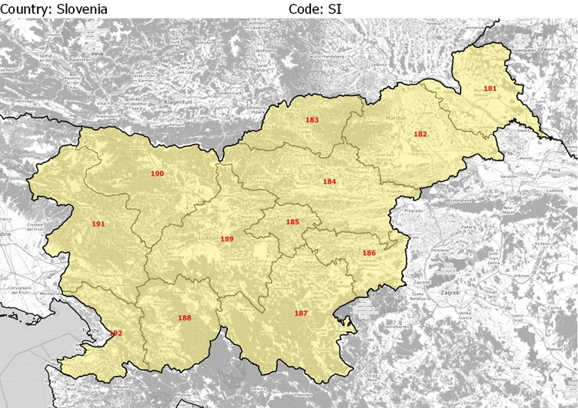
Source: Authors, based on Eurostat
The correspondence table between EMTM TAZs and statistical units in Slovenia is provided below, together with the main socioeconomic parameters.
Table 11: TAZs of the EMTM in Slovenia and main socioeconomic parameters
COUNTRY | TAZ | NUTS3 | NAME | POPULATION | GDP | EMPLOYEES
SI | 181 | SI031 | Pomurska | 115,477 | 1,611 | 32,830
SI | 182 | SI032 | Podravska | 322,043 | 5,412 | 112,490
SI | 183 | SI033 | Koroska | 70,761 | 1,173 | 22,540
SI | 184 | SI034 | Savinjska | 254,761 | 4,858 | 95,450
SI | 185 | SI035 | Zasavska | 57,280 | 625 | 12,470
SI | 186 | SI036 | Posavska | 75,544 | 1,307 | 22,150
SI | 187 | SI037 | Jugovzhodna Slovenija | 142,711 | 2,921 | 51,370
SI | 188 | SI038 | Primorsko-notranjska | 52,582 | 788 | 15,650
SI | 189 | SI041 | Osrednjeslovenska | 539,672 | 15,869 | 282,280
SI | 190 | SI042 | Gorenjska | 203,800 | 3,769 | 67,399
SI | 191 | SI043 | Goriska | 117,747 | 2,252 | 41,220
SI | 192 | SI044 | Obalno-kraska | 113,517 | 2,416 | 42,050
Source: Authors, based on Eurostat; Notes: population data refer to 2017, GDP data in million EUR (current market prices 2017) refer to 2017 and employees data refer to 2017

For information and clarifications on this report please contact Tplan Consulting:
roberto.zani@tplan.consulting
Tel.: +39 0542 1905289
www.tplan.consulting

