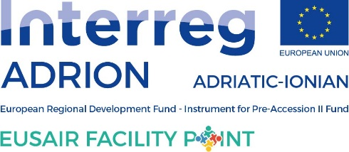

PILLAR 3: Environmental Quality

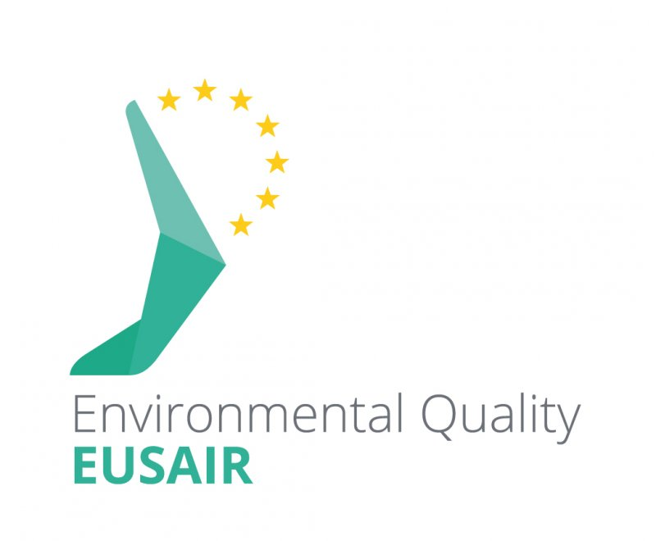

ANNUAL PROGRESS REPORT FOR YEAR 2020

Prepared by Pillar Coordinators, supported by the relevant EUSAIR Facility Point Project Partner, and approved by Written procedure, 4th February 2020.

Background:

As provided in the TSG Rules of Procedure (Point 8), every year, by end-February, Pillar Coordinators shall submit to the Governing Board an Annual Progress Report for the pillar concerned covering the preceding year (1st January-31st December).
The Annual Progress Report, jointly prepared by Pillar Coordinators, with the support of the relevant EUSAIR Facility Point Project Partner, is approved by the respective TSG prior to transmission to the Governing Board.
The Governing Board will be called to take note of the aforementioned reports, and, on that basis, to establish an Annual Progress Report for the EUSAIR as a whole, to be presented to the EU-28 High Level Group on macro-regional strategies and to the EUSAIR political/ministerial level.
General remarks:
The following table of content and the template itself show the sections that should be completed (none of them should be left blank or deleted from the report). If necessary and justified, additional (sub) sections could be added.
The report shall not exceed a maximum number of 5 pages (Arial 12 or equivalent).
Additionally, please note the following:
- The information should be well-structured within each of the sections and should be synthetic and to the point, addressing the content and not aiming for quantity.

- Do not include information which could be found elsewhere, e.g. minutes of the meetings or list of TSG members.

- The language should be direct and clear. Using acronyms, jargon or internal technicalities is not recommended.

- Refer to factual information, and be as concrete as possible. Vague and general comments (e.g. "the situation is progressing favourably and quite rapidly") without justification should be avoided.

- Any other important information (monitoring reports etc) should be added as annexes.

- TSG PROCESS (GOVERNANCE)

The EU Strategy for the Adriatic and Ionian Region (EUSAIR) and its Action Plan are key documents in order to implement sustainable development in the macro-region. In the Action Plan are defined four Pillars that address the core challenges and opportunities for the macro-region.

Regarding the Governing Board (GB) documents/rules all pillars are co-chaired by EU and non-EU countries. According to this, Republic of Slovenia and Republic of Bosnia and Herzegovina are co-chairs of the Pillar 3 - Environmental Quality. Following the setting-up process of TSG3, all countries nominated their representatives in TSG3, and the Rules of Procedures of TSG3 was adopted in 2015, as well.

TSG3 organized two meetings in 2020: 12th meeting (3-4 March 2020, Beograd, Serbia) and 13th meeting (17th December 2020, on-line). Five countries participated in the meeting in Beograd (Serbia) and the 13th meeting (17th December 2020) on-line with the representatives from DG REGIO, EUSAIR Facility Point Lead partner and project partner Municipality of Izola and other invited guests with the approval of TSG 3 members.

Within the Mediterranean Coast and EU MRS Week 2020 we organized one workshop: TSG 3 and INTERACT workshop “The opportunities of the European Green Deal and the EU macro-regional strategies” on 21th and 22nd of September 2020. EUSAIR Pillar Coordinators for TSG3, members with EUSAIR Facility Point, members from all TSGs, EUSAIR Facility Point representatives, Commission representative(s), representatives from the sectors/Ministries were present at the TSG 3 workshop that was held on-line.

1) TSG 3 meetings:
At the TSG 3 meetings were discussed key issues, in order to ensure an efficient implementation of EUSAIR and its Action Plan.
- In Beograd: main outcomes:
- a recap of the Technical PC meeting and GB in Brussels,
- the preparation of the list of national priorities for 3 flagships of TSG3 was agreed
- theme ‘’ Importance of blue and green infrastructure in a light of the new EU Post 2020 biodiversity framework: How to enhance the delivery of essential ecosystem services throughout the Adriatic – Ionian Region?’’ for TSG3 panel session at the 5th EUSAIR Forum, Belgrade, Serbia, was agreed,
- the TSG 3 Annual report 2018 was presented, approved and sent to the 9th GB (20-21 February 2019),
- the document for the monitoring and evaluation process: Monitoring and evaluation of the EUSAIR MRS in the framework of Facility Point was approved,
- the TSG 3 Activity plan 2020 was amended.
- Online: main outcomes:
2) Workshops organised by TSG 3:
Workshop “The opportunities of the European Green Deal and the EU macro-regional strategies”, 21-22 September 2020 (Izola, Slovenia - online).

Despite the COVID-19 situation in EU and particular in SLO TSG3 managed organized one one workshop: TSG 3 and INTERACT workshop “The opportunities of the European Green Deal and the EU macro-regional strategies” on 21th and 22nd of September 2020. The main focus of the meeting was to invite relevant thematic coordinators from all four macro-regions, Commission as well as environmental experts, to kick off the debate on how to best use the framework provided by MRS to achieve objectives and ambitions set by the European Green Deal, with particular focus on preserving and restoring ecosystems and biodiversity and transforming to a clean and circular economy.
The closing remarks of the workshop can be found on the EUSAIR Facility Point YouTube Channel or by clicking the name of each speaker:
- Andreja Jerina, National Coordinator for EUSAIR, EUSALP and EUSDR in Slovenia
- Humberto Delgado Rosa, DG ENVIRONMENT (Director, Directorate D-Natural Capital), European Commission
- Jean Pierre Halkin, DG REGIO (Head of Unit D1, Macro-regions, Transnational/Interregional/External Cooperation, Enlargement), European Commission
- Mitja Bricelj, EUSAIR Pillar 3 ‘Environmental Quality’ Coordinator, Slovenia
- Senad Oprašić, EUSAIR Pillar 3 ‘Environmental Quality’ Coordinator, Bosnia and Herzegovina

3) TSG3 also contributed to the:
- Technical Meeting of EUSAIR Pillar Coordinators, 18th February 2020, Brussels (Belgium). TSG 3 coordinators presented the TSG 3 work in 2019 and work plan in 2020.
- Meeting of the Governing Board of the EUSAIR, 18-19th February 2020, Brussels (Belgium). TSG 3 coordinators presented the TSG 3 work in 2019 and work plan in 2020.
- Presentation of national EUSAIR TSG3 Flaghsips, 27. May 2020, On-line
TSG 3 coordinators presented the TSG 3 national priorities.
- Technical Meeting of EUSAIR Pillar Coordinators, 16th September 2020, Izola (Slovenia) and online. TSG 3 coordinators presented the TSG 3 work in 2020 and work plan ahead.
- Meeting of the Governing Board of the EUSAIR, 16-17th September 2020, Izola (Slovenia) and online. TSG 3 coordinators presented the TSG 3 work in 2020 and work plan ahead.

- MAIN ACHIEVEMENTS

In 2020:
- According to Rules of Procedures two meetings with quorum of TSG 3 were organized. The meetings were hosted: 1) by Serbia in Belgrade; 2) held on-line.
- Organisation of one TSG 3 workshop hosted by Slovenia in Izola.
- Further steps in development process on four mono-pillar project concepts among TSG 3 under EUSAIR Facility Point strategic project WP T2 – Facilitating strategic project development were implemented.
- Submission of the ASOSCOP project proposal under EC Call Prevention and Preparedness for Marine Pollution at Sea and on Shore (March 2020).
- One inter-pillar project idea: Inter-pillar project TSG 3, 2 and 4 For people for planet was prepared to be submitted to FP+ call.
- Amendment of the M&E of the EUSAIR MRS in the framework of Facility Point document, see Annex 4.
- Preparation of promotional posters to promote the TSG3 project ideas and Flaghips, see Annex 5 to 8.
- Active participation of TSG 3 members at the Mediterranean Coastal and EU Macro-regional Strategies Week 2020, which was organised in the framework of INTERREG V-B ADRION strategic project: EUSAIR Facility Point. In particular, the TSG3 workshop “The opportunities of the European Green Deal and the EU macro-regional strategies” (20-21 September 2020, Izola, Slovenia).
- Active participation at PC Technical meetings and GB meetings in Brussels, Belgium, 18-19 February 2020 and in Izola, Slovenia, 16-17 September 2020.

- MAIN ISSUES/CHALLENGES ENCOUNTRED

Main challenges encountered in 2020 are:

Key messages to GB, High Level Group or Governments in EUSAIR countries:

- THE WORK AHEAD

According to Rules of Procedures at least two meetings of TSG 3 per year will be organized. In the year 2021 the 14th meeting and the 15th. The country that will host the meeting is TBD.

TSG 3 workshops on national level will be held in each country for further development of mono-pillar projects concepts under WP T2 of the EUSAIR Facility Point project and cross-pillar project concepts under Facility Point Plus.

TSG 3 will actively participate in the 5th EUSAIR Forum in Belgrade (Serbia) January 2021 and at the 6th EUSAIR Forum in Izola (Slovenia) May 2021 with organisation of possible plenary session for Environmental quality in collaboration with the organisers.

TSG 3 also foresees to (co)organize events for implementation of TSG 3 EUSAIR Action plan, identified TSG 3 priorities and project concepts.

In the year 2021 TSG 3 will mainly focus on:

- Implementation of recommendation and conclusion of TSG 3, Governing Board and EUSAIR Forum.
- Organisation of two TSG3 meetings according to the RoP.
- Possible organisation of workshops for the development of mono-pillar and cross-pillar projects concepts.
- Further discussion on actions/priorities that have macro-regional value in environmental quality and thus sustainable development within the 14th and 15th TSG 3 meetings.
- Contributing to the 5th EUSAIR Forum in Belgrade, in accordance to the Agenda of the Forum, yet to be prepared.
- Contributing to the 6th EUSAIR Forum in Belgrade, in accordance to the Agenda of the Forum, yet to be prepared.
- Further implementation of activities for development of Environmental Quality in the Adriatic-Ionian region as continuation of the activities.
- Maintaining and improving cooperation between pillars to achieve the best output for all of them while using an ecosystem approach.

- OTHER INFORMATION

ANNEX 1
ATTENDANCE AT TSG 3 MEETINGS IN REPORTING YEARS 2019
Pillar 3 | 12th meeting  City: Beograd  Date: 3-4/03/2020 | 13th meeting  City: Online  Date: 17/12/2020
EU Countries  [please list them] | Croatia, Slovenia represented by designated members
Non-EU countries  [please list them] | Montenegro, Bosnia and Herzegovina, Serbia represented by designated members
TOTAL | 5

ANNEX 2
MACRO-REGIONAL PROJECT/MEASURES
Indicate the macro-regional projects/measures identified by the TSG as having a macro regional value and contributing to the achievement of the Pillar's objectives in line with the EUSAIR Action Plan
Project/measure title | Main activities  Short description of the project/measure, what are the objectives, added value for the EUSAIR, envisioned period… | Mono / Cross Pillar project  Indicate, if the project has a mono or cross pillar approach, in case of cross-pillar, indicate the relevant pillar(s) | Status  Describe the status of the project/measure (e.g. project idea/concept, mature project ready for implementation, project under implementation or completed, etc.) | Involvement of EUSAIR countries | (Targeted) funding sources
To promote a sustainable growth of the AI region by implementing ICZM and MSP also to contribute CRF on ICZM of Barcelona convention,  Acronym: ICZM&MSP | Combining ICZM and MSP as inclusive and complementary governance instruments/approaches, strengthening institutional capacities to apply the ecosystem approach to protect the environment and manage natural and cultural assets, to keep in balance environmental protection and social-economic development, also considering the increasing pressures of human activities and environmental changes.  - Main Activities: defining gaps in marine and coastal knowledge including expertise needed for ICZM and MSP case studies implementation  - mapping and assessment of socio-economic activities and environmental relevant issues  - identify conflicts and propose sustainable options for action  - facilitate adoption of National Strategies on ICZM (ICZM Protocol), including consideration on maritime spatial planning (MSP Directive) and in line with the UNEP/MAP Common Regional Framework on ICZM | mono-pillar | Project Concept | All EUSAIR Countries
Protection and enhancement of natural terrestrial habitats and ecosystems.  Acronym: PET HAB ECO | The project aims at improving the resilience of large carnivores populations at transnational level in the face of environmental threats and risks, mainly for bears. The activities to be undertaken are primarily related to conservation and restoration of large carnivore populations, public awareness activities to bring these unique species to the public’s attention and restoration of ecosystems in which they play a key role.  - Activities: Enlarge and make more efficient the ecological corridors  - networks, mainly for bears (e.g.: analyzing and gathering information on gaps from all relevant stakeholder regarding large carnivores’ distribution and already existing networks (Emerald, Natura 2000...))  Develop joint researches to:  - acquire better knowledge of large carnivores behaviour, habitats etc.  - How to improve the efficiency of the corridors (propose concrete tools and guidelines from research activities)  - Conflict management (at all levels: international, national, local) promoting a new management practices and the development of innovative technologies  - Research and monitoring activities as gathering of the data on populations is of highest priority  - Development of regional action plan for large carnivore monitoring and protection | Mono-pillar | Project Concept | All EUSAIR Countries
Monitoring and management of marine protected species  Acronym: 3MPS | Addressing the threats to biodiversity caused by human activities, like deterioration of water quality (in particular impact of marine litter, micro plastic and chemical pollutants) and by bio toxins.  Foreseen WPs: Establishment of monitoring network towards marine litter,  Implementation of monitoring activities  Analyses and study on level of impact on threatened populations  Defining regional management measures regarding marine litter in order to combat impact on threatened species.  Methodology guidance on analyses regarding level of impact coming from marine litter on threatened species. | Mono-pillar | Project Concept | All EUSAIR Countries
Adriatic/Ionian Sub/regional Oil spill contingency plan  Acronym: ASOSCoP | Aims to examine and update the existing contingency Plan for the Northern Adriatic Sea and possibly to extend it, to other interested Adriatic countries by coordinating it with the existing national contingency Plans; in order to prevent and reduce Oil spill impacts on the coast, raise awareness on pollution prevention, produce a contingency plan that will define standard operational procedures and roles of stakeholders in the event of marine and coastal pollution from Oil Spill. | Mono-pillar | Project Concept | All EUSAIR Countries
Managing Tourism Flows in Protected Areas  Acronym: ADRIONet | General objectives  a) Environmental quality:  - To ensure a good environmental and ecological status of the protected areas by 2020 in line with the relevant EU acquis and the ecosystem approach of the Barcelona Convention;  - To contribute to the goal of the EU Biodiversity Strategy to halt the loss of biodiversity and the degradation of ecosystem services in the EU by 2020, and restore them in so far as feasible, by addressing threats to marine and terrestrial biodiversity.  b) Sustainable tourism:  - Improving the quality and innovation of tourism offer and enhancing the sustainable and responsible tourism capacities of the tourism actors across the macro-region. | Inter-pillar – TSG 3 and 4 | Project Concept submitted under FP+ | All EUSAIR Countries
Project on MSP and ICZM | Combining ICZM and MSP as inclusive and complementary governance instruments/approaches, strengthening institutional capacities to apply the ecosystem approach to protect environment and manage natural and cultural assets with the aim of good governance of economic activities in this sea region and implementation of common plans which will drive to innovative maritime and marine growth in the A-I region by promoting sustainable economic growth and jobs as well as business opportunities in the blue economy sector. | Inter-pillar – TSG 3 and 1 | Project Concept submitted under FP+ | All EUSAIR countries
For people for planet | The project idea includes actions that will serve as a platform to foster an inclusive policy dialogue with key stakeholders and partners and to showcase national pathways and specific mitigation actions for transport, such as electro-mobility.  The project will show the state of the art in the EUSAIR countries, especially in those where more detailed information is missing in order to identify possible actions to be taken on policy level to manage a comprehensive approach to follow the UN Resolution Sustainable Goals.  - improve the common understanding among ADRION Partners about the needs and the opportunities for transnational cooperation in the fields of environmental protection, sustainable tourism, transport innovation, emission regulation, ecosystem services and climate change adaptation;  increase in the availability of information to ensure the delivering of evidence based responses through a well-framed exchange of data and capacity buildings concerning reducing transport emission, tourism management and environmental preservation. | Inter-pillar – TSG 3, 2 and 4 | Project Concept | All EUSAIR countries

ANNEX3
PILLAR / TSG EVENTS AT NATIONAL OR MACRO-REGIONAL LEVEL IN THE REPORTING PERIOD
Event / Country / National or Macro-regional | Short description | Participants (what kind of participants) | Main outputs
TSG 3 workshop: How to progress from TSG 3 priorities towards EUSAIR macro-regional projects”, 19-20 September 2019, Macro-regional, Izola, Slovenia | The main focus of the meeting was to invite relevant thematic coordinators from all four macro-regions, Commission as well as environmental experts, to kick off the debate on how to best use the framework provided by MRS to achieve objectives and ambitions set by the European Green Deal, with particular focus on preserving and restoring ecosystems and biodiversity and transforming to a clean and circular economy. What are experiences, practices and approaches that could be applied? Furthermore, event participants elaborated on potentials of MRS in creating place-based and inclusive responses to macro-regional challenges. | EUSAIR Pillar Coordinators for TSG 3 and members from all TSG, interested members from all TSGs, EUSAIR Facility Point representatives, Commission representative(s), representatives from the sectors/Ministries were present at the workshop. | The closing remarks of the workshop can be found on the EUSAIR Facility Point YouTube Channel or by clicking the name of each speaker:  Jean Pierre Halkin, DG REGIO,  Humberto Delgado Rosa, DG ENVIRONMENT  Mitja Bricelj, EUSAIR TSG3 Pillar Coordinator  Senad Oprašič, EUSAIR TSG3 Pillar Coordinator  Andreja Jerina, SI National Coordinator MRS

Events are/will be listed in the TSG 3 Activity plan – find on INTRANET. The document can be constantly updated.

