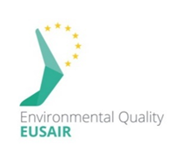
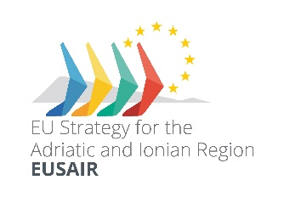
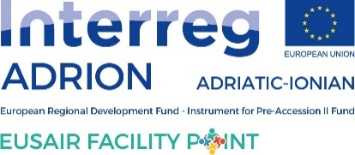

Report
Workshop ''The opportunities of Green Deal for macro-regions''
EUSAIR Pillar 3 (Environmental Quality) and INTERACT
Mediterranean coast an macroregional strategies week 2020

21 -22 September 2020, Izola, Slovenia – On-line

DATE: 21 -22 September 2020
PLACE: Izola, Slovenia – On-line
PROGRAMME: See Annex 1.
The workshop fcused on key concept of the the Slovenian Presidency to the EUSAIR the European Green Deal. It was the first workshop on the topic of the European Green Deal, aimed at establishing a sustainable EU economy. The goal of the European Commission is very ambitious: environmentally and climate neutral Europe by 2050. The workshop was organized by members of the EUSAIR thematic steering group for Environmental Quality, implementation structure of the EUSAIR Facility Point Slovenian project partner Municipality of Izola, with the support of INTERACT, Slovenian Ministry of Foreign Affairs and Ministry of Environment and Spatial Planning.
Day 1

The first day focused on the framework rovided by MRS to achieve objectives and ambitions set by the European Green Dea and briefly touched upon practical cases showing how MRS can deliver Green Deal on a more regional scale – macro region that is closer to citizens. Andreja Jerina, National Coordinator for EUSAIR, EUSALP and EUSDR in Slovenia provided some wellcoming words about EU Green Deal vision and needed actions and commitments at (macro)regional level. She was was followed by the EUSAIR Pillar 3 ‘Environmental Quality’ Coordinators Mitja Bricelj and Senad Oprašić who provided the participants with the information about Achievements of TSG3 since last September 2019, EU Green deal challenge and post COVID-19 situation in Western Balkans and Synergies among EU Macroregional strategies – Modern planning for river basin management and coastal and maritime zone management by introducing green and blue corridors to include biodiversity and sustainable solutions 4 development of green infrastructure.
The main objective of the panel panel discussion on EU macro-regional strategies as a framework to advance the implementation of the European Green Deal was to discuss the role of the EU macro-regional strategies as a policy framework leading to coordinated actions and synergies to implement the European Green Deal also in the Western Balkans and to investigate opportunities, potentials and mutual benefits of macro-regional cooperation for more sustainable, green and inclusive Europe. The speakers who provided their input were

- Andreja Jerina, National Coordinator for EUSAIR, EUSALP and EUSDR in Slovenia
- Sander Happaerts, DG REGIO (Unit G1, Competence Centre Smart and Sustainable Growth), European Commission
- Giacomo Luciani, DG REGIO (Unit D1, Macro-regions, Transnational/Interregional/External Cooperation, Enlargement), European Commission
- Carlo Franzosini, AdriaPAN - Adriatic Protected Areas Network
- and Marko Starman, Municipality of Izola on behalf of the EUSAIR Pillar 3 ‘Environmental Quality’ who also provided the Concluding statement.

Day 2
The second day the discussion was more practical and put in the focus one element of Green Deal – EU Biodiversity Strategy 2030 and green and blue connectivity in particular. EU Biodiversity strategy beeing the central element of EU Recovery Plan, and crucial to build resilience of future policies and provide investment and business opportunities to recover from economic crisis. Restoring biodiversity is seen as a core part of recovery. The aim of discussion was to showcase EU macro-regional strategies contribution to the implementation of the European Green Deal and to the economic recovery through concrete macro-regional actions, underlining the business, investments and employment opportunities led by nature restoration. The discussion was set on initiatives of the speakers from 3 MRS strategies – EUSAIR, EUSALP and EUSDR and from speaker from DG Environment.
- Michaela Künzl, EUSALP Action Group 7’ Green Infrastructure’ Leader, Bavaria, Germany
- Ana Kobašlić, EUSDR Priority Area 6 ‘Biodiversity, Landscapes and Air & Soil Quality’, Croatia
- Mitja Bricelj, EUSAIR Pillar 3 ‘Environmental Quality’ Coordinators, Slovenia
- Senad Oprašić, EUSAIR Pillar 3 ‘Environmental Quality’ Coordinator, Bosina and Herzegovina
- Karin Zaunberger, DG ENVIRONMENT (Unit D2, Biodiversity), European Commission
Following the discussions of both days the concluding messages on the workshop were posted on the weppage dedicated to the event and also on posted on EUSAIR Facility Point youtube channel. The remarks can be seen here or by clicking the name of each speaker:
- Andreja Jerina, National Coordinator for EUSAIR, EUSALP and EUSDR in Slovenia
- Humberto Delgado Rosa, DG ENVIRONMENT (Director, Directorate D-Natural Capital), European Commission
- Jean Pierre Halkin, DG REGIO (Head of Unit D1, Macro-regions, Transnational/Interregional/External Cooperation, Enlargement), European Commission
- Mitja Bricelj, EUSAIR Pillar 3 ‘Environmental Quality’ Coordinator, Slovenia
- Senad Oprašić, EUSAIR Pillar 3 ‘Environmental Quality’ Coordinator, Bosnia and Herzegovina

