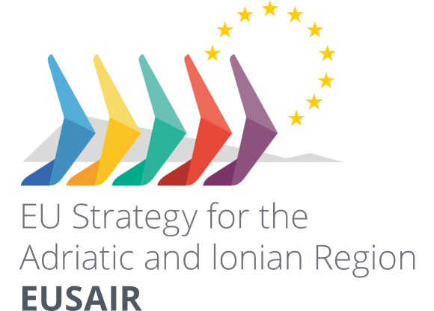

**Pillar Roadmap of Actions**

Template

1st Draft

5.9.2025

**Table of contents**

Introduction to the Pillar Roadmap 2

Topic 1 Detailed Breakdown of Actions – Blue and Green Technologies 2

1.1 Action title (from the Action Plan): Building Adriatic-Ionian region innovation ecosystems that will promote research and innovation networks in green and blue technologies 2

Expected results (from the AP) 2

TSG Activities 4

1.2 Action title (from the Action Plan): Building Adriatic-Ionian region innovation ecosystems that will promote research and innovation networks in green and blue technologies 6

2. Topic 2 Detailed Breakdown of Actions – 6

# Introduction to the Pillar Roadmap

The Pillar Roadmap serves as an operational blueprint for implementing the actions outlined in the EUSAIR Action Plan (revised March 2025). It breaks down each action into granular activities, timelines, responsibilities, and resources, while adhering to basic intervention logic (inputs → activities → outputs → outcomes → impacts). This ensures alignment with the Action Plan's expected results and indicators, facilitating measurable progress toward 2030 targets. The roadmap is pillar-specific but can be adapted across all five EUSAIR pillars (Blue Sustainable Economy, Connecting the Region, Environmental Quality, Sustainable Tourism, Improved Social Cohesion). It emphasizes horizontal topics i.e. Enlargement, Capacity Building, Research, Innovation and Development and cross-cutting topics i.e. Circular Economy, Green Rural Development and Digitalization.

# Topic 1 Detailed Breakdown of Actions – Blue and Green Technologies

## Action title (from the Action Plan): Building Adriatic-Ionian region innovation ecosystems that will promote research and innovation networks in green and blue technologies

### **Expected results (from the AP**)

* Digital Innovation Hubs, Knowledge and Innovation Communities and clusters focusing on green and blue technologies created
* Improved Research, Development and Innovation and cooperation among SMEs and between SMEs, large enterprises and research centres operating in the Adriatic-Ionian region
* Increased networking between researchers, SMEs and clusters
* Increased joint research papers and number of researchers exchanged within the macro-region
* Access to finance and promotion of the creation of start-ups has improved
* Enhanced collaborative networks among relevant players in the Adriatic-Ionian region concerning innovation and research on green and blue technologies
* Increase in innovation investments on the macro-regional level
* Enhanced digital transition and strengthening digital innovation hubs

### TSG Activities

TSG activities that will lead towards the expected results contribution. Please note, each activity can contribute to more than one expected results.

Summary table

|  |  |  |  |  |  |  |  |  |
| --- | --- | --- | --- | --- | --- | --- | --- | --- |
| **Activity number** | **Activity title** | **Start YYYY/MM** | **End YYYY/MM** | **Expected outputs and date of delivery** | **Contribution to expected results** | | **Contribution to indicator** | |
| Contribution to which expected result | Extent of the contribution | Indicator number and title | Extent of the contribution |
| A.1.1.1 |  |  |  |  |  |  |  |  |
|  |  |  |  |  |  |  |  |  |
|  |  |  |  |  |  |  |  |  |
|  |  |  |  |  |  |  |  |  |
|  |  |  |  |  |  |  |  |  |
|  |  |  |  |  |  |  |  |  |
|  |  |  |  |  |  |  |  |  |
|  |  |  |  |  |  |  |  |  |
|  |  |  |  |  |  |  |  |  |
|  |  |  |  |  |  |  |  |  |

#### Activity 1.1.1. (Topic 1, Action 1, Activity 1) Title of activity

**Short description**:

**Linked to Flagships**

Name of the Flagship, strategic project and short description of how the activity is linked to the Flagship

**Inputs**

Who implements the activity:

Stakeholders to be engaged:

Financial sources for the activity:

EGP support needed:

**Expected outputs:**

|  |  |  |
| --- | --- | --- |
| **Output title** | **Description** | **Delivery date** |
|  |  |  |
|  |  |  |

**Contribution to expected results and indicators:**

|  |  |  |  |
| --- | --- | --- | --- |
| **Contribution to expected results** | | **Contribution to indicator** | |
| Contribution to which expected result | Extent of the contribution | Indicator number and title | Extent of the contribution |
|  |  |  |  |
|  |  |  |  |
|  |  |  |  |
|  |  |  |  |
|  |  |  |  |

**Contribution to horizontal and cross-cutting topics if relevant**

Please describe to which horizontal and cross-cutting topics activity is contributing and how.

#### Activity 1.1.2. (Topic 1, Action 1, Activity 1) Title of activity

….

## Action title (from the Action Plan): Building Adriatic-Ionian region innovation ecosystems that will promote research and innovation networks in green and blue technologies

….

# Topic 2 Detailed Breakdown of Actions –