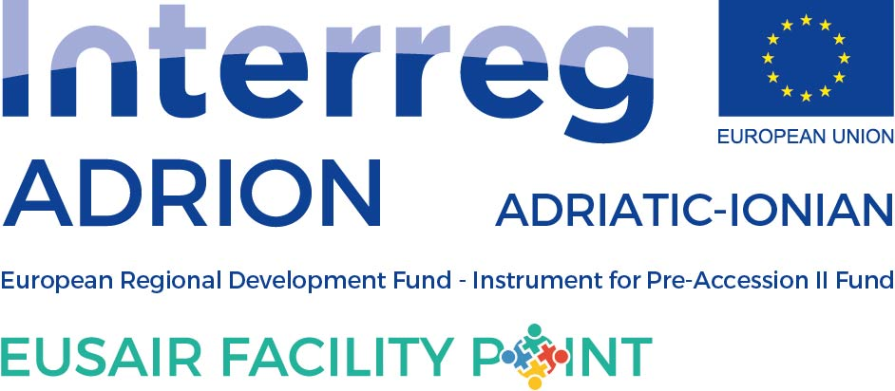

ANNUAL TSG 3 ACTIVITY PLAN FOR 2020

to be filled in by TSG 3

Please, fill in the events planned for 2020 within the TSG 3 Pillar Environmental Quality, having in mind the EUSAIR Action Plan. While preparing the Activity Plan, please consult the National Coordinators, Pillar Coordinator and TSG members from your country. When no specific data is known, please insert “tba”.

Event title | Date or quarter of the year | Location (country and/or town) | Type of event |  | Description of the event
 |  |  | Macro-regional, national, regional | Meeting, workshop, conference, info day, forum, etc.
Roundtable on “Development and drafting of joint plans for cross-border habitats and ecosystems management, and joint plans for managing big carnivores“ | 11th December 2019 (TBC) | Serbia | Macro-regional | Round table | TBA
TSG 3 Panell session 5th Forum, Belgrade, Serbia | May 2020 (TBD) | Serbia | Macro-regional | Panell session - forum | TBA
TSG 3 Workshop within Mediterranean Coast and Macro-regional Strategies Week | September 2020 (TBD) | SI | Macro-regional | Workshop | Continuation of TSG 3 workshops dedicated to further development of mono-pillar TSG 3 project concepts – in 2020 the workshop will be focused on project concept ASOSCoP
Exceptionally also roundtable foreseen in Serbia foreseen in December 2019 is included
OTHER NEEDS, PROPOSALS (please, add if other needs and proposals are detected (issue papers, studies…)

