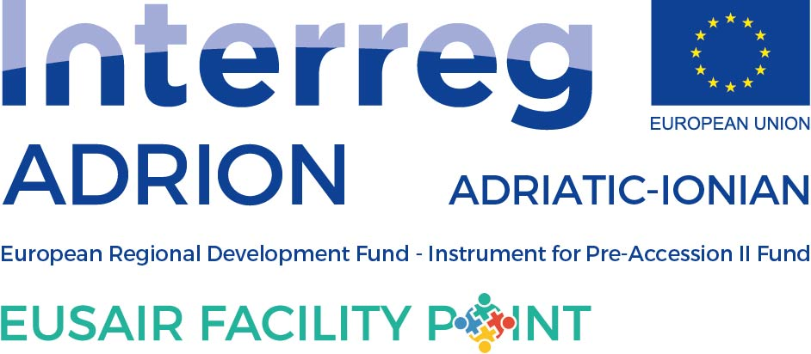

ANNUAL TSG 3 ACTIVITY PLAN FOR 2023

to be filled in by TSG 3

Please, fill in the events planned for 2023 within the TSG 3 Pillar Environmental Quality, having in mind the EUSAIR Action Plan. While preparing the Activity Plan, please consult the National Coordinators, Pillar Coordinator and TSG members from your country. When no specific data is known, please insert “tba”.
Event title | Date or quarter of the year | Location (country and/or town) | Type of event |  | Description of the event
 |  |  | Macro-regional, national, regional | Meeting, workshop, conference, info day, forum, etc.
Workshop on the preparation of the Action Plan for biodiversity and marine protection with special reference to the possible establishment of a protected area in the part of the Adriatic Sea belonging to BiH | January 2023 (TBD) | Bosnia and Herzegovina (TBD) | Macro-regional | Workshop | TBA
Round table on the potentials of EUSAIR countries for the establishment and improvement of the Circular Economy system | February 2023 (TBD) | Bosnia and Herzegovina (TBD) | Macro-regional | Workshop | TBA
18th TSG 3 meeting | March 2023 (TBD) | TBD | Macro-regional | meeting | 18th regular TSG 3 meeting
A workshop on the development of a Contingency Plan for the middle and southern part of the Adriatic Sea | April 2023 (TBD) | Bosnia and Herzegovina (TBD) | Macro-regional | Workshop | TBA
TSG 3 Panel session 8th EUSAIR Forum, Bosnia and Herzegovina | May 2023 | Bosnia and Herzegovina | Macro-regional | Panell session - forum | TBA
TSG 3 Workshop within Mediterranean Coast and Macro-regional Strategies Week | September 2023 (TBD) | TBD | Macro-regional | Workshop | TBA
19th TSG 3 meeting | October/November 2023 (TBD) | TBD | Macro-regional | meeting | 19th regular TSG 3 meeting
OTHER NEEDS, PROPOSALS (please, add if other needs and proposals are detected (issue papers, studies…)

