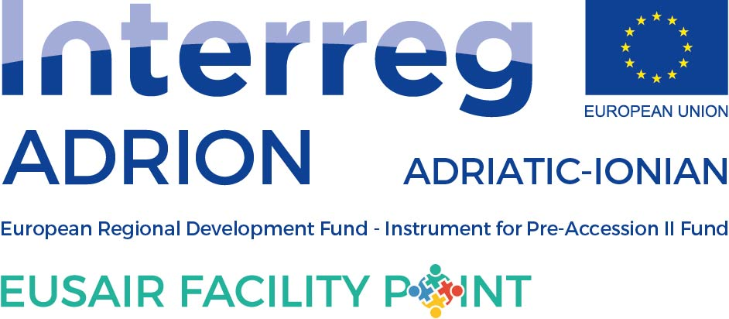

ANNUAL TSG 3 ACTIVITY PLAN FOR 2020

to be filled in by TSG 3

Please, fill in the events planned for 2020 within the TSG 3 Pillar Environmental Quality, having in mind the EUSAIR Action Plan. While preparing the Activity Plan, please consult the National Coordinators, Pillar Coordinator and TSG members from your country. When no specific data is known, please insert “tba”.

Event title | Date or quarter of the year | Location (country and/or town) | Type of event |  | Description of the event
 |  |  | Macro-regional, national, regional | Meeting, workshop, conference, info day, forum, etc.
Roundtable on “Development and drafting of joint plans for cross-border habitats and ecosystems management, and joint plans for managing big carnivores“ | 17th December 2019 | Serbia | Macro-regional | Round table | Main conclusions: except the marine environment, MR cooperation also needs to focus on the protection and reservation of terrestrial ecosystems; the AI region has reach biodiversity in comparison to the average EU region; it is needed to take concerted actions at all levels so regional and transboundary cooperation and conservation activities will make the key to finding solution for halting the loss of biodiversity and ecosystem services; with the strong AII and EUSAIR is needed to improve the necessary administrative capacities and to involve subnational government levels to mobilize regions, cities, agencies, institutions such universities, private sector and civil society towards its better implementation.
Workshop with HR for ASOSCoP | February 2020 (TBD) | HR | Macro-regional | Workshop | Meeting dedicated for further development of ASOSCoP monopillar project concept.
12th TSG 3 meeting | 4-5 March 2020 | Belgrade, Serbia | Macro-regional | meeting | 12th regular TSG 3 meeting
Event with Marche Region – linked to Pillar 3 and Portodimare – (also possible pillar 1/3) | March - TBA | Italy - TBA | TBA | TBA | Maybe linked to Pillar 1/3
TSG 3 Panel session 5th EUSAIR Forum, Belgrade, Serbia | 11-13 May 2020 (TBC) | Serbia | Macro-regional | Panell session - forum | TBA
TSG 3 possible side event at 5th EUSAIR Forum, Belgrade, Serbia | 11-13 May 2020 (TBC) | Serbia | Macro-regional | Side event | TBA – possible TSG 3 side event at the EUSAIR Forum in Serbia
EU Green week – on biodiversity | 1st – 5th June 2020 | Brussels | Macro-regional | events | Focus on Biodiversity
Portodimare conference - on MSP – joined with Pillar 3 | June 2020 | TBC | Macro-regional | event | TBA
TSG 3 Workshop within Mediterranean Coast and Macro-regional Strategies Week – ASOSCoP | September 2020 (TBD) | SI | Macro-regional | Workshop | Continuation of TSG 3 workshops dedicated to further development of mono-pillar TSG 3 project concepts – in 2020 the workshop will be focused on project concept ASOSCoP
13th TSG 3 meeting | October/November 2020 | TBC | Macro-regional | meeting | 13th regular TSG 3 meeting
Exceptionally also roundtable foreseen in Serbia in December 2019 is included
OTHER NEEDS, PROPOSALS (please, add if other needs and proposals are detected (issue papers, studies…)

