ANNEXES to EUSAIR Youth Council Concept Paper
- Contributions from other existing Adriatic-Ionian youth initiatives and projects (EUSAIR POPRI, AI-NURECC PLUS, Cooperation & Development Institute, At the School of OpenCohesion – ASOC)
- EUSAIR Youth Closed Consultation results
- EUSAIR Youth Open Consultation results

A) Contributions from other existing Adriatic-Ionian youth initiatives and projects

6.1 Primorski Tehnološki Park – EUSAIR POPRI
    - Short summary including plans
POPRI is a process of entrepreneurial learning for young people with a clear vision, innovative ideas and entrepreneurial spirit aged 14 to 29. This annual event has become an entrepreneurial brand/movement that takes place in 10 participating countries of the Adriatic-Ionian region and is recognized by national and international authorities, including the European Commission. It consists of a learning and support process through technology parks, including their mentors and the business community, and ends with events during the EUSAIR Forum.
EUSAIR POPRI youth is an effective response to the global challenge of an inclusive and innovative society and an example of good practice of socially responsible activities in the field of youth entrepreneurship development.
The challenges faced by youth in the Adriatic-Ionian region may vary, but it is important to address these challenges to ensure a better future for youth in the region. Youth engagement can be crucial for positive change in the region. Young people often bring new perspectives, innovative ideas and energy to tackle pressing issues. Active participation in initiatives and projects can help to find solutions. Collaboration between youth and various stakeholders, including governments, business support organizations, schools, businesses and SMEs, can lead to more comprehensive and sustainable approaches.
EUSAIR POPRI youth is a concrete tool and mechanism that equips young people with innovative and entrepreneurial thinking and delivers results and brings institutions from EUSAIR participating countries closer in cooperation.
EUSAIR POPRI youth 2024 is organised by Primorski tehnološki park, Slovenia, together with ZICER – Zagreb Innovation Centre (Croatia) and in close cooperation with technology parks, incubators and schools of EUSAIR participating countries, namely Local Economic Development Agency Auleda Vlore (Albania), ICBL – Innovation Centre Banja Luka (Bosnia and Herzegovina), Science & Technology Park of Crete (STEP-C) (Greece), CONFCOOPERATIVE FVG (Italy), Studentski Biznis Centar Univerziteta Donja Gorica (Montenegro), CKM – Center for Knowledge Management (North Macedonia), Republic of San Marino Innovation Institute (San Marino) and Business Incubator Novi Sad (Serbia).
As part of the process, the young people develop their own business ideas into business models with the support and guidance of mentors and people from the business world. They prepare documents to be evaluated and present them orally to the jury members during the EUSAIR Forum. During the events, they have the opportunity to meet and openly discuss with successful entrepreneurs and network during the award ceremony.
The network of technology parks, schools, companies and other participating institutions sees this project as a traditional project (flagship) that connects and provides learning and networking opportunities for all participants, from which all countries benefit equally. It acts as a flagship project with the possibility to be further developed as a project with workshops and meetings of institutions that regularly share knowledge and best practices and grow together.
    - Estimate of the cost of annual activities for young people
Basic activities with some exchange of knowledge between 10 TPs, excluding personnel costs
- Enabling national POPRI activities of network of Techno HUB (10 technology parks):
- Preparatory workshops – experts and support (5) 25.000€
- Accommodation and travel – 5.000€/10 partners = 50.000€
- Visibility and materials 5.000€
TOTAL: 80.000€
- POPRI at Annual Forum
- and during the year: 50.000€
- PTP process management, experts’ inclusion 30.000€
- Activities at the level of the participating states /5.000€ for 9 TPs (no PTP costs) = 45.000€
- Accommodation and travel of youth and jury members (cca 50 persons) 35.000€
TOTAL: 160.000€
- Summer boot-camp for best 50 participants from 4 MRS
Follow up EUSAIR POPRI youth – for 4 MRS members: 30.000€
The total basic activities per year for the learning process and some events are estimated at 270,000€ /no staff costs included, only the costs for accommodation and travel of the young people and the jury members at EUSAIR POPRI youth final events are estimated at 35,000€.
    - Interaction of EUSAIR POPRI youth with EUSAIR Youth Council
Cooperation between the two structures is possible, but the role, mandate and interests of the newly established Youth Council and its members must be taken into account. The collaboration should involve and bring together the participants of both initiatives, so that the members of the Youth Council are involved in and learn about the POPRI project (but do not become too involved and overburdened if they also have other commitments). With our proposal, we see an opportunity for the content of the strategy to be shared with POPRI participants and for YC members to actively participate in POPRI events. Discussion and collaboration are needed. POPRI deals with business model development and the success story has been running for 3 years within EUSAIR; it has its own path and its own rules that are followed.
Additional value added of YC members is in contributing to the visibility of the activities of projects, especially to those that are not directly involved in the governance structure. A young person could be identified for social media and other visibility activities of EUSAIR POPRI youth project.

  - AI-NURECC PLUS
    - The project potential in a nutshell
The project is a joint initiative of the Conference of Maritime and Peripheral Regions (CMPR) and four key stakeholders from the AI area: the Adriatic Ionian Euroregion (AIE), the Forum of Adriatic and Ionian Cities (FAIC), the Forum of the Adriatic and Ionian Chambers of Commerce (FORUM AIC), and the Association of Universities of the Adriatic Ionian area (UniAdrion). Since 2018, the partnership works to support the implementation of the EUSAIR by enhancing Regional and Local Authorities’ appropriation of its objectives and opportunities.
Given its geographical coverage and contacts, this partnership offers a unique potential to foster multi-actor networking and closer cooperation including multiple levels of government, universities and civil society organisations in all EUSAIR participating countries and beyond (external outreach to EUSDR and Mediterranean countries).
For more at: www.ainurecc.eu
    - The youth action
Between 2021 and 2023, the AI-NURECC PLUS has implemented an extensive youth engagement action with a view to support young people’s understanding of and participation in the EUSAIR, while sustainably providing them with opportunities to connect across the region, and to discuss how their perspectives could be embedded in EUSAIR priorities, to meet EU and EUSAIR stakeholders.
The scope of the action has included activities in EUSAIR cross-pillars (Research and Innovation, SMEs Development, and Skills Development) and thematic attention to EUSAIR-relevant topics (Sustainable Tourism, Cultural and Creative Industries, and Circular Economy).
Youth-centred activities implemented:
- A Summer School on Sustainable Tourism in September 2022, attended by 33 AI graduates, with a winning team presenting their project idea at the TSG4 on Sustainable Tourism in October 2022.
- Student mobility for 11 interns in local and regional authorities of the region as well as in Bruxelles, in autumn 2023.
- 3 events on youth skills for youth: two-youth led events one in Skopje in January 2023 and one in Sarajevo in May 2023, and a conference on blue skills in San Marino in November 2023.
- Focus on gender equality and social topics by participating in the Strong Women Conference of July 2023 with an AI-NURECC/AIYN panel and by organising an event on Women Entrepreneurship, in Budva, in October 2023.
- 2 youth-led networking events focusing on the contribution of AIYN to EUSAIR processes: the Action Plan revision and the Youth Council consultations.
- 4 editions of the Adriatic Ionian Youth Organisations Forum (AIYOF), two of which held in conjunction with the AII/EUSAIR Annual Fora (in May 2022 and 2023).

    - New ideas
The AI-NURECC PLUS future activities will aim at capitalising and scaling up the results achieved. The scope and outreach of the youth action will be expanded to include work on the following areas:
- promotion of blue and green balance aimed at better involving rural youth;
- advancing the mechanisms for strengthening youth structures for a greater youth engagement and creating a collaborative alliance between AIYN and EUSAIR Youth Council;
- promotion of entrepreneurship among young people, and exploration of the idea to establish a youth-led entrepreneurial hub;
- contributing to embedding EUSAIR priorities at local level by involving young administrators;
- promotion of education and social inclusion especially as linked to the new EUSAIR Action Plan.

Area | Leader | Activities
Promotion of  blue skills | CPMR | - Capitalisation of work done on blue skills (ISOLMet Erasmus project)
Youth structures and participation | AIE | - 6th Adriatic Ionian Youth Forum, led by AIYN  - Definition of a capacity building path for better organising advocating and communicating youth needs in a transnational environment
youth employment and entrepreneurship | Forum AIC | - Multiplier events  - Congress of women entrepreneurship with a focus on youth in autumn (Forum AIC is intermediary organisation for Erasmus for Young Entrepreneurs)
Culture and tourism  development | FAIC | - 1 event involving young administrators and dealing with cultural and creative industries  - Synergy with in TTG Travel Experience
Promotion of education and  social inclusion | UniAdrion | - Spring school on EUSAIR topics with special attention to new Action Plan  - Conference

    - Interaction with the EUSAIR Youth Council
The current work on the establishment of a EUSAIR Youth Council could benefit from the youth engagement expertise of AIE and its preferential relationship with 19 youth organisations forming the Adriatic Ionian Youth Network ( ). AIE and AIYN have decided to strengthen their cooperation by signing a multilateral Declaration of Intents. The idea is to co-design and implement youth-led advocacy, awareness raising and capacity building actions aimed at further stimulating youth appropriation of EU and EUSAIR goals and opportunities.
The AIYN is eager to support the creation of a EUSAIR Youth Council and to establish with it a Collaborative Alliance to participate in the Strategy with a fully-fledged advisory role as well as to ensure a deep and broad territorial coverage. To better support this process, we believe that the AIYN could be represented in the EUSAIR Youth Council. Also, with a view to the sustainability of the action, the AIYN could work as an Alumni for former Council participants.
A further element is the experience that the CPMR achieved as co-coordinator of the Mediterranean Youth Council (MYC), a transnational cooperation initiative which aims to be the representative body of youth from all shores of the Mediterranean. The MYC was present at the 8th AII/EUSAIR Annual Forum and is already in contact with the AYIN.
    - Finances
Our annual projection for one year of activity is of 400.000 euro, covering staff costs, travel and accommodation, activities.

  - Cooperation & Development Institute
    - Summary of your activities for youth including your plans for the future
CDI’s ongoing initiatives & projects are dedicated to amplifying youth involvement in policy-making aiming reforms & enlargement process. Notably, the Connecting Youth (CY) initiative & the yearly Tirana Connectivity Forum (TCF) stand out as exemplary long-term initiatives, spanning 8 & 10 years, respectively. CY and TCF are designed to outreach, inform, empower & encourage youth to actively participate in cross-WB activities, in EU programs covering EUSAIR candidate countries, & to play a role in shaping policies that impact them. By receiving the Austrian MFA Intercultural Achievement Award 2021, CY was recognized as an Innovative Best Practice initiative advancing youth cooperation in the WB6.
The 2023 "Raising Awareness on the Youth Manifesto in the WBs" initiative supported by DG Regio, has successfully contributed to reshaping perceptions of youth participation in the INTERREG and EUSAIR stakeholder’s ecosystem. This was achieved through a comprehensive multi-level approach involving INTERREG programs in EUSAIR participating countries with candidate status, their governments, academia and schools, and the youth ecosystem. The primary objective was to foster systemic youth engagement in EUSAIR and INTERREG IPA programs.
Looking ahead, our forthcoming efforts will concentrate on leveraging the achievements of our existing initiatives with the aim of bringing youth closer to EU policies through advocacy, research and capacity building. Built on our key expertise, our partnership has agreed to actively contribute to EUSAIR and to engage in INTERREG IPA programs in the EUSAIR area, ERASMUS+, and other relevant instruments.
    - Estimation of how much yearly operation of your activities concerning youth in AIR costs
Estimation for 2024-2026 partnership-based initiatives lead by CDI amounts to 1.325.000,00 EUR.
    - Interaction with the EUSAIR Youth Council
Some ideas on possible interaction between CDI and EUSAIR YC:
- Establishment and Setting in Motion of EUSAIR YC: Leveraging CY's expertise in fostering networking, competence and trust through a blend of vision and daily commitment, utilizing tools such as a MoU, 3-year Strategy, annual action plans, which encompass capacity-building programs, youth-led research and outreach, CDI stands ready to assist ESUAIR YC throughout its design, set up phase & subsequent operation phases.
- Youth dimension and EUSAIR pillars: Building upon CDI's youth & connectivity programmes expertise, youth-aimed research, the development of engagement patterns, and influencing policy-making, CDI can contribute to the overall efforts in: i) integrating youth perspectives into EUSAIR thematic policy areas (connectivity, transport, energy, social, etc.), ii) supporting youth monitoring of EUSAIR flagship projects, and iii) establishing links between EUSAIR youth actions and the Cohesion & EU Enlargement policies.
- CDI, as a prominent civil society stakeholder actively involved in the Berlin Process, in the EU’s Economic and Investment Plan and upcoming Growth Plan for the WBs, and in Enlargement process, offers its unique expertise, networking ability and monitoring capabilities to benefit EUSAIR YC, fostering the competencies and trust of young individuals in regional policy-making processes and enhancing networking opportunities for EUSAIR YC to ensure impact of youth engagement in the region.
- Dialogue dimension of EUSAIR YC: Drawing upon CDI's youth and connectivity programmes expertise, with a specific focus on insights gained and results achieved from the recent initiative "Raising Awareness on the Youth Manifesto in the WBs" CDI can support EUSAIR YC in nourishing the external dialogue facet of EUSAIR. Acknowledging that many young people in the region are unfamiliar with EUSAIR, this dimension gains strength through the involvement of CY's youth councils’ network to extend outreach to young individuals across various parts of the AIR. Our action on the ground has shown the need for this process to include peer discussions on regional youth pressing matters within the EUSAIR framework and mobilization of national and local institutions to participate in such EUSAIR dialogue efforts.

  - At the School of OpenCohesion – ASOC
    - Short summary including plans
At the School of OpenCohesion [ASOC – A Scuola di OpenCoesione] is an innovative interdisciplinary educational course programme intended for all types of secondary school for promoting civic monitoring of public finances through the use of open data and information and communication technologies. Under a single educational programme, the ASOC course brings together civic education, acquisition of digital, statistical skills and data journalism, transverse competencies such as developing critical thinking, problem solving, group work, and interpersonal and communication skills, and integrates them with ordinary study material. Students are required to construct civic monitoring research using the data and information on interventions financed by EU cohesion policies within their own territory, delivering the results and actively involving citizens. The educational programme is provided through project-based methods combining asynchronous learning - typical of Massive Online Open Courses (MOOCs) - with facilitation activities guided by the teachers themselves (provided via webinars), group work, and online interactions with the team behind the project. The course is structured into 4 lessons over the course of a school year.
In March 2019, the European Commission – DG REGIO has launched a call for expression of interest “Pilot on civic engagement in monitoring EU-funded projects in the OpenCohesion School” in order to support the replication of the ASOC model in other Member States. Five different Members States, namely Bulgaria, Croatia, Greece, Portugal and Spain, were selected to participate. The ASOC EU project aimed at promoting good governance on regional development, given the importance of open data at EU and national level on cohesion policy and the information and communication requirements in the CPR of the current programming period, as reinforced in the EC proposals for 2021-2027. The project also aimed to implement and transfer innovative practices at European level, strengthen the educational sector, build a community of active and aware citizens, especially the young ones. To do so, the Action supported the transfer of skills and expertise in the selected Member States to replicate the ASOC model and foster the culture of active citizenship among high-school students.
In the 2023-2024 academic year, ASOC has been also launched in Slovenia, and re-launched in Spain and Portugal.
Within the ASOC framework and with the support of the INTERACT Programme and the Managing Authority of Interreg Italy-Croatia 2014-2020 Programme, a new initiative called “ASOC ETC” has been implemented starting from 2021 to invite students and teachers of selected high-schools based in the countries involved in the CBC programmes to carry on civic monitoring research by observing Interreg projects with different points of view and verify their impact in the territories.
The main objective is to involve Italian and Croatian high schools in civic monitoring activities on projects selected among the Interreg Italy-Croatia Programme, to verify their impacts in the territories, with the participation of several pairs of Italian / Croatian schools. The pilot edition took place in the school year 2021-2022 involving 4 pairs of schools, while the 2022-2023 edition involved 7 pairs of schools. A total of 22 schools (11 Italian and 11 Croatian) have joined the project so far.
Civic monitoring activities are conducted by schools observing the same project with different points of view. Specifically, students are required to achieve several outputs: 4 Lesson reports according to the ASOC teaching model, including Research Dossier, Data Journalism Article, Infographics, Civic Monitoring Report, Communication and Multimedia material; 1 on-site civic monitoring visit; 1 Final Report to be produced jointly by the Croatian / Italian school pairs (in English).
At the School of OpenCohesion belongs to the broader OpenCoesione initiative, a national open government programme on cohesion policies, financed in Italy by European and national funds, and currently coordinated by the programming analysis and assessment team of the Department for Cohesion Policy of the Presidency of the Council of Ministers. ASOC is carried out in collaboration with the Ministry of Education and with the EU Commission Representation in Italy; it is financially supported by Cohesion Funds.
From the first pilot in Italy (2013) the project reached overall 37,000 secondary school students in civic monitoring activities on 1,500 projects financed by cohesion policy and freely selected by students, with the support of 3,100 teachers.
    - Estimate of the cost of annual activities for young people
In Italy, ASOC is financed by National Operational Programmes on Governance and Administrative Capacity which cover the following:
- Definition and preparation of the educational contents
- Creation and organisation of the central coordination staff
- Communication and promotional activities and material
- Events, workshops, dialogues, rewards for the students involved in the project
In Italy, the project is managed by the National Evaluation Unit – Department for Cohesion Policy. The Communication Unit of DG REGIO supported the experimentation 2019-2021 with training, coaching, assistance and translating all the contents of the Italian educational programme. In the Member States involved in the experimentation, the activities have been managed by National Coordination Managing Authorities for the ERDF Programs, National Communication Authorities for the ESIF, National/Regional coordinators in Departments committed to Open Government and Transparency.
The National and Regional Managing Authorities worked on adapting the educational materials, connecting with the teachers and students, producing national ASOC websites, publishing the schools’ outcomes online, interacting with the national Ministries of Education and Science, issuing public calls to select schools.
The Estimated Total Cost per participating Country (1 year, 3-5 schools per Country) is € 30,000 - € 40,000. This cost includes:
- 1 Senior Community Management Expert (plus 1 possible additional Middle Expert in support);
- Translations, adaptation and editing of multimedia educational contents : texts, slides, voice-overs, video-pills (contents are already translated and available in Croatian, Greek, Slovenian; the commitment for the translation process, excluding the video-editing, consists of about 2 months for an indicative budget of € 3,000-3,500 per Country);
- Communication, promotion and dissemination of the project activities;
- Website, ad hoc communication channels (creation and management);
- Evaluation of the research works produced by schools;
- Missions.
In addition to the above costs, the following overall expenses should be added:
- € 20,000: Award for winning school(s) - event organization, accommodation, travel costs;
- € 15,000 - € 20,000: Central Staff Coordination.
The Central Staff Activities include: Coordination of all Countries involved; Kick-off meeting with all the participants involved in the pilot edition; Support for the management of the ASOC educational course programme; Support for organising online webinars with teachers; Support for collecting student report forms at the end of each Lesson; Support to the schools evaluation process; Logo toolkit for the brand identity purposes; Guidelines for Communication and Community management; Guidelines for organizing civic monitoring visits, civic engagement activities and events; Collaboration to improve the corporate project identity; Periodic online meetings with the National Managing Authorities; Final seminars (open to selected authorities); Improvement of the dedicated web pages on the web portal www.ascuoladiopencoesione.it; Multimedia contents on the outputs of the project with promotional messages.
The cost estimate presented here is an initial proposal, which will need to be adjusted and detailed according to the scale and duration of the project.
    - Interaction with EUSAIR Youth Council
The representatives of the Youth Council, who will presumably be selected also considering their background in civil society activism, in addition to their advisory role in the Governance, could also be involved in civic monitoring of the funds of the Interreg ADRION programme. In this sense, the ASOC model can be easily adapted to the transnational ADRION context.
One proposal could be to accompany individual participant applications to the Youth Council with a call to select one to three schools per Country. These schools could work on both ASOC (civic monitoring actions on ADRION funds) and act as local antennas for EUSAIR activities (communication actions for EUSAIR).
More specifically, in adapting the ASOC model to the ADRION framework, the commitment should be dedicated to:
- Selection of schools at national level (i.e. public calls for expression of interest)
- Adaptation of educational contents (and proposal of new ones)
- Management of training courses (webinars) for teachers
- Community Management
- Implementation of territorial networks to support the project
- Interaction with teachers, students and other partners involved
- Communication activities (web/social management, multimedia production, etc.)
Thanks to this model, Youth Council members can also become important ambassadors over time, showcasing how Cohesion policies operate and impact territories.

B) EUSAIR Youth Closed Consultation results
Do you have previous experiences with EUSAIR or is this your first contact with it?
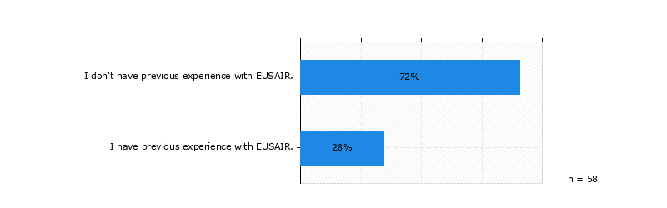
Who do you consider to be a rightful representative of youth in the context of youth engagement in EUSAIR? Multiple choice question
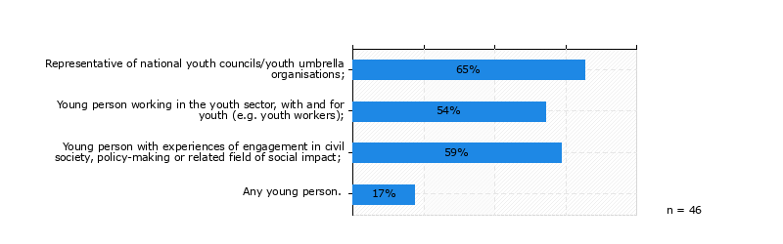
Within which age bracket should youth representatives in the EUSAIR Youth Council fall?
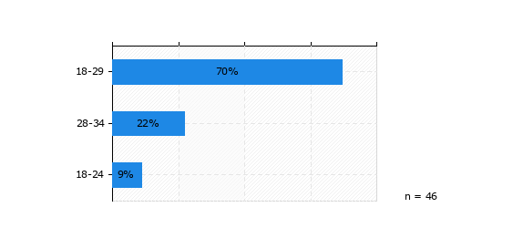
How many representatives should there be in the EUSAIR Youth Council per EUSAIR participating country?
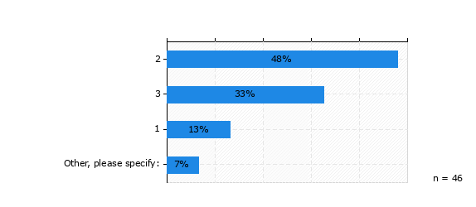
Other, please specify
three people would provide both representation and better follow-up of decisions/activities
5
equal, from all countries
How should youth representatives be selected for the EUSAIR Youth Council?
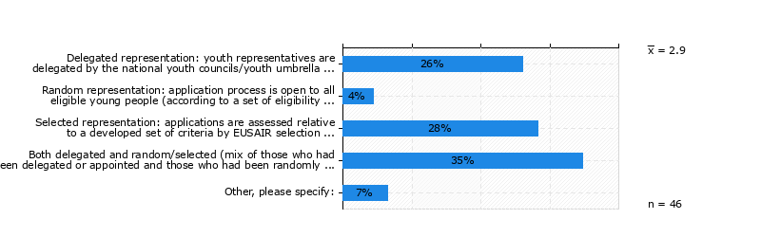
Other, please specify
just no.1 or a mix of 1. and 3.
recognised youth organisations (not national youth councils) should delegate representatives.
the process could mix delegate representation (from nyc and other umbrella organisations) and selected representation when it comes to youth representatives of other youth organisations. including also youth representatives from other types of organisations would guarantee an open process, based on equal opportunities and non-discrimination and deeper territorial coverage. it is not to be fogotten that under the ai-nurecc plus project the adriatic ionian euroregion (aie) created the adriatic ionian youth network (aiyn), which is - for now - a loosely organised network of 20+ youth organisations in 10 eusair countries. the aiyn could provide its contribution to the creation of the eusair youth council as well as to its capitalisation at territorial level. for this reason, i suggest to find a mechanism for its inclusion as well.
Please rate how important you find each of the guiding principles in selection of representatives, 6 being 'most important' and 1 being 'least important'.
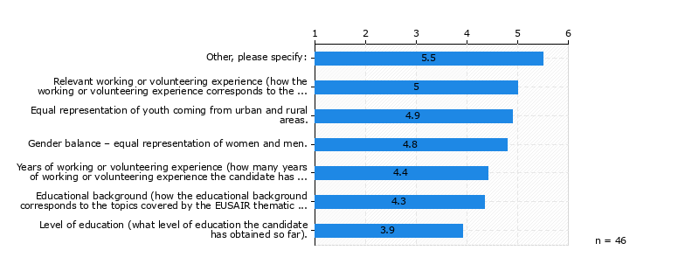
Other, please specify
motivation and willingness to cooperate
some engagement experience with policy making in the topics covered by eusair; experience with regional cooperation could constitute an added value
some engagement experience with policy making in the topics covered by eusair; experience with regional cooperation could constitute an added valueration
experiance in working/cooperating with international teams and bodies
willingness to collaborate - enthusiasm
willingness to collaborate and contribute- enthusiasm

How long should youth representatives serve their mandate in the EUSAIR Youth Council?
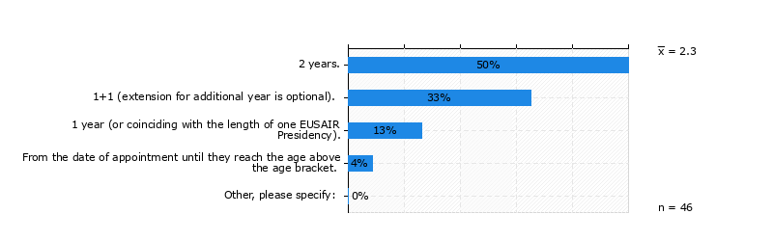
Should youth representatives have the opportunity of the limited extension of mandate?
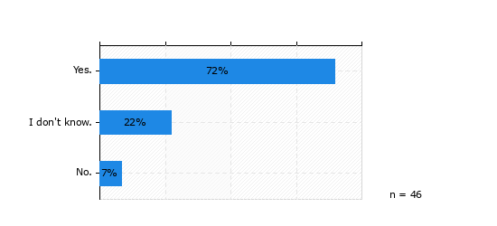
What kind of role should EUSAIR Youth Council play within EUSAIR? Multiple choice question
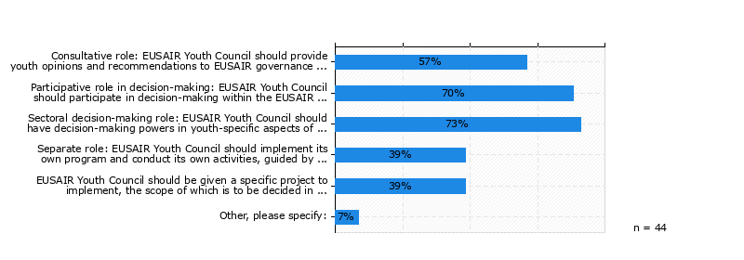
Other, please specify
it is recommended to establish well-defined guidelines and a monitoring framework that includes clear indicators before initiating the eusair yc. furthermore, if the inception period approach is taken into account, and depending on the youth dimension\`s vision and available resources, it may be worthwhile to discuss the extent of eusair yc involvement in decision-making.
the eusair yc should participate in decision-making to ascertain within eusair governing structures that the ideas, needs, projects related to youth are followed up with decisions that determine how these will be implemented or embedded in policy-making. participation in eusair decision-making structures cannot be enough to afford the eusair yc the capacity to make a difference and boost youth engagement in the region. for this reason, the eusair yc should also have decision-making power in youth-specific aspects of eusair action plan and strategic projects. thid means that youth-related aspects should be considered in the eusair action plan, that actions and strategic project should be envisaged therein, under a specific pillar (e.g. social pillar). the collaboration with stakeholders can only be beneficial to this process of fully-fledged engagement of the eusair yc in the strategy and to its territorial implementation. the eusair yc could be the implementer of its own programme and conduct its own activities, guided by thematic pillars and priorities of eusair macro-regional strategy, and thus have an operative role. what if this more “operative” part was shared with the adriatic ionian youth network?

With which governance structures should EUSAIR Youth Council interact? Multiple choice question If you need a reminder of the EUSAIR governance structure, you can jog your memory by returning to the e-learning module [FP1] or checking out this link!
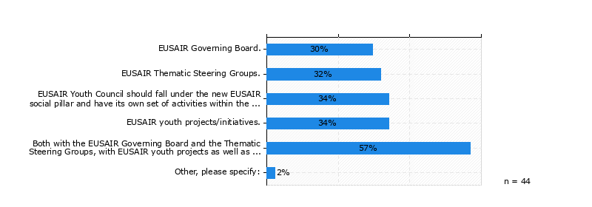
Other, please specify
again, fully-fledged participation would positively impact the role of the eusair youth council and the results of its action. cooperation with with eusair youth projects and the aiyn could be crucial to a better implementation and follow-up, as well as to a broader and deeper impact.

What area topics should fall under EUSAIR Youth Council matter of interest? Multiple choice question 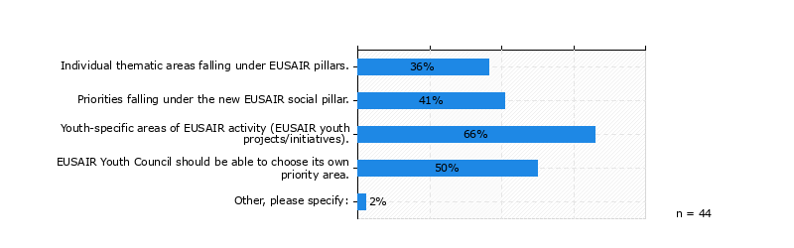
Other, please specify
the eusair youth council should be able to choose its own priority. however, in coordination with eusair structures, it could explore individual thematic areas falling under eusair pillars with a view to the promotion of a better youth employment, entrepreneurship as well as innovation, as well as priorities falling under the new eusair social pillar with a view to a better education and social inclusion. eusair youth projects/initiatives could be useful to support the eusair yc in developing youth-specific areas of eusair activity.
What should be the role of the already existing Adriatic-Ionian youth initiatives (such as POPRI, AI-NURECC – Adriatic Ionian Youth Organisations Forum, CDI Connecting Youth platform, etc..) upon the set up of the EUSAIR Youth Council?
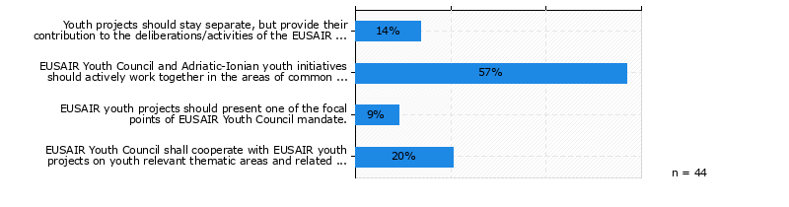
What should be the relation of the EUSAIR Youth Council to the national youth organisations or associations in the EUSAIR participating countries?
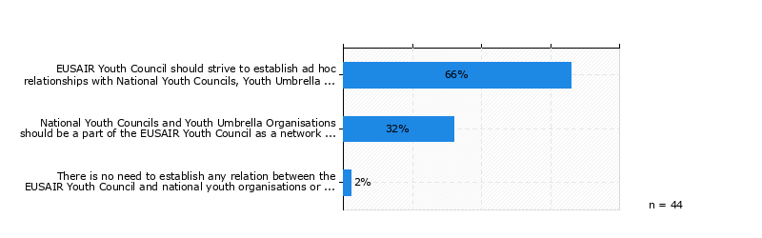
How should EUSAIR Youth Council be set up?
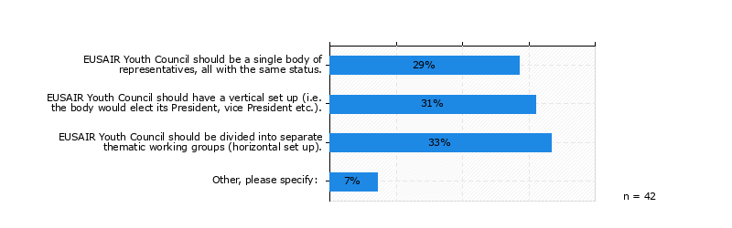
Other, please specify:
eusair youth council should be a single body of representatives, all with the same status. however, pillar working groups and a secretariat shall be created to ensure both an efficient and impactful engagement with eusair governance and a functioning and sustainable eusair yc.
the adriatic ionian region is very diverse and, although political priorities of the strategy are all the same across the region, each country has its own distinctive strenghts, weaknesses, challenges and resources. for this reason, equal opportunity of representation is crucial to tackling these differences more effectively

Who should draft the Rules of Procedures for the EUSAIR Youth Council (taking also into account the results of this survey)?
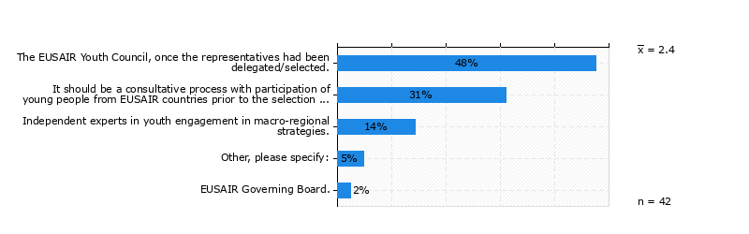
Other, please specify:
it should be a consultative and participated process prior to the selection process , in cooperation with independent experts in youth engagement, and with the possibility to revise the rop after one year since the eusair youth council is set.
it whould be a consultative and participated process prior to the selection process , in cooperation with independent experts in youth engagement, and with the possibility to revise the rop after one year since the eusair youth council is set

How should decisions be made within the EUSAIR Youth Council?
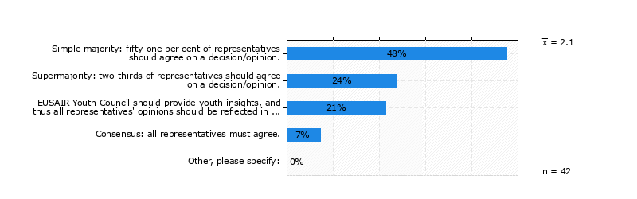
Please rate individual elements of existing youth engagement models in MRS in relation to their potential added value to the youth engagement model in EUSAIR, on a scale of 1 to 7, where 1 is ‘no added value’ and 7 is ‘high added value’.

Where are you from (country)?
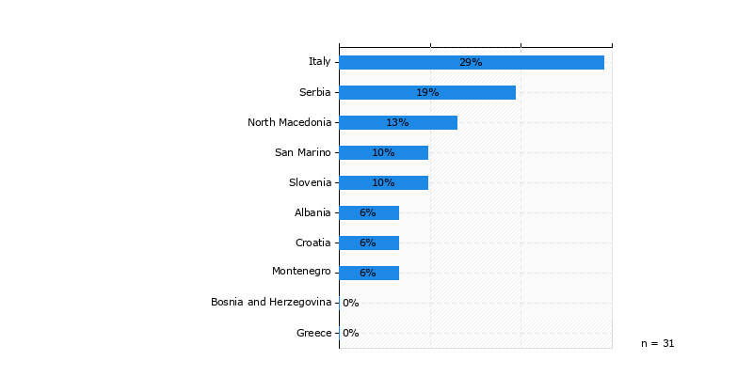
When were you born (year)?

What is your youth engagement role?
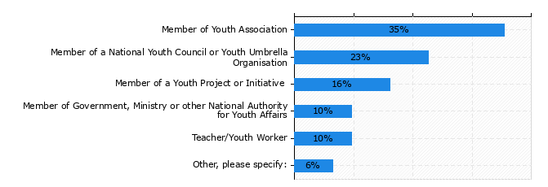

C) EUSAIR Youth Open Consultation results
Do you have previous experiences with EUSAIR or is this your first contact with it?
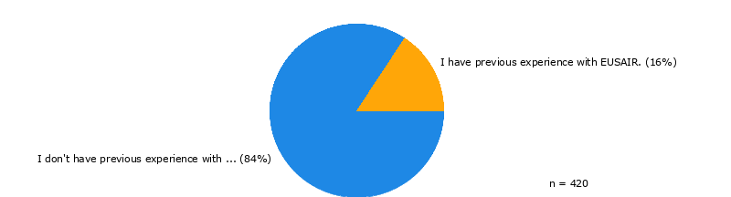
Who do you consider to be a rightful representative of youth in the context of youth engagement in EUSAIR? Multiple choice question
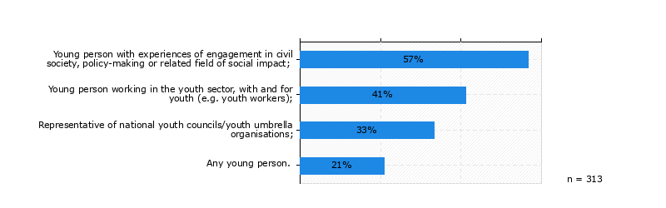
Within which age bracket should youth representatives in the EUSAIR Youth Council fall?
How many representatives should there be in the EUSAIR Youth Council per EUSAIR participating country?
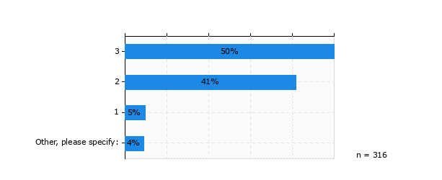
Other, please specify
100
5 or 7 people
4
5
6
10

How should youth representatives be selected for the EUSAIR Youth Council?
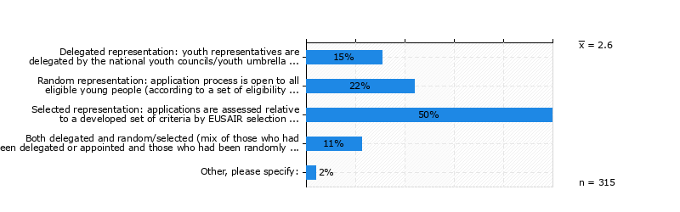
Other, please specify
two of the three representatives should be chosen by a developed set of criteria (selected representation) and one of the three representatives should be chosen by a lottery system in order to counter potential bias eusair selection committee could have.
be elected

Please rate how important you find each of the guiding principles in selection of representatives, 6 being 'most important' and 1 being 'least important'.
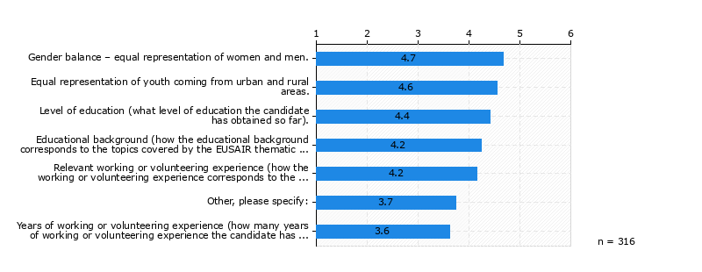Other, please specify
different backgrounds, interests and fields of work or study
ideali politici
aaa
creative ideas, thinking, retorical capabilities
yes, no
genuinely careing about the cause or the project is presented to him/her/they

How long should youth representatives serve their mandate in the EUSAIR Youth Council?
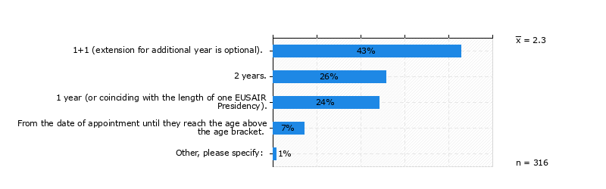
Other, please specify
yes
2 years and the possibility to get re elected for another two years

Should youth representatives have the opportunity of the limited extension of mandate?
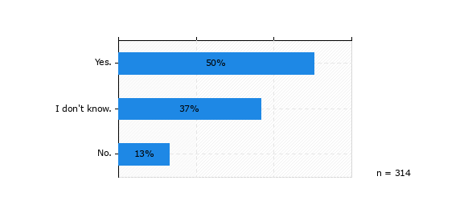

What kind of role should EUSAIR Youth Council play within EUSAIR? Multiple choice question
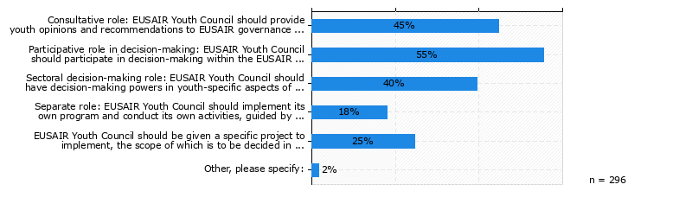
With which governance structures should EUSAIR Youth Council interact? Multiple choice question If you need a reminder of the EUSAIR governance structure, you can jog your memory by returning to the e-learning module [FP1] or checking out this link!
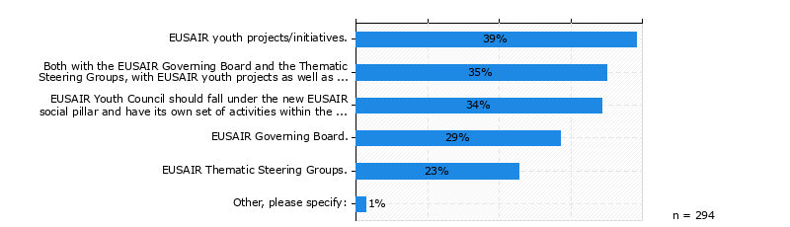
What area topics should fall under EUSAIR Youth Council matter of interest? Multiple choice question
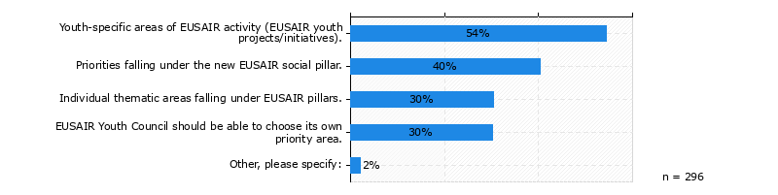
What should be the role of the already existing Adriatic-Ionian youth initiatives (such as POPRI, AI-NURECC – Adriatic Ionian Youth Organisations Forum, CDI Connecting Youth platform, etc..) upon the set up of the EUSAIR Youth Council?
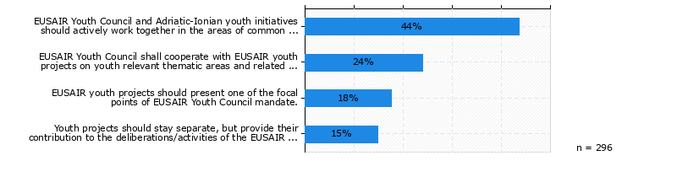
What should be the relation of the EUSAIR Youth Council to the national youth organisations or associations in the EUSAIR participating countries?
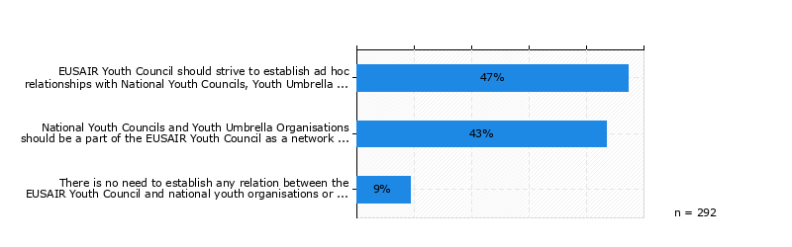
How should EUSAIR Youth Council be set up?
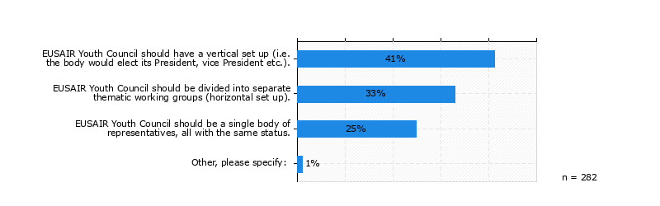
Who should draft the Rules of Procedures for the EUSAIR Youth Council (taking also into account the results of this survey)? (n = 282)
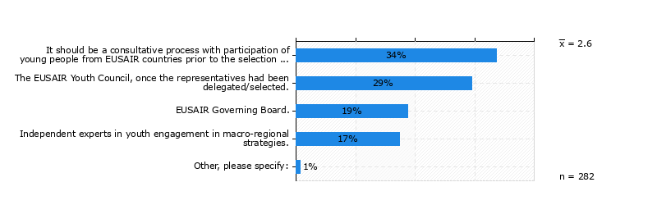
Other, please specify

eusair youth council and governing board

How should decisions be made within the EUSAIR Youth Council?
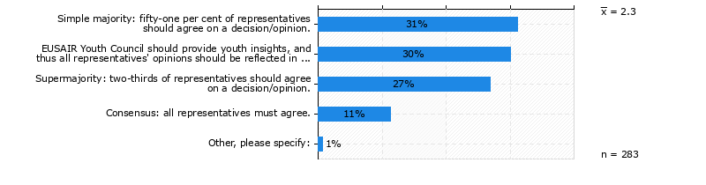
How often should EUSAIR Youth Council meet?
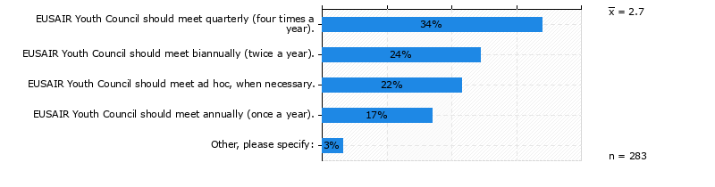
Other, please specify
four times a year and when necessary
at least 6 times a year
4 volte all\`anno di base, se ci fossero problemi urgenti, con più consigli quante sono le urgenze
2 times a year
twice a year in person, other times online
non posso che non rispondere...
once a year or before if it\`s necessary
3 volte l\`anno
regolarmente 1 volta all\`anno, in caso di necessità si possono riunire più volte

Please rate individual elements of existing youth engagement models in MRS in relation to their potential added value to the youth engagement model in EUSAIR, on a scale of 1 to 7, where 1 is ‘no added value’ and 7 is ‘high added value’.
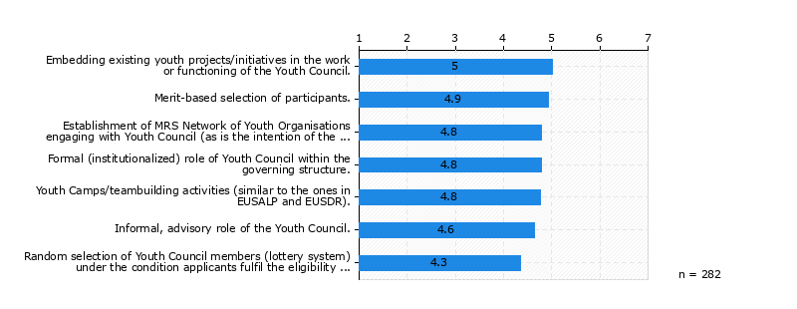
Where are you from (country)?

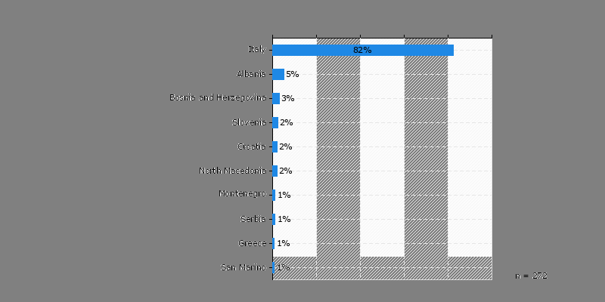
When were you born (year)?

Are you working or studying?
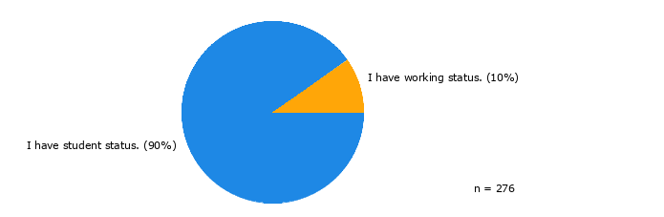

Depending on project acquisition success rate and including secured funding.
Question was revised in line with comments received to EUSAIR GB Written Procedure 2024/1.
Question was revised in line with comments received to EUSAIR GB Written Procedure 2024/1.

