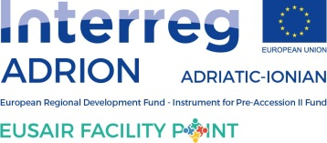

TOWARDS THE REVISION OF THE
EUSAIR ACTION PLAN
Background document with the Roadmap
14 November 2022, V.4.0

CONTENT:
1. Introduction 3
2. Scope of the EUSAIR revision 3
History of EUSAIR 3
Reasons behind the revision of the EUSAIR Action Plan 4
Scope of the revision 9
Key existing sources for the revision 10
3. Towards the revision 12
Proposed course of actions – ROADMAP & MILESTONES 12
Facility Point technical coordination: 13
Revision timeframe: 13
Roadmap & milestones: 14
EUSAIR revision process further explained 20
EUSAIR internal consultation 20
National consultation 21
Public consultation 21

Introduction
The Izola Declaration, adopted at the 6th Adriatic and Ionian Council/EUSAIR Ministerial Meeting, held in Izola on 11 May 2021 under Slovenian Presidency, paved the way for the start of the EUSAIR Action Plan revision. Paragraph 11 of the Declaration calls on the participating countries to CONSIDER the necessity of the revision of the EUSAIR Action Plan to adapt the Strategy to the changes in its membership and respond better to current challenges including those generated by the COVID-19 pandemic.
At the 16th EUSAIR Governing Board meeting countries decided that EC, Albanian Presidency and the Facility Point prepare the roadmap for the revision.
As agreed by the GB, the first draft Background document with Roadmap was presented at the 17th GB meeting, held on 2 and 3 March 2022. The document focused on scope of the Action Plan revision process, methodology and the relevant timeline.
The Tirana Declaration, adopted at the 7th Adriatic and Ionian Council/EUSAIR Ministerial Meeting, held in Tirana on 16 May 2022, reaffirmed its commitment to the EUSAIR Action Plan and its revision process. At the 16th EUSAIR Governing Board meeting countries decided that EC, Albanian Presidency and the Facility Point prepare the roadmap for the revision.
The main purpose of this document is to outline the basic framework of the EUSAIR revision: scope of the revision, sources of information and revision process (roadmap with milestones and timeline as well as methodology of key revision steps). The strategic course of the revision, challenges, and opportunities of the region to be addressed by the revision of the strategy and the relevant thematic response are part of the revision process outputs and results and as such not to be found in this document.

Scope of the EUSAIR revision

History of EUSAIR
The EU Strategy for the Adriatic and Ionian Region (EUSAIR) was adopted by the European Commission and endorsed by the European Council in 2014 to become the third macro-regional strategy in the EU. During extensive stakeholder engagement region’s common challenges, opportunities and anticipated response through designated pillars and topics were identified and agreed. From the beginning, the Strategy encompassed eight countries, with the ninth country, North Macedonia, officially joining in 2020, and tenth country, San Marino, officially joining in 2022, namely:
- 4 EU Member States: Croatia, Greece, Italy (regions Abruzzo, Basilicata, Calabria, Emilia-Romagna, Friuli-Venezia Giulia, Lombardia, Marche, Molise, Puglia, Sicilia, Umbria, Veneto, Provincia Autonoma di Bolzano/Bozen, Provincia Autonoma di Trento) and Slovenia;
- 5 EU candidate or potential candidate countries: Albania, Bosnia and Herzegovina, Montenegro, North Macedonia and Serbia;
- 1 third country: San Marino.
The European Commission (DG REGIO, with the support of line DGs), acts as a strategic advisor of the EUSAIR participating countries.
The Communication (SWD(2020) 57 final, replacing document SWD(2014) 190 final) is the Action Plan accompanying the Strategy, a document which further details areas of mutual interest with high relevance for the Adriatic-Ionian countries identified in the Strategy, and points to actions/projects relevant for addressing common challenges and opportunities of the Strategy.
The countries aim to create synergies and foster coordination among all territories in the Adriatic-Ionian Region in the four thematic areas/pillars which are coordinated by a tandem of countries:
1) Blue Growth (Greece, Montenegro)
2) Connecting the Region (Italy, Serbia, from 2020 also North Macedonia)
3) Environmental Quality (Slovenia, Bosnia and Herzegovina)
4) Sustainable Tourism (Croatia, Albania).
In addition, the Strategy and Action Plan list two cross-cutting issues:
- Research, innovation and SMEs
- Capacity building, including communication
In addition to the political level, consisting of Ministers for EU Funds and Ministers of Foreign Affairs of ten participating countries taking strategic decisions at the EUSAIR Annual forums’ ministerial meetings, the EUSAIR governance architecture involves two main levels: the coordinating level represented by a Governing Board and the implementation level represented by Thematic Steering Groups. Operational support to both levels is provided by the EUSAIR Facility Point strategic project (co-financed by Interreg Transnational Programme ADRION).

Reasons behind the revision of the EUSAIR Action Plan
The Strategy defines the geographical perimeter of the region, the main objective, commonly identified challenges and opportunities and outlines the basic approach of the response: the Action Plan. The aim of the Action Plan is to go from ‘words to actions’ by identifying the concrete priorities for the macro-region. The Strategy and Action Plan were drafted through an extensive, bottom-up consultation process that involved a wide range of stakeholders from the Adriatic-Ionian Region representing national, regional and local authorities, but also the private sector, academia and civil society. This approach allowed stakeholders at all levels to select four Pillars as well as to point to actions/projects under each Pillar that appeared promising for responding to challenges and opportunities shared by participating countries. The Action Plan is conceived to be rolling. This means that new actions may be added as needs change over time while existing actions are adapted as they move closer to completion. To ensure an effective rolling system, regular and systematic monitoring and evaluation activities should be foreseen, to highlight the state of the art of the implementation of current actions, and point out new ones to be developed.
After seven years of implementation, it can be said that the Strategy is robust and resilient enough and that it has delivered, also during the Covid-19 crisis. However, a number of new challenges have emerged or further anchored in the policy agenda (e.g. climate change adaptation and decarbonisation, digitalization, after covid recovery, youth involvement, migration, gender equality and women’s empowerment, security etc.). Furthermore, present crises (war in Ukraine and related adjustments in the energy sector’s priorities, related food security crisis, after covid related supply chain crisis) and their long-term effects also call for a coordinated response. After EU-2020 EU policies and Commission’s priorities were revised to address these new challenges and are supported by the current financial framework (2021-2027). Moreover, the changes in the geography of the Strategy call for a revision of the Action plan that enhances the role of EUSAIR in contributing to the EU enlargement and the achievement of full EU membership by EUSAIR candidate and potential candidate countries, supporting the adoption of the acquis communautaire and facilitating the process of adaptation to EU decision making. From the very beginning, European integration is one of the two main objectives of the Strategy, together with harmonious and sustainable development. In synthesis, the revision of the Action Plan has to satisfy two objectives, as indicated by the Declaration of Tirana and Izola:
a) to respond better to current challenges including those generated by the COVID-19 pandemic, and the Ukrainian crisis, in line with the existing EU and West Balkans agendas and strategic guidelines. For example, the limitation of movement due to the pandemic first and then to the war has had a particular impact on tourism which represents important percentages of the states' economy; tourism sustainability must now include these new aspects;
b) to adapt the Strategy to the changes in its membership, and in the geography, enhancing the role of the Strategy in promoting and accompanying the enlargement process, supporting the Western Balkans in their reform process towards the adoption of the acquis communautaire. Therefore, it needs to align with new policy developments, address common challenges with its own region-specific response and respond to regional needs such as support for the enlargement process, education and skills gap, economic and social disparities, including gender equality and women’s empowerment etc.
Key implementers and stakeholders shall now discuss what worked, what did not work during eight years of implementation of the EUSAIR, what can be changed and if new cooperation topics in line with the new challenges or new priorities should be added to the Action Plan.
The Commission Report on the implementation of macro-regional strategies from September 2020 (SWD(2020) 186 final) stresses that the EUSAIR has yielded significant results in terms of establishing stable and efficient governing structures, increased regional cooperation in its priority sectors, support in the enlargement process of Western Balkan countries and more. Now MRS key implementers, stakeholders and the public expect meaningful progress in putting in place joint actions and projects that aim to improve the attractiveness, competitiveness and connectivity of the region.
The report also identifies several challenges, such as:
- Gap between official political commitments and the ability of national administrations to follow up on them.
- Difficulties in developing ownership among national and local stakeholders, complexity of governing structures, lack of clear mandates for key implementers and difficulties with funding mechanisms.
- More coordination and exchange of information between AII, the AI Fora and their network AII and the governing structures of the EUSAIR needed.
- EUSAIR should reach out more to NGOs, associations, and businesses that are only occasionally involved.
- Efforts by key implementers and stakeholders are needed to increase EUSAIR’s impact on policies. A more strategic vision for implementing the Strategy is needed. On the one hand, a stronger political guidance is needed to mobilise relevant administrative structures in all participating countries. On the other hand, wider participation of civil society needs to be sought through extensive consultations for governing structures to get better acquainted with the needs at grassroots level.
- Line Ministers have little involvement in implementing the EUSAIR, which needs a coordinated approach to yield meaningful results. This has consequences at implementation level, where a low level of ownership and staff constraints, poor awareness in sectoral administrations and lack of participation to TSG meetings affect the overall decision-making capacity of these bodies and impacts on the desired objectives.
- More capacity building is needed for EUSAIR key implementers to improve strategic planning and to make the EUSAIR a place for regional discussion on key challenges and opportunities, and to adapt actions to relevant EU policies. This would not only support the development of macro-regional projects, but would also help key implementers to focus on processes and increasing cooperation from the political level down to civil society.
- The difference in administrative capacity and availability of human resources as well as the disparities in the internal organisation of the administration has an impact on the level of involvement of actors in national EUSAIR governing structures. As a consequence, the ability to achieve the objectives of the EUSAIR under each pillar and to align to EU policy differs from country to country.
- There is a need to liaise more with initiatives at European and international level, to define responsibilities, avoid overlapping and looking for complementarities. Some cooperation exists between the EUSAIR and the Barcelona Convention, which is part of the EU Acquis, and a number of relevant multilateral organisations, such as the Energy Community, the Transport Community, the Council of Europe, but a more structured coordination and clearer division of responsibilities would support the efforts of all organisations concerned.
- Raising funds for the implementation of genuine macro-regional projects is one of the main concerns of EUSAIR key implementers. The MRS come with no new funds, meaning that stakeholders or beneficiaries needs to look at a variety of available EU, international, national and private funding instruments in order to finance their activities. The EUSAIR key implementers should support and provide guidance on funding opportunities. Emphasis should be given to the development of capacity to matching funds, project ideas and proposals.
- A difference between access to EU funding between EU Member States and non-EU countries. A balanced implementation throughout the Adriatic and Ionian region of EUSAIR actions and projects is a challenge due to a lower of financial capacity in IPA countries. Beside the ongoing activities of embedding EUSAIR priorities into ESI and IPA Funds mainstream programmes, a discussion regarding the use of EU directly managed funds (HORIZON 2020, LIFE, COSME, CEF, ERASMUS+, etc.), as well as on seeking support from International Financial Institutions and private funds should be initiated. This also involves representatives of the Commission departments dealing with directly managed funds, the European Investment Bank (EIB), the Western Balkans Investment Framework (WBIF) and other funding and financial instruments relevant to EUSAIR TSGs.
- Bringing enlargement countries closer to EU values and policies poses practical difficulties in terms of embedding EUSAIR priorities in ESI and IPA funding programmes. Different structures, regulations, methodologies, timing and available amounts have to be addressed. This makes it challenging to devise joint, parallel or coordinated actions and projects implementing the EUSAIR action plan.
- Political support needs to be translated into more stable participation in governing structures, particularly in TSGs.

The report proposes that a revision of the EUSAIR Action Plan should ensure its contribution to national and EU policies (for EUSAIR relevant sectors) and priorities (‘a stronger Europe in the world’, the ‘European Green Deal’, ‘an economy that works for people’) and add the flexibility needed to allow for prompt reactions to crisis and to keep abreast of changing needs. The need for such flexibility became clear in March 2020 with the outbreak of the COVID-19 crisis.

Together with advancing the embedding process, a closer link to the enlargement process shall be of utmost importance to reaffirm the European perspective in the Western Balkans, in line with the new Commission objective of ‘a stronger Europe in the world’. The EUSAIR, as a flexible instrument, should adapt its activities to the reform of the enlargement methodology (COM (2020) 57 final) and should 'go from words to actions' by practically supporting the enlargement process operationally. By allowing cooperation on a level playing field, the EUSAIR is the ideal instrument to open gradually EU policies (those related to the four EUSAIR pillars) to candidate and potential candidate countries. At political level, sharing knowledge and cooperating should be established through high-level political initiatives in the region such as the EU-Western Balkan Summits and relevant regional cooperation initiatives. This will reduce overlaps, allow for better coordination and increase regional cooperation with the end goal of having a stronger, more positive impact on people living in the region.

Considering the cross-sector nature of this theme, and its wideness, an effective approach could consist in introducing the Enlargement as a horizontal dimension of the Strategy, similar to what has been done for Research and Innovation and Governance. In this way, the enlargement dimension should be considered all along the Strategy implementation, from the development of the actions, to the projects selection criteria, up to the monitoring and evaluation activities, in order to support IPA countries in their reforms towards the adoption of the acquis communautarie and to progressively socialise them to the EU decision making rules.
The Commission Report on the implementation of macro-regional strategies proposes further topics and objectives:
‘Climate change mitigation’, as a horizontal objective of the EUSAIR, contributes across all the pillars to achieving the goals of the ‘European Green Deal’. In the future programming period, commitments to reducing the carbon footprint in the region needs to be boosted, particularly for the transport, energy and tourism sectors. To maximise the impact of the European Green Deal, the entire Europe, including the Western Balkans, should put mitigation of climate change high on their national agendas. Together with the ‘Green Agenda for the Western Balkans’, which is currently under preparation, the EUSAIR is the ideal instrument to enable cooperation on joint actions, projects and processes supporting decarbonisation efforts in the Adriatic and Ionian region.
Any revision of the EUSAIR Action Plan should embed the EU target to make Europe a climate-neutral continent by 2050 and the connected targets of a toxic-free environment by combating pollution, enhancing the circularity of the economy and preserving and restoring biodiversity. It is also essential to align the EUSAIR to national strategic and development documents in all participating countries such as policy implementation plans and programmes required by the EU acquis.
Macro-regional strategies offer to its constituencies a flexible instrument for cooperation, not bound by EU funding regulations or international financial instrument conditions. In these particularly unprecedented times, participating countries should use the EUSAIR as an appropriate tool to respond to the COVID-19 crisis in cooperation with their neighbours. Any future revision of the Strategy should envisage mechanisms that allow swift reactions to crises and sudden challenges, be they at regional level, as in the case of migration (of non-EU nationals), or at global level, as in the case of the COVID-19 crisis.
In particular, the pandemic crisis showed the importance of promoting cooperation and coordination in the field of social and health sectors, to defend the well-being of people, and to protect the most fragile and at risk of exclusion groups. To that scope a new thematic Pillar, dealing with social and health-related themes, could be entered into the Strategy. Such a Pillar could also respond to the need for involvement of youth, as was highlighted at the 16th Governing Board meeting (18.-19.10.2021), which could consider both the education and skill development aspects, to facilitate the participation of young people to the economic development and to labour market, and the empowerment of youth to better participate to the development of European policies and strategies, such EUSAIR.
Children needs, in line with the Children Guarantee framework, could also be included in a new “Social Pillar” of the Strategy, considering the impact of the pandemic and of the Ukraine crisis in the EUSAIR area.

Scope of the revision
Starting from the political mandate expressed in the Izola and Tirana Declarations, and taking into account the findings of the EUSAIR evaluation, the relevant Commission reports, and the experience of the participating countries, the proposals of Thematic Steering Groups and EUSAIR stakeholders, the revision process may address the following:

- Strategy response: pillars and topics
- Elements of the Action Plan
- Thematic contents of the Action Plan
- Governance of EUSAIR (internal and external)
- Strategy’s cooperation with other macro-regional strategies, sea-basin strategies and initiatives in the region
- Interplay of EUSAIR with European Funding Facilities (embedding & implementation)
- Cooperation with region’s key stakeholder networks.
The revision process shall involve all possible stakeholders (EU, EUSAIR key stakeholders, national, regional and local actors, civil society, academia and others). It shall duly take into account the principle of inclusive participation allowing for co-design, (i.e. participatory approach to the design of the Roadmap) and shall take into account different levels of consultation:

- Strategic (Governing Board - GB, National Coordinators - NCs);
- Thematic (Thematic Steering Groups - TSGs);
- Public consultation (EUSAIR key stakeholders and interested general public with special focus on youth).

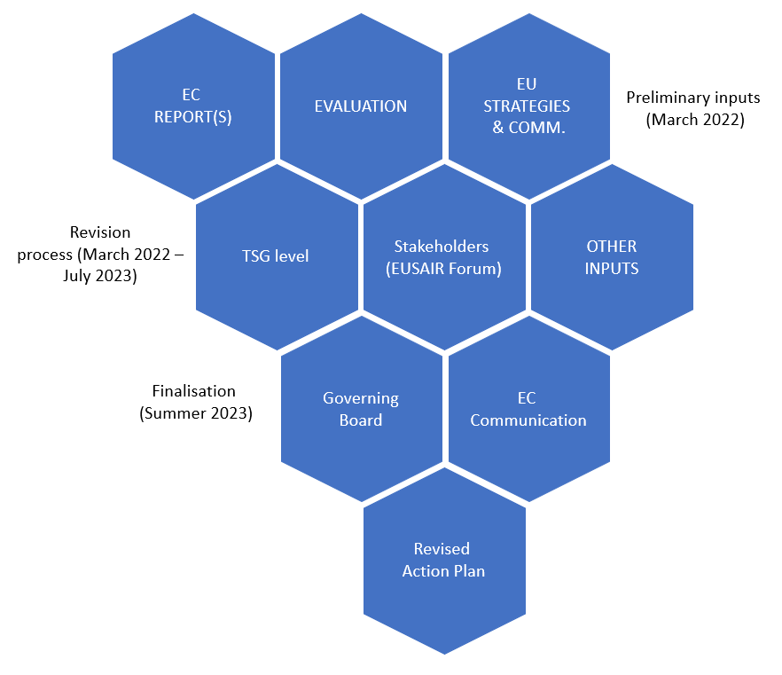
Figure 1: Three steps of the revision process

Key existing sources for the revision

EUSAIR Evaluation (presented at the Governing Board in March 2022) covers three key aspects: (i) Strategy and its Action Plan, (ii) Suitability of the implementation mechanisms, (iii) Operability of the governing structures. It will serve as an input in addressing the issue on whether to amend the Strategy and Action Plan, how to amend it and which elements to modify. As stated in the Evaluation apart from identifying the actions, the following issues will be considered in the revised Action Plan:
- Use of a rationale from projects to macro-processes, expanding on the flagships experience and focusing on few priorities with a strategic character, clear expectations, added value and multiplier effects.
- Define “programming periods” and a coherent system of indicators based on the Common Indicators of the ESIF, with a common methodology for all Pillars and aligned with clear strategy objectives.
- Standardization of the TSGs working methodologies, to support them in delivering “chains of projects” and “project to policy loops”.
- Creating new roles in the TSGs for smoother implementation.
- Appropriate arrangements for the active involvement of MAs and DG Services at project level.
- Political backing of the TSGs and their members from their home institutions.

Revision process will take into account additional available key sources, for example:
- EUSAIR Synthesis Monitoring Report for year 2021, MNEC (Greece)
- EUSAIR Synthesis Report: Multi-level Governance and Cross-Sector Practices Supporting the European Union Strategy for the Adriatic and Ionian Region, 2019;
- EU Strategy for the Adriatic and Ionian Region (EUSAIR) facilitating the enlargement process of Western Balkans, 2021;
- Repositioning of the European Union Strategy for the Adriatic and Ionian Region (EUSAIR), 2021;
- The EC report on EUSAIR bringing the Green Deal to the region, announced by the EC during the 16th Governing Board meeting;
- Ex-ante assessment of air quality in EUSALP and EUSAIR macro-regions - Publications Office of the EU (europa.eu)
- Study on macroregional strategies and their links with cohesion policy (COWI): Data and analytical report for the EUSAIR (2017);
- Pillar related studies
- Last but not least, the revision process shall take into account also the events, workshops and other sessions’ outcomes.

Moreover, EU policy documents will be taken into account (indicative list):
- EU Green Deal (with reference to Climate goals for 2030 and 2050-climate change prevention and adaptation measures; Providing clean, accessible and safe energy; Mobilizing industry for a circular economy; Building and renovating efficiently; Accelerate the change towards connected and gentle mobility; From the farm to the fork; Preserve and restore ecosystems and biodiversity; Zero pollution goal for an environment free of toxic substances) in line with some of the strategic documents cited in the next points);
- Manifesto for Young People by Young People to Shape the European Cooperation Policy;
- A new approach for a sustainable blue economy in the EU (linked with the Blue Economy Report);
- EU biodiversity strategy 2030;
- New EU Forest Strategy;
- Smart and sustainable mobility strategy;
- Communication on TEN-T extension to third countries;
- EU fit for the digital age;
- Tourism Transition Pathway;
- Long term vision for the rural areas;
- EU Urban Agenda;
- -Horizon Europe, and the updated documents related to the European Research and Innovation policyVIII Relation on Cohesion, taking also into account the Governance, Capacity building, and Quality of the Institution aspects;Economic and Investment Plan for the Western Balkans;
- Green Agenda for the Western Balkans;
- Western Balkans Agenda on Innovation, Research, Education, Culture, Youth and Sport
- REPowerEU plan
- Etc.
This is a non-exhaustive list, a more detailed list of policy documents has been inserted in each Initial policy paper and sent to the single TSGs and sub-groups.
Furthermore, political declarations, studies and reports from key stakeholders related to Adriatic and Ionian Region will be also considered. For example AII - Adriatic Ionian Initiative; relevant UN programmes, commissions and centres, RCC - Regional Cooperation Council.
The revision process shall also consider available data and evidence base stemming from other ongoing or finished monitoring and evaluation processes (ESPON EMTM – European and Macro-regional Territorial Monitoring Tool, JRC reports, Territorial Analysis carried out under the ADRION Transnational Programme, relevant commission studies and reports), whenever appropriate, in order to streamline and focus EUSAIR activities.

Towards the revision

Proposed course of actions – ROADMAP & MILESTONES
The Roadmap is a living document that shall be regularly monitored and updated by applying the participatory approach. The existing communication channels as well as the newly established Group “EUSAIR Revision Spot” in the EUSAIR Stakeholder Platform will ensure regular exchange between EUSAIR implementers and with the interested stakeholders aiming to help maintain ownership throughout the revision process.
Key implementers and their role in the revision process:
- EUSAIR Presidency: leads the process;
- EC (DG Regio): observes and advises the process, coordinates with other DGs;
- National Coordinators: carry out national coordination and present strategic positions on the Action Plan revision throughout the process, approve advancements in the drafting process - decide on Action Plan structure, governance implications and contents, provide feedback to the draft of input document for EC Action Plan Staff Working Document, a dedicated Revision Working Group will be formed to consolidate proposals before taking decisions by the National Coordinators;
- Governing Board: adopts the Background document with Roadmap, approves the input document for EC Action Plan Staff Working Document, takes key decisions regarding content, structure and governance of the Action Plan, if so requested by the National Coordinators’ Revision Working Group;
- Pillar Coordinators (PCs): coordinate the thematic consultation in TSGs with the support of the EUSAIR Facility Point;
- TSG members: present country thematic inputs within TSGs on Pillar related topic;
- EUSAIR Facility Point: facilitates the process & ensures the transparency of the process.
- Interested general public with special focus on youth and EUSAIR key stakeholders: share their views regarding revision through public consultation on transnational and national levels.

Facility Point technical coordination:
- Facility Point Lead partner (FP LP) with external consultants facilitates the process on the EUSAIR level and gathers all inputs brought from the participating countries to the EUSAIR level via NCs and PCs (TSGs).
- Pillar-related thematic inputs shall be gathered by PCs, assisted by FP LP with external consultants and pillar thematic experts. TSG members are assisted by the Facility Point project partners (FP PPs).
- Inputs from broad range of stakeholders will be gathered through public consultation on transnational level by the FP LP and from national level by relevant FP PPs, if so decided by the country. Reports from these consultations will be shared within the EUSAIR Stakeholder Platform (ESP), where a dedicated Group “EUSAIR Revision Spot” will be established for the revision process. The exchange encouraged through the established ESP Group shall contribute to the transparency of the processes before and during the revision.

Revision timeframe:
There are two main reasons for the proposed timeframe of the process:
- As mentioned, the process is facilitated by the EUSAIR Facility Point project, which ends in August 2023 at the latest. There are no possibilities for further prolongations, because the Interreg ADRION Programme, financing the project, has to be closed by the end of 2023. It is anticipated that new Facility Point projects 2023-2030 will be submitted to the Interreg IPA ADRION Programme by then to ensure financial and institutional continuity, however delays are possible. Consequently, the majority of revision activities shall be concluded by the end of June 2023.
- As recommended in the EUSAIR Evaluation, the timelines of the EUSAIR revision process and of the EU Financial Frameworks shall align to ensure the revised Action Plan approval prior to the start of the programming. For 2021-2027 Financial Framework EUSAIR revision arrives very late and even too late for numerous Interreg Programmes (including Interreg IPA ADRION).

Roadmap & milestones:
STEPS/MILESTONES | TIME FRAME | WHO | HOW | REMARKS | STATUS
The first draft of the Roadmap & Agreement with the AL Presidency | January 2022 | AL, EC, FP LP | FP LP prepares the draft concept and the Presidency and the EC agree on the draft concept. |  | Comple-ted
Engagement of an external expert that shall facilitate the revision | February-March 2022 | FL LP | To be engaged within the WP T.1 of the FP project, ToRs prepared in February and experts engaged in March 2022 |  | Comple-ted
M1:  Agreement on the process | February- November 2022 | GB | Background document v1.0 presented at 17th GB (2.-3.3.2022), detailed process added for version 2.0 presented at NC meeting on 20.4.2022, version 3.0 prepared for the NC/18th GB meetings (5.-6.10.2022) |  | In progress
Establishment of the Stakeholder Platform EUSAIR Revision Spot (Group within the EUSAIR Stakeholder platform) | April 2022 | IT FP PP | One-stop-shop for the revision of the Action Plan to be established within the EUSAIR Stakeholder Platform where all the documents are presented transparently. | https://esp.aimacroregion.eu/Nu/section/Base/role/(Group)/id_group/1169 | Comple-ted
Launch of EUSAIR level public consultation with key stakeholders and interested general public including youth | May – June 2022 | PCs in Forum Pillar sessions, FP LP on behalf of AL EUSAIR Presidency | Addressing the revision process in the Pillar sessions, on-line questionnaire at EUSAIR website open until 30.6.2022, Speaker’s Corner on revision for youth at the Forum. | Questionnaire for the public consultation was sent to the NCs, PCs, EC and PPs before publication, no comments were received | Comple-ted
EUSAIR level public consultation report published | September 2022 | FP LP with external consultants | Public consultation report published on the EUSAIR website and within ESP Group.  Findings to be presented to EUSAIR key implementers at their Autumn meetings and included in the thematic consultation. |  | In progress
Establishment of Revision Working Group | October/ November 2022 | National Coordinators | National Coordinators nominate country representatives in the Revision Working Group |  | In progress
Launching the internal EUSAIR consultation phase on the relevant EUSAIR levels | October 2022-January 2023 | All key implementers and EC involved in EUSAIR internal consultation, led by Presidency and coordinated, supported by FP LP with external consultants; National consultation to be supported by FP PPs, if necessary | 1st round of EUSAIR consultations on thematic level on existing AP Pillars and Topics in parallel with 1st round of EUSAIR consultation on strategic level regarding Pillars/Topics changes and AP elements.  Meetings are planned before and after the consultation round. | How National consultations are organised/led/ coordinated is up to each country to decide.
M2:  AP pillars, topics/AP structure/governance agreed | February 2023 | This step is led by Presidency, coordinated and supported by FP LP and involves only the strategic level: NCs/GB and EC. | NC/GB decisions based on 1st round of EUSAIR internal consultations on revised Pillars/Topics, AP elements and governance implications. | NC/GB meeting
Second round of thematic consultation | February-April 2023 | All key implementers and EC involved in EUSAIR internal consultation, led by Presidency and coordinated, supported by FP LP with external consultants; National consultation to be supported by FP PPs, if necessary | A second round of Thematic consultation on new pillars/topics and Action Plan elements takes place in TSGs.  TSG meetings are planned.  Another NC meeting organised if needed. | How National consultations are organised/led/ coordinated is up to each country to decide.
M3:  1st Draft Action Plan | May 2023 | Led by Presidency, prepared by FP LP with external consultants | FP LP then prepares the First Draft Action Plan to be shared with EUSAIR implementers.
Final round of internal EUSAIR consultation | May-June 2023 | All implementers and EC involved, led by Presidency and coordinated, supported by FP LP with external consultants; National consultation to be supported by FP PPs | Another round of internal consultation on both strategic and TSG level is envisaged. Feedback is gathered and the draft Action Plan is revised accordingly by FP LP.  Any remaining issues are resolved at meetings on NC/TSG level. | Another round of National consultation may take place to gather feedback, if necessary.
M4:  Input document for EC Action Plan Staff Working Document (SWD) | July-September 2023 | This last phase is led by presidency, coordinated and supported by FP LP and involves only the strategic level: NCs/GB and EC. | Draft document is prepared by FP LP and shared with the NCs. Any final remarks are gathered during Summer to fine-tune the document. Final Input document for EC Action Plan SWD is sent to GB for approval in September 2023.
Draft EC Action Plan SWD | Autumn 2023 | EC | To be drafted by the Commission
Publication of Action Plan Staff Working Document | Early 2024 | EC

The EUSAIR revision timeline and the 4 milestones of the roadmap are visually presented in the below diagram.
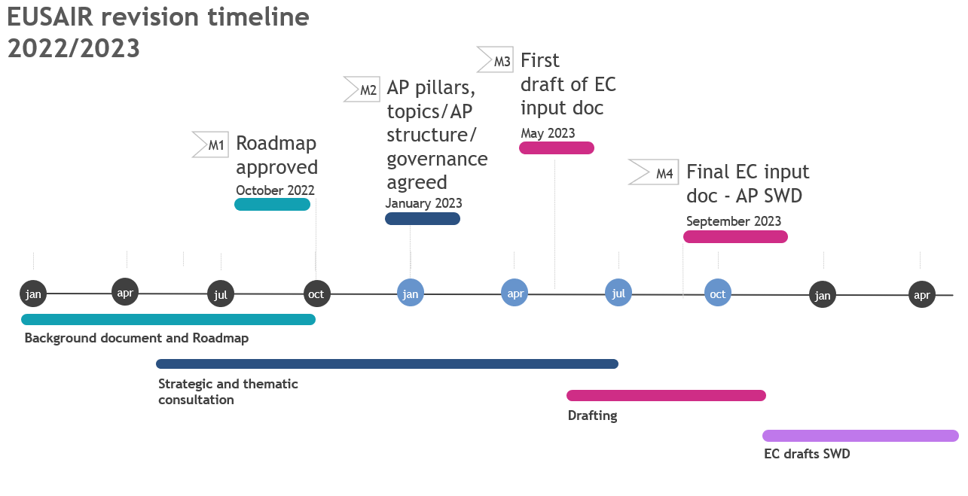
Figure 2: EUSAIR revision timeline with 4 milestones of the roadmap

EUSAIR revision process further explained
The main components of the revision process as briefly described in the Roadmap are further detailed in the next paragraphs and schematically presented in the Figure 3.

EUSAIR internal consultation
The internal consultation is planned on two levels:
- Strategic consultation
Is organised on the level of the NC/GB and concerns the revision of the Action Plan pillars and topics, Action Plan structure (which elements to include in the Action Plan), validation and approval of Action Plan contents provided by the thematic level and related implications on the EUSAIR governance. The NCs bring strategic country positions to the process. A Revision Working Group (WG) is proposed for operational coordination in between meetings to smoothen the process and prior to GB meetings to agree on proposals for decisions. It would consist of a manageable number of nominated NCs.
- Thematic consultation
Is organised on the level of TSGs. In line with TSG Rules of Procedure (RoP) TSGs identify actions of the Action Plan and prepare proposals for Action Plan contents. The results of country consultation on contents of Action Plan elements are brought to the process on the level of TSGs. Pillar Coordinators organise the thematic consultation with support of FP LP (with external consultants) and with pillar thematic experts of the FP PPs. The country inputs are gathered by Pillar Coordinators, who are supported by their Pillar thematic experts and FP LP in preparation and proposals for the strategic level. The results of the Thematic consultation will be the basis for conducting national consultations.
FP LP coordinates timing of both consultations to ensure relevant exchange. The results of the strategic consultation will be presented by the FP LP at the level of thematic consultation to provide strategic guidance. The results of the thematic consultation will be presented as proposals by FP LP or Pillar coordinators at the strategic level, feedback will be gathered, and decisions will be taken to further steer the process. This exchange occurs several times during the revision process. When the draft Action Plan is prepared another round of national consultations shall be organized in the countries by members of the EUSAIR implementing bodies.
Both consultations start after the approval of the revision process methodology. For each TSG Initial policy paper will be prepared together with corresponding questionnaires by the FP LP on the basis of sources listed in Chapter “Key existing sources for the revision” and with consideration of public consultation results. The existing Action Plan will be confronted with newly identified challenges, new policy developments and advancements in the existing Pillars. The TSG initial policy papers and questionnaires are agreed with relevant PCs and their Pillar thematic experts. The aim of the first round of thematic consultation is to gather revision inputs on pillars and topics of the existing Action Plan.
In December 2022 the FP LP will integrate gathered inputs into proposals for early 2023 meetings. In February NC/GB meetings will be organised to decide on Action Plan pillars and topics, Action Plan elements and governance implications. Results of the first round of thematic consultation will be brought to the strategic level to provide input to NCs discussion on revision of the existing Action Plan contents.
TSG meetings will follow in February and March 2023 to validate results of the first round of TSG consultation and agree on first contents of Action Plan elements aligned with GB decisions. At the TSG meetings the relevant new pillars/topics agreed by the GB will be introduced by FP LP. Indicator proposals will be discussed in TSG meetings.
For thematic consultation on new pillars country representatives need to be nominated to participate in the consultation and present country inputs.
After the second round of thematic consultation another NC meeting will be organised if needed to agree on decisions further detailing the Action Plan. At this point the First draft of the Action Plan will be drawn up and another round of national consultations shall be organized in the countries by members of the EUSAIR implementing bodies. Feedback will be gathered by the FP LP and any additional meetings will be organized if needed to resolve any remaining issues. Draft input document for the EC Action Plan Staff Working Document will be ready by the end of June 2023 and any last fine-tuning would have to be organised during the Summer to have the final input document ready in August 2023 for the GB approval in September 2023.

National consultation
How national consultation is organised is up-to to each participating country to plan and implement. The FP PPs could be engaged to support this national process. The results of national consultation shall be brought to the revision process by National Coordinators mainly on strategic aspects of the revision (Action Plan pillars and topics, Action Plan elements and governance), while country input on Action Plan content is brought to the TSGs by TSG members or appointed country representatives (for any possible additional pillars or topics). The results of thematic consultation will be the basis for conducting national consultations. The national consultations should be organized as requested by the national rules and practice (in order to involve all necessary stakeholders, e.g. regions or other competent bodies).

Public consultation
The public consultation will mainly focus on the thematic aspect of the revision process. EUSAIR key stakeholders and interested general public will be invited to provide their input. The process will be organised by the FP LP, while the FP PPs will promote the process on the national level. The public consultation will be organised through online public consultation to be launched at the 7th EUSAIR Forum and open until the end of June 2022. Key EUSAIR stakeholders will be invited to directly contribute to the consultation. Special activities will be dedicated to encouraging the involvement of youth in the consultation. The results will be published on the EUSAIR website and within ESP Group. Findings will be presented to EUSAIR key implementers at their Autumn meetings and considered in the thematic and strategic consultation.
Public consultation can also be organised on national level, if deemed necessary and supported by the relevant FP PP. Results of this consultation will be brought to the process by country representatives.
In line with the suggestions of several countries, it is proposed to carry out an additional public consultation of interested stakeholders once the action plan revision process is more advanced, it could be repeated at the next Annual Forum in year 2023.

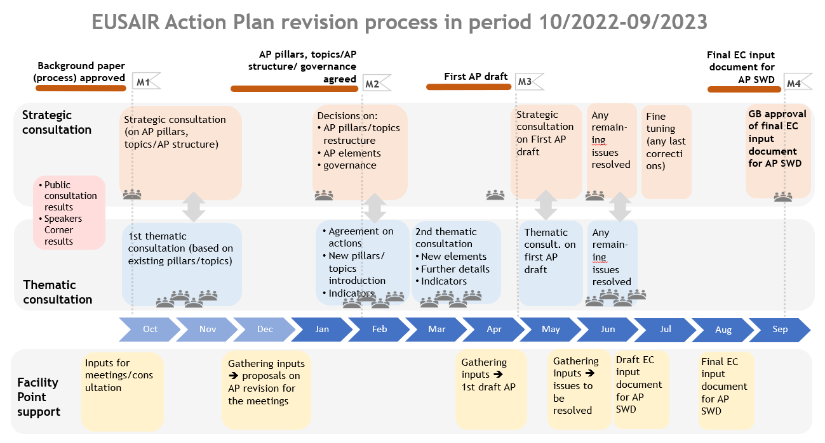
Figure 3: Detailed EUSAIR Action Plan revision process

COM(2014) 357 final of 17.6.2014
COM(2020) 132 final of 2.4.2020
COM(2022) 44 final of 14.2.2022
Repower EU
COMMISSION STAFF WORKING DOCUMENT Accompanying the document REPORT FROM THE COMMISSION TO THE EUROPEAN PARLIAMENT, THE COUNCIL, THE EUROPEAN ECONOMIC AND SOCIAL COMMITTEE AND THE COMMITTEE OF THE REGIONS on the implementation of EU macro-regional strategies - Publications Office of the EU (europa.eu)
Funds directly managed by the EU Commission such as Horizon 2020, CEF, LIFE, COSME, ERASMUS+ only envisage a very limited participation of third countries; there is a huge difference in size between mainstream ESI funds available for Member States and IPA funds available for enlargement countries; the amount of IPA funds (€15.7 million) in ADRION programme is much lower compared to ERDF (€83.5 million).
Enhancing the accession process – A credible EU perspective for the Western Balkans – COM(2020) 57 final.
These are Action Plan chapters, for example: objectives and challenges of topics, actions, indicators, key stakeholders, policy framework, support for enlargement, embedding into funding instruments, flagships etc.

