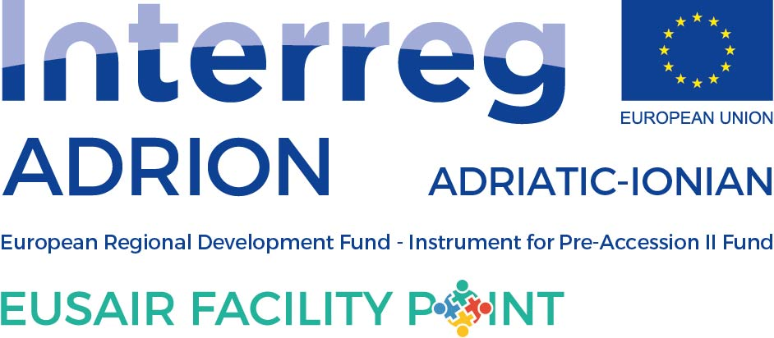

ANNUAL TSG 3 ACTIVITY PLAN FOR 2021

to be filled in by TSG 3

Please, fill in the events planned for 2020 within the TSG 3 Pillar Environmental Quality, having in mind the EUSAIR Action Plan. While preparing the Activity Plan, please consult the National Coordinators, Pillar Coordinator and TSG members from your country. When no specific data is known, please insert “tba”.

Event title | Date or quarter of the year | Location (country and/or town) | Type of event |  | Description of the event
 |  |  | Macro-regional, national, regional | Meeting, workshop, conference, info day, forum, etc.
TSG 3 Panel session 5th EUSAIR Forum, Belgrade, Serbia | 28th-29th January 2021 (TBC) | Serbia | Macro-regional | Panell session - forum | TBA
14th TSG 3 meeting | 16-17 March 2021 (TBC) | TBD | Macro-regional | meeting | 14th regular TSG 3 meeting
TSG 3 Panel session 6th EUSAIR Forum, Izola, Slovenia | 11-12 May 2021 | Slovenia | Macro-regional | Panell session - forum | TBA
Conference of Mediterranean commission for sustainable development (MCSD) | June 2021 (TBC) | Slovenia | Macro-regional | Conference | TBA
TSG 3 Workshop within Mediterranean Coast and Macro-regional Strategies Week | September 2020 (TBD) | TBD | Macro-regional | Workshop | TBA
15th TSG 3 meeting | October/November 2021 (TBD) | TBD | Macro-regional | meeting | 15th regular TSG 3 meeting
OTHER NEEDS, PROPOSALS (please, add if other needs and proposals are detected (issue papers, studies…)

