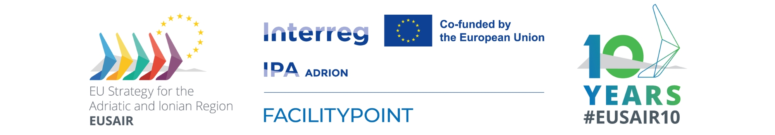
5th Meeting of Members of the EUSAIR Youth Council
24 June 2025, 15.30 – 17.00 CET

Participants: Members of the EUSAIR Youth Council, EUSAIR Presidency of North Macedonia, EUSAIR Presidency of Hellenic Republic, European Commission, EUSAIR Facility Point Lead Partner

Facilitator and Chair: EUSAIR Youth Council Chairs
Location: Online.
Link: https://teams.microsoft.com/l/meetup-join/19%3ameeting_YzVlOGQ1YWQtM2QyOC00ZjE1LTgwYTEtYTkwMzkwYzI4MmM3%40thread.v2/0?context=%7b%22Tid%22%3a%2249fad77b-acc0-4d52-a56e-97109d9cdc3b%22%2c%22Oid%22%3a%2251be00ce-b21b-4e7e-8c83-df121e9af050%22%7d

DRAFT AGENDA

24 June 2025
15:15-15:30 | Tunning-in
15:30-15.35 | - Introduction  (EUSAIR Presidency, EC, FACILITY POINT LP, Chairs)
15:35-16:20 | - Overview of the YC Task Force meeting outcomes, key agreements reached, next steps  (FACILITY POINT LP)  Discussion  (EUSAIR Youth Council Members, EUSAIR Presidency, EC, FACILITY POINT LP)
16:20-16:30 | - Technical and Communication Matters  (FACILITY POINT LP)  - SharePoint/intranet  - EYC Zoom account and email account  - Social Media  - Website and logo management
16:30-16:50 | - Work of the EYC  (EUSAIR Youth Council Members)  - Ongoing and planned activities  - Open questions and clarifications
16:50-17:00 | - Autumn In-person meeting & Next steps  (EUSAIR Youth Council, EUSAIR Presidency, EC, FACILITY POINT LP)

