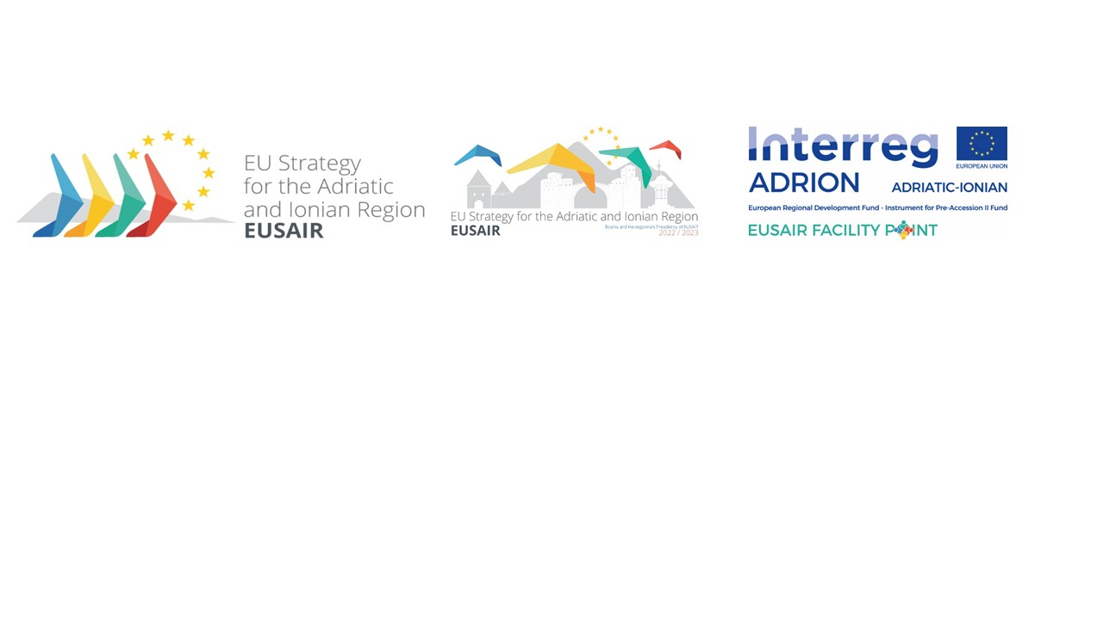

**19th GOVERNING BOARD MEETING** **of the**

**European Union Strategy for the Adriatic and Ionian Region (EUSAIR)**

**15-16 March 2023**

**Draft operational conclusions**

|  |  |
| --- | --- |
| **Item 2**  **Adoption of the Agenda** | * **Agenda was adopted.** |

|  |  |
| --- | --- |
| **Item 3**  **Approval of the minutes of the 18th EUSAIR Governing Board meeting** | * **The minutes of the 18th EUSAIR Governing Board meeting with amendments provided by Italy were formally approved.** |

|  |  |
| --- | --- |
| **Item 4**  **Presentation of the Implementation of the BiH EUSAIR Programme** | * **The implemented activities and outcomes of the BiH EUSAIR Programme have been acknowledged by EUSAIR Governing Board members, as well as the organisational process of the 8th EUSAIR Annual Forum.** |

|  |  |
| --- | --- |
| **Item 5**  **EUSAIR Youth Consultation follow up** | * **The BiH Presidency reported to the EUSAIR Governing Board (GB) on the two meetings of the Youth Consultation Task Force (TF) held in Sarajevo (9.1.2023) and on-line (7.3.2023). During these meetings, some countries expressed their uncertainty on the very mandate of the TF, either ensuring youth consultation to set up the Youth Council (YC) or to set up the YC by attracting youth. Italy, through the FP Project Partner Region Marche proposed at the last TF meeting to prepare an input paper, in coordination with the FP Lead Partner, proposing guidelines for consultation process to be discussed within the TF at the next meeting (to be convened in May during the Forum or earlier, if deemed appropriate by the participating countries). Every agreement of the TF will be adopted by consensus. The GB will be informed about the TF conclusions.** |

|  |  |
| --- | --- |
| **Item 6**  **Follow up on the embedding process and next steps** | * **The GB members have acknowledged the state of play on embedding process in some of EUSAIR participating countries.** * **EUSAIR Trio Presidency shall prepare a proposal for Council Conclusions on how to make the Managing Authorities Network operational.** |

|  |  |
| --- | --- |
| **Item 7**  **Follow up on the Revision of the EUSAIR** | * **An accompanying EUSAIR communication will be necessary for the current Action Plan revision.** * **As the EC pointed out, the reflection on the possible new priorities, in particular regarding social inclusion, sustainable agriculture and green rural development and youth involvement, should be speeded up and amplified. Referring to the recent MRS report, “MRSs also facilitate the implementation of core European political initiatives across their territories aligning and coordinating them with regional and local initiatives”. These possible, new priorities are critical for green, digital and social transition in the macro-region and EUSAIR should bring a territorial dimension in this context, especially when preparing EU enlargement of Western Balkan. Whether these new priorities should be treated as new pillars or integrated into existing ones is another aspect to be further explored. However, any possible proposal of integration into existing pillars should be fully elaborated and all aspects of original proposal should be kept.** * **The GB members agreed that the Methodology to guide TSGs in drafting contents of the Action Plan revised according to the comments received on the Revision Working Group conclusions and on the document itself is considered good enough to be used in the Spring TSG consultation. The external experts, recently engaged by the FP Lead Partner will exchange bilaterally with PCs to explain and adjust the revision methodology, and take account of pillar-specific issues. It will be a challenge to ensure a harmonised approach/structure of the new Action Plan while factoring in specificities of the Pillars.** * **By end of next week (i.e. 24.3.2023) the participating countries provide feedback on proposed new thematic elements based on the table elaborated by the FP Lead Partner in their presentation for Item 7.** * **The 3rd meeting of the EUSAIR Revision Working Group meeting to be organised on 11 May 2023 in Sarajevo, BiH.** * **The revision of the document “Towards a streamlined governance and management architecture for the EUSAIR” will start within the EUSAIR Trio Presidency in Autumn 2023.** |

|  |  |
| --- | --- |
| **Item 8**  **Presentation and state of play of the Annual Report of TSG (15 March a.m.)** | * **EUSAIR Governing Board took note of the report from the Technical meeting of Pillar Coordinators and the latest activities of Thematic Steering Groups.** |

|  |  |
| --- | --- |
| **Item 11**  **EUSAIR Governance support 2021-2027 by three strategic projects**  ***Item 11 was not closed, therefore additional conclusions might be added when the 19th GB meeting resumes.*** | * **EUSAIR Governing Board took note about state of play in development of 3 strategic projects providing support of 6 functions to EUSAIR.** * **The project concepts of the 3 strategic governance support projects will be shared with the EUSAIR Governing Board members.** |

|  |  |
| --- | --- |
| **Item 14**  **Conclusions and next steps** | * **EUSAIR Governing Board will continue its meeting to discuss remaining agenda items (continuation of Item 11 - EUSAIR Governance support 2021-2027 by three strategic projects; Item 9 - Presentation of the IPA ADRION programme - state of play; Item 10 - EUSAIR Facility Point and Item 12 - AII: report on the meeting of the Committee of Senior Officials) on 27 April afternoon at Event Lounge, Brussels, during the 2023 MRS week.** |