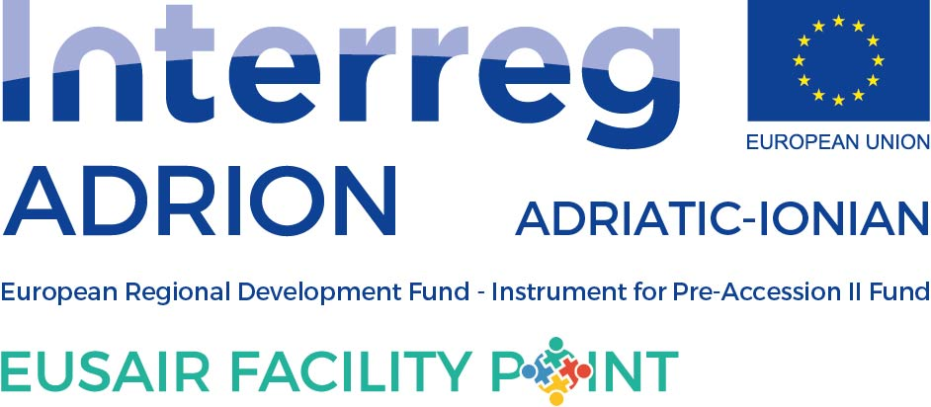
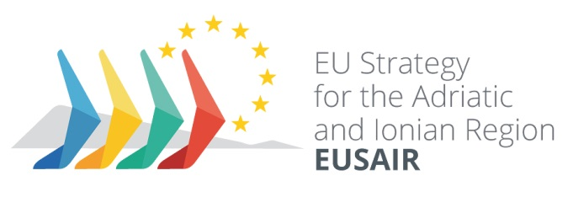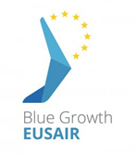

12th Meeting of the Thematic Steering Group for Pillar 1 – Blue Growth
under the EU Strategy for the Adriatic and Ionian Region (EUSAIR)
7 December 2020, (virtually)
DRAFT MINUTES
Item 1 – Welcome

Welcoming remarks were delivered by Pillar Coordinators, Ms Slavica Pavlovic (MNE) and Ms Irene Tzouramani. Taking into account the recent changes in the TSG1 group, new as well as old members introduced themselves. Very high participation was noticed. Eight (Albania, Bosnia and Herzegovina, Croatia, Greece, Italy, Montenegro, Serbia, Slovenia) out of nine countries participated at the virtual meeting, quorum was obtained and formal decisions could be taken. Beside the country representatives, at the 12th TSG1 meeting were present officers from the services of the European Commission (DG Regio and DG Mare), Facility Point project partners (Greece, Slovenia and Montenegro – in the name of Lead Partner) as well as respective thematic and pillar experts.

Item 2 - Up-date on Slovenian Presidency

On the occasion of the 12th TSG1 meeting, Slovenian EUSAIR National Coordinator Ms Andreja Jerina took participation and informed on activities run by current EUSAIR Slovenian Presidency which is in its second half. She informed that even in the difficult situation, circumstances and limitations caused by COVID-19 Presidency keeps implementing activities foreseen with the Presidency Programme. She presented main achievements of the Presidency among which are EUSAIR flagships that were adopted in the very beginning of Slovenian Presidency. Also, she reminded on the 3rd European Commission Report on implementation of macro-regional strategies which refers also to the work done within the EUSAIR governance structures. Following the European Council’s conclusion which were adopted recently by the General Affairs Council, Presidencies of all MRSs are for the first time invited, by the current German EU Presidency, to present main goals and achievement of MRSs, said Ms Jerina. This kind of improvement gives us the clear political orientation/guidance. Having in mind the recently adopted Economic Investment Package for the Western Balkans, Ms Jerina informed on possibility to organize meeting/workshops on matching between EUSAIR as well as EUSDR priorities with thematic priorities of the Economic Investment Package for the Western Balkans. In terms of identified and approved EUSAIR flagship, Slovenian NC stressed that the current Presidency will continue to monitor progress related to this item. Participants were informed on the 6th EUSAIR Forum which is planned to be organized in Izola on 11-12 May 2021. Following the previous practice, during the Forum each EUSAIR pillar has its own sessions what will be the case also during the 6th Forum. In that light and as it was previously communicated via email, Ms Jerina reminded TSG1 members to consider topics for their respective Pillar Session and inform back by 15 January 2021.

Item 3 - Adoption of the Agenda and item 4 - approval of the Minutes/Operational Conclusions of the 11th TSG1 Meeting

Agenda of the 12th TSG1 meeting was adopted unanimously, with minor changes proposed by the Slovenian representatives. Minutes from the 11th TSG1 meeting were adopted unanimously with comments received previously in written procedure. Agenda and the minutes were shared with the participants’ prior the meeting and uploaded on the intranet.

Item 5 - Outcomes of the technical meeting of the EUSAIR Pillar Coordinators and the 13th EUSAIR Governing Board meeting

Pillar I Coordinators (Ms Tzouramani Irene and Ms Slavica Pavlovic) informed TSG1 members on the outcomes of the last EUSAIR Governing Board and technical meeting of Pillar Coordinators meeting as well as on Blue-Boost event. Ms Pavlovic presented the conclusion from the GB and PCs technical meeting and informed that GB discussed with important insight from DG NEAR and DG REGIO on the progress in embedding process and that It will be further monitored and discussed at the next GB meeting. One of the messages from the meetings was the flagships need to be further promoted with the MAs and other authorities responsible for programming, in coordinated manner in consultation with the EUSAIR Facility Point. In order to transmit the message and work done so far on the highest EC and participating countries level, Slovenian Presidency, on behalf of EUSAIR, sent the letter with EUSAIR final list of flagships for embedding. Ms Pavlovic also informed that the 5th EUSAIR Forum will be organized virtually by previous Presidency. Pillar Coordinators briefly informed TSG1 members on their participation at the final PORTODIMARE conference, which will be held on 9-10 December 2020 (virtually) and one previously held – Blue Boost event. Ms Tzouramani Irene informed TSG1 members that she participated at the final event of the Blue Boost project which was financed by the INTERREG ADRION Programme. On this occasions she presented the flagships of Blue Growth Group and future work. She also informed that in the focus of Blue Boost project was development of methods for boosting Blue Growth sectors as well as voucher scheme for funding 35 small scale innovation sectors. Under this item, PCs informed on participation on consultations with Greek and Italian Managing Authorities. The purpose and idea behind was to introduce MAs of ETC programes of both countries with flagships and discuss possible matching with programmes priorities/topics.

Item 6 - Follow up on the embedding process and next steps

Representatives of DG Regio, Ms Klaudia Feurle and DG Mare, Ms Eleni Hatziyanni informed on the progress in terms of proposed EUSAIR macro-regional priorities and flagships which were shared with relevant EC services by Slovenian Presidency. They informed that 2021-2027 regulations on ESIF programmes have not yet been adopted and that its adoption is expected in the 1st quarter of the next year. They invited TSG1 representatives to catch the momentum and coordinate and communicate with MAs on incorporation in OPs. Ms Feurle said that programmes for 2021-2027 are in the final process of development and that some draft programmes proposal have been already received. As the process of preparation for the new programming period is in final phase, she reminded that there are only few months left for coordination with programming authorities on flagships and its incorporation. Ms Hatziyanni invited participants to contribute in Sustainable Blue Economy Consultations, which were previously share among participants. Also, she stressed out that this timing/period is unique opportunity to see how to boost new projects and incorporate it within the new programmes.
Taking into account the major role of the INTRREG ADRION programme and its preparation for the new financial perspective, TSG1 representatives agreed to invite ADRION representatives on the next meeting, in order to jointly work on the preparation of the ADRION Cooperation Programme for the next period in terms of Blue Growth field. Italian member of TSG 1 Mr. Federico Rosset welcomed inviting ADRION programme representatives to next TSG 1 meeting, taking into account programme’s area which proves to be the most relevant with EUSAIR, but he also proposed to save similar methodology/approach and extend participation to future TSG1 meetings with Managing Authorities of other Funding Programmes with relevance to EUSAIR Blue Growth priorities. PC Slavica Pavlovic thanked for the initiative of the Italian representative and suggested possibility to invite representatives of MA of different Funding Programmes as observers or guests to future TSG 1 meetings.

Slovenian members of TSG1 Ms Marta Ciraj informed members on health issues which are in correlation with the Blue Growth Pillar, its possible actions/benefits. Participants as well as EC representatives agreed to provide to the ADRION Programme Authorities the proposal of including the health as a horizontal topic into the new ADRION Cooperation Programme.

Item 7 - EUSAIR Facility Point

Under this item, Facility Point Lead Partner and Facility Point Plus manager informed and discussed the state of art in terms of activities related to strategic project. Ms Olga Abram from the EUSAIR Facility Point Lead Partner reminded on challenges in the implementation of the EUSAIR Facility Point strategic project planned activities caused by COVID-19. However, she informed on the very good/increased usage of the EUSAIR stakeholder platform, which was proved to be a useful and functional tool during the pandemic period. Also, 5th and 6th EUSAIR Forums were announced, and all partners and participants called to increase the visibility of EUSAIR in this period. Ms Abram reminded that preparation of Annual Activity Plan for 2021 is about to start and invited participants to consider activities and propose/contribute. With regards to the state of art on the Facility Point Plus project, participants were interested in the timeline of already approved cross pillar project ideas, engagement of experts for its development and its delay as well on the new call for project ideas. Project manager for this project Ms Mojca Krisch informed that due to administrative, legal and other obstacles did not manage to publish call for cross pillar projects which were approved last year within Facility Point Plus project activities. The main reasons for delay were of technical/legal reasons including COVID19 circumstances and manner of work. Also, she said that the process of preparation of the ToRs for the second call of project ideas has started and will be finished in the upcoming weeks. On behalf of the EUSAIR Facility Point Greek Partner, Ms Mathilde Konstantopoulou briefed on the implementation of Pillar 1 activities under WP2. She stressed out that the FISH TOUR AIR project idea of TSG1 group is under preparation whose terms of reference for the procurement under WP2 are currently finalized and are scheduled to be published before the end of the year. The WP3: Monitoring and Evaluation Expert, mrs. Victoria Chorafa (LKN Analysis), updated TSG1 members about the pillar 1 related study “IDEAL EUSAIR” and the results achieved so far. She reminded on the survey that was done previously and presented survey findings. Her presentation to participants included comprehensive overview and also included survey structural response (per each participating country), categories of organizations which were involved in the survey as well as SWOT analyses per topics/subtopics (blue technologies, fisheries and aquaculture, maritime and marine governance and services). With regards to the EUSAIR Facility Point Work Package 3: Monitoring and Evaluation expert, Mr Michalis Nikitaridis (LKN Analysis), presented overall tasks conducted and those that are in progress/to be conducted in the upcoming period. He reminded and introduced new members to 3 main activities under this WP: Building the Knowledge Base relevant to Blue Growth, Establishing the EUSAIR Monitoring and Evaluation Framework, Capacity building for public authorities / administrations. Also, he informed that Pillar 1 related study titled “IDEAL Eusair” is in progress and that this activity/task is expected to be finalized by February 2021. Following the practice from the last year, 2nd Pillar 1 Annual Monitoring Report for 2020 as well as 2nd EUSAIR Annual Synthetic Monitoring Report 2020 are in progress and their finalization is also expected in the following period.

Item 8 - WP2: Project Development Pillar 1 – Blue Growth

Participants discussed, scored and approved the last project idea - AIM-FRISH, which was presented at the previous TSG1 meeting (July 2020). This project idea will be forwarded to Facility Point Greek Partner for further development under WP2.. Experts presented and informed the TSG1 members about 3 new project ideas: SeaSusPack, AMOS, EURYNOME. Mrs. Theofania Tsironi from the Agricultural University of Athens presented the project idea “Sustainable packaging of fish and seafood based on marine bioresources – SeaSusPack", mr. Manolis Ntoumas from the Institute of Oceanography (GR) along with Dr. George Chatzigeorgiou from the Institute of Marine Biology, Biotechnology and Aquaculture (GR) and Dr. Katja Klun from the National Institute of Biology (SI) presented the project idea “Aquaculture Monitoring Observatory System - AMOS”. The last project idea, titled “The Effects of anthropogenic pressures and climate change in the nutritional and commercial value of two small pelagic fish species of importance to ADRION region fisheries: Biodiversity and energy flow from the Ecosystem to the final product – EURYNOME" was presented by Dr. Grigorios Krey from the Fisheries Research Institute of the Hellenic Agricultural Organization.
These project ideas will be circulated to TSG1 members for further commenting and upgrading. Afterwards, will follow the evaluation process and approval via written procedure. All information on the features of proposed ideas will be shared among participants including PPT presented during the meeting.

Item 9 – 5th EUSAIR Forum (Belgrade, January 2021)

Pillar Coordinators in communication with the Serbian TSG1 member proposed the topic for the TSG1 Pillar session at the occasion of the 5th EUSAIR Forum, i.e. Freshness of fresh water fishes or other important topic for Freshwater aquaculture as Involvement of a new technology in aquaculture or Trends on aquaculture production and market of the aquaculture products. Serbian representatives informed that such a topic will be warmly welcomed to be discussed on the 5th EUSAIR Forum taking into account that the (host) country has no access on the sea. Also, it will be for the first that during Forum’s Pillar 1 session topic dedicated to fresh water. Ms Klaudia Feurle informed that save the date for the 5th EUSAIR Forum is to be shared very soon. Preliminary the 5th EUSAIR Forum is expected be organized in Belgrade (virtually) on 28-29 January 2021. Pillar Coordinators will send the proposed topic for Pillar 1 session to be approved via the written procedure.

End of Meeting
The Pillar Coordinators thanked all participants for their presence and contribution during the meeting and announced preliminary the next TSG1 meeting which is expected to be held during the spring 2021.

